Bid Advertisement
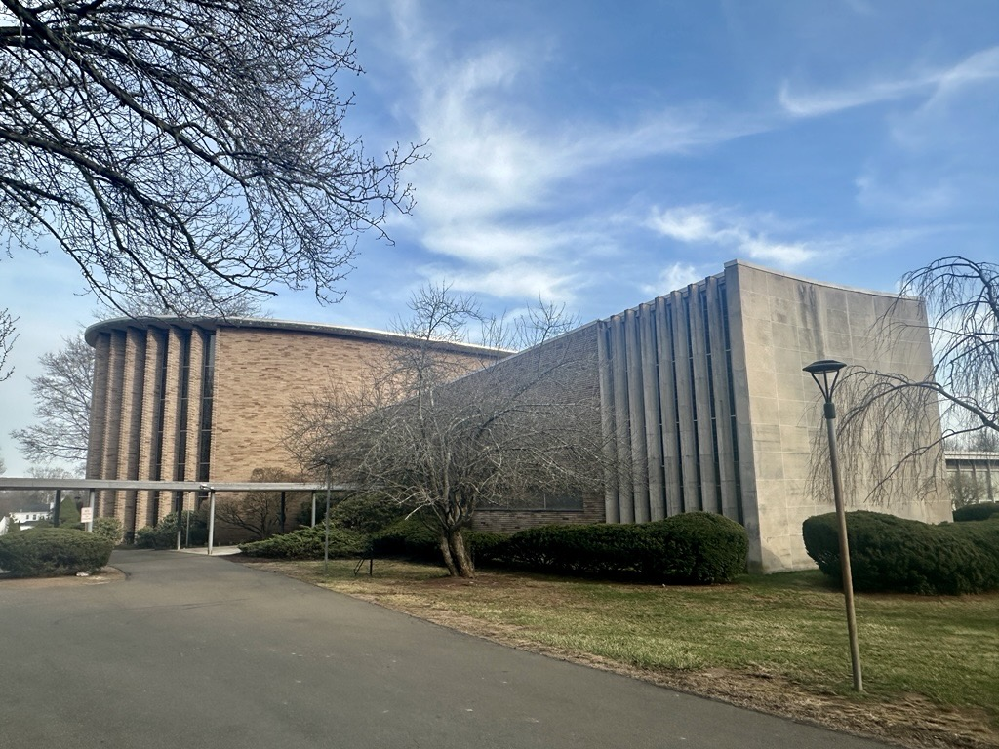
Congregation Mishkan Israel, one of Connecticut’s oldest Jewish congregations, invites qualified roofing contractors to submit bids for the replacement of the existing roof at its historic synagogue campus located at 785 Ridge Road in Hamden. Serving the Greater New Haven community for more than 175 years, the congregation’s campus remains an important center for worship, education, and community life, and this project will help preserve the facility for future generations.
The project includes replacement of the existing roof and associated work as detailed in the bidding documents prepared by Hoffmann Architects + Engineers. Contractors should review all project requirements, specifications, warranty provisions, insurance and bonding obligations, and submission requirements as outlined in the bid package. Interrested bidders may acquire an electronic copy of the Bid Documents by wending a written request to e.kesegi@hoffarch.com.
Partial funding for this project is provided by Connecticut's Historic Restoration Fund, which is funded by the Connecticut Community Investment Act and administered by the Connecticut State Historic Preservation Office (CT SHPO) with the Department of Economic and Community Development. All work must meet the Secretary of the Interior's Standards for the Treatment of Historic Properties and by approved by the CT SHPO.
A mandatory pre-bid meeting and site walkthrough will be held at Congregation Mishkan Israel, 785 Ridge Road, Hamden, CT 06517, Main Lobby, on Tuesday, July 28, 2026 at 10:00 AM. Attendance is required; failure to attend will result in bid rejection.
Questions regarding the bidding documents must be submitted in writing to Erin L. Kesegi, AIA (e.kesegi@hoffarch.com) no later than 4:00 PM on Tuesday, August 4, 2026. Responses and any necessary clarifications will be distributed to all registered bidders through formal addenda.
Bids must be submitted electronically to Jody Dietch (jdietch@cmihamden.org) no later than 12:00 PM on Tuesday, August 11, 2025. Contractors must also provide references for five comparable projects completed within the past five years.
Please read the bidding documents in full for complete project scope, qualification requirements, insurance and bonding requirements, submission procedures, and deadlines.

