Request for Bids
Golden Hill United Methodist Church
210 Elm St., Bridgeport, CT. 06604
Contact: Reverend Jeremiah Paul. Email: Jeremiah.Paul@nyac-umc.com
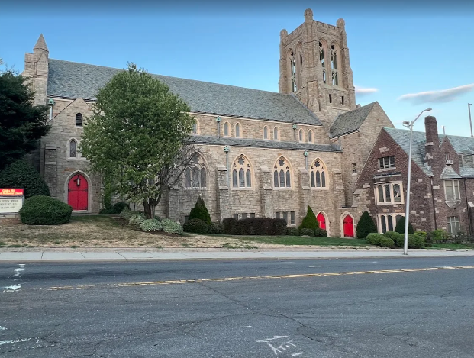
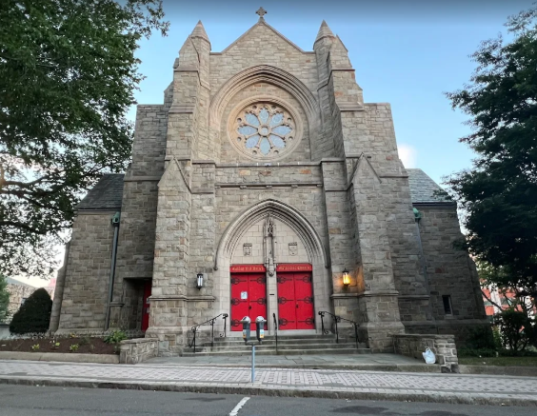

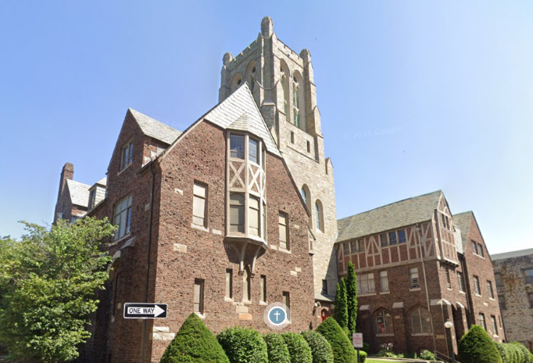
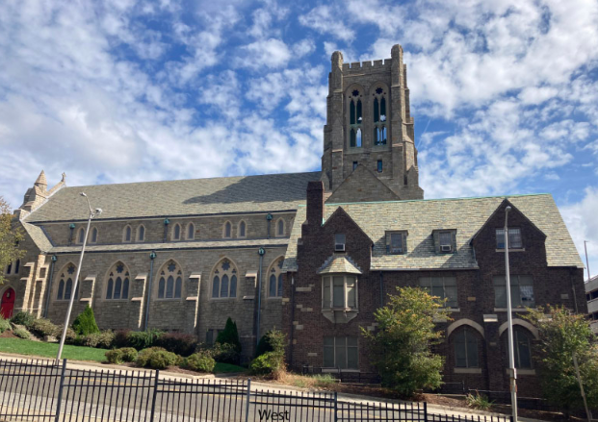

Projects:
Masonry repointing
Selective slate roof repairs

Key dates:
Request for bidders opens on 3/2/2026
Mandatory pre-bid conference on site at: 10AM,3/16/2026
Bids due by: 12 Midnight, 3/29/2026

Invitation to Bid
All bids shall be provided on a lump sum basis.

Bids will be accepted until 3/29/2026, 12 midnight, by email to Rev. Jeremiah Paul at Jeremiah.Paul@nyac-umc.com. Bids received after this time will not be accepted.

A mandatory pre-bid conference will be held at the church on: 3/16/2026, 10 AM.

No bid may be withdrawn for a period of 90 days from receipt of bid.

The church reserves the right to reject any or all bids and to make such awards, including acceptance of something other than the lowest bid, as it is deemed to be in the best interest of the church. The church is an affirmative action equal opportunity employer. Minority and Women’s Business Enterprises are encouraged to apply.

The project will be financed in part by a Historic Restoration Fund grant from the State of Connecticut through the State Historic Preservation Office in the Department of Economic and Community Development. Due to the nature of this project all bidders have been prequalified by virtue of experience to fulfil the work requirement by the proposed contract documents. All bidders must be familiar with the Secretary of the Interior Standards for Historic Rehabilitation and have experience working on historic structures.

Background:
Golden Hill United Methodist Church was selected by the American Institute of Architecture in Connecticut as the most architecturally beautiful church in Fairfield County. Specifically, it has a late Gothic Revival and Tudor Revival style, which is located within the bounds of Bridgeport’s central business district. The current construction was in 1928-1929, designed by Southey, Allen, and College and built by W.R. Muirhead. The church retains a high level of integrity both on the exterior and interior.

Significant materials will include matching mahogany wood, windows, sills, fascia, metal framing, roofing materials, including new slate shingles, matching bricks, and paint.

Bidder Requirements:
Each bidder should examine the proposed documents carefully and visit the site to examine the existing conditions prior to submitting a bid for the work.

Each bidder should carefully inform themselves of all existing conditions and limitations under which the work shall be performed and should include in their bid a sum sufficient to cover all the costs necessary to complete the work as set forth in the proposed contract documents. No allowance will be made to a bidder because of a lack of such examination or knowledge.

Submission of a bid shall be construed as conclusive of evidence that the bidder has performed such an examination and obtained such knowledge.

The successful bidder shall carry the following insurances:
- Workers Compensation and Employers Liability Insurance in full accord with the laws of the State of Connecticut with coverage as follows:
  - Employer’s bodily injury by accident with liability limits of $500,000 each accident.
  - Employer’s bodily injury by disease with liability limits of $500,000 each accident.
- Commercial General Liability Insurance with a liability limit of at least $1,000,000 per occurrence for all damage arising out of bodily injury, property damage, products/completed operations and contractual liability coverage for the indemnification provided under the contract. Each annual aggregate limit shall be not less than $2,000,000.
- Automobile Liability Insurance with respect to any owned, non-owned or hired vehicles which provide a liability limit of $1,000,000 per occurrence for bodily injury and property damage.
- The “Hold Harmless” endorsement of the insurance shall include the interest of the church and the State of Connecticut.
- The successful bidder shall provide evidence of the required insurances by means of an insurance certificate naming the State of Connecticut and the Church as additional insureds.
- The bidder’s insurance carriers shall be licensed to do business in the State of Connecticut and shall have an A.M. best rating of A-VII or better.

Bonding Requirements:

Where the general contract exceeds $100,000, the grantee shall require bid bonds or certified checks from the general contractor. If a construction manager is employed, each subcontract exceeding $100,000 shall be bonded or a certified check is required.
Lien waivers will be required if subcontractors are employed.

Contractor Qualifications
- Masonry and roofing contractors shall have minimum 5 years documented experience with historic masonry and slate roofing.
- Slate work shall be performed by craftsmen experienced in traditional slate repair methods, not asphalt-based systems.

Standards and References
All work shall conform to:
- Secretary of the Interior’s Standards for Rehabilitation
- NPS Preservation Brief #1 – Cleaning Historic Masonry
- NPS Preservation Brief #2 – Repointing Historic Masonry
- NPS Preservation Brief #29 – Repair, Replacement, and Maintenance of Historic Slate Roofs

Protection
- Protect existing slate, masonry, stained glass, and adjacent roofing systems from damage.
- No power washing or abrasive cleaning methods permitted.

MASONRY REPAIRS
Scope of Masonry Work: selective repairs to brick masonry, chimneys, stone/precast elements, and localized repointing, particularly at 5 buttresses on West side and small buttress on North side.

Masonry Cleaning
- Cleaning shall be low-pressure water wash (max 100 psi) with non-ionic detergent.
- No acids, sandblasting, or grinders permitted.
- Cleaning shall precede repointing.

Repointing
- Remove deteriorated mortar by hand tools only.
- Minimum removal depth: 2x joint width or until sound mortar is reached.
- Mortar shall match original in:
  - Color
  - Texture
  - Strength (Type N or custom lime-based mortar as approved)

Brick and Stone Repair
- Replace only masonry units that are cracked, spalled beyond repair, or missing.
- Replacement units shall match original in size, color, and texture.
- Tooth-in new masonry; no straight vertical joints.

Chimneys
- Clean chimneys to remove carbon staining.
- Repoint corbelled tops as needed.
- Verify and repair counterflashing at roof intersections.

SELECTIVE SLATE ROOF REPAIRS
General Roof Scope: work includes selective slate replacement, flashing repair/replacement, and repair of associated wood elements, primarily at:
- South and southeast Parish House roofs
- Slate gables
- Dormers and roof-wall intersections
- Chimney and ridge locations
- Sanctuary roof

Slate Repair
- Salvage existing sound slate for reuse.
- Replace missing, cracked, or delaminated slate with matching natural slate (color, thickness, exposure).
- Installation method:
  - Copper nails
  - Copper bibs or slate hooks where required
- No mastic, asphalt, or sealants permitted as primary repair.

Flashing
- Replace deteriorated flashing with minimum 16 oz. copper:
  - Step flashing
  - Counterflashing
  - Ridge caps where required
- Flashing shall be integrated into masonry joints, not surface-mounted.

Wood Fascia and Trim
- Repair or replace deteriorated wood fascia and rake boards adjacent to slate repairs.
- Replacement wood shall match original species, dimension, and profile.
- Prime all sides before installation.

Include allowances for:
- Additional slate replacement discovered during work
- Additional masonry repointing beyond base scope
- Hidden wood rot at roof edges

CHRO Requirements
The bidder must complete the form titled: Commission on Human Rights and Opportunities Contract Compliance Regulations Notification to Bidders.

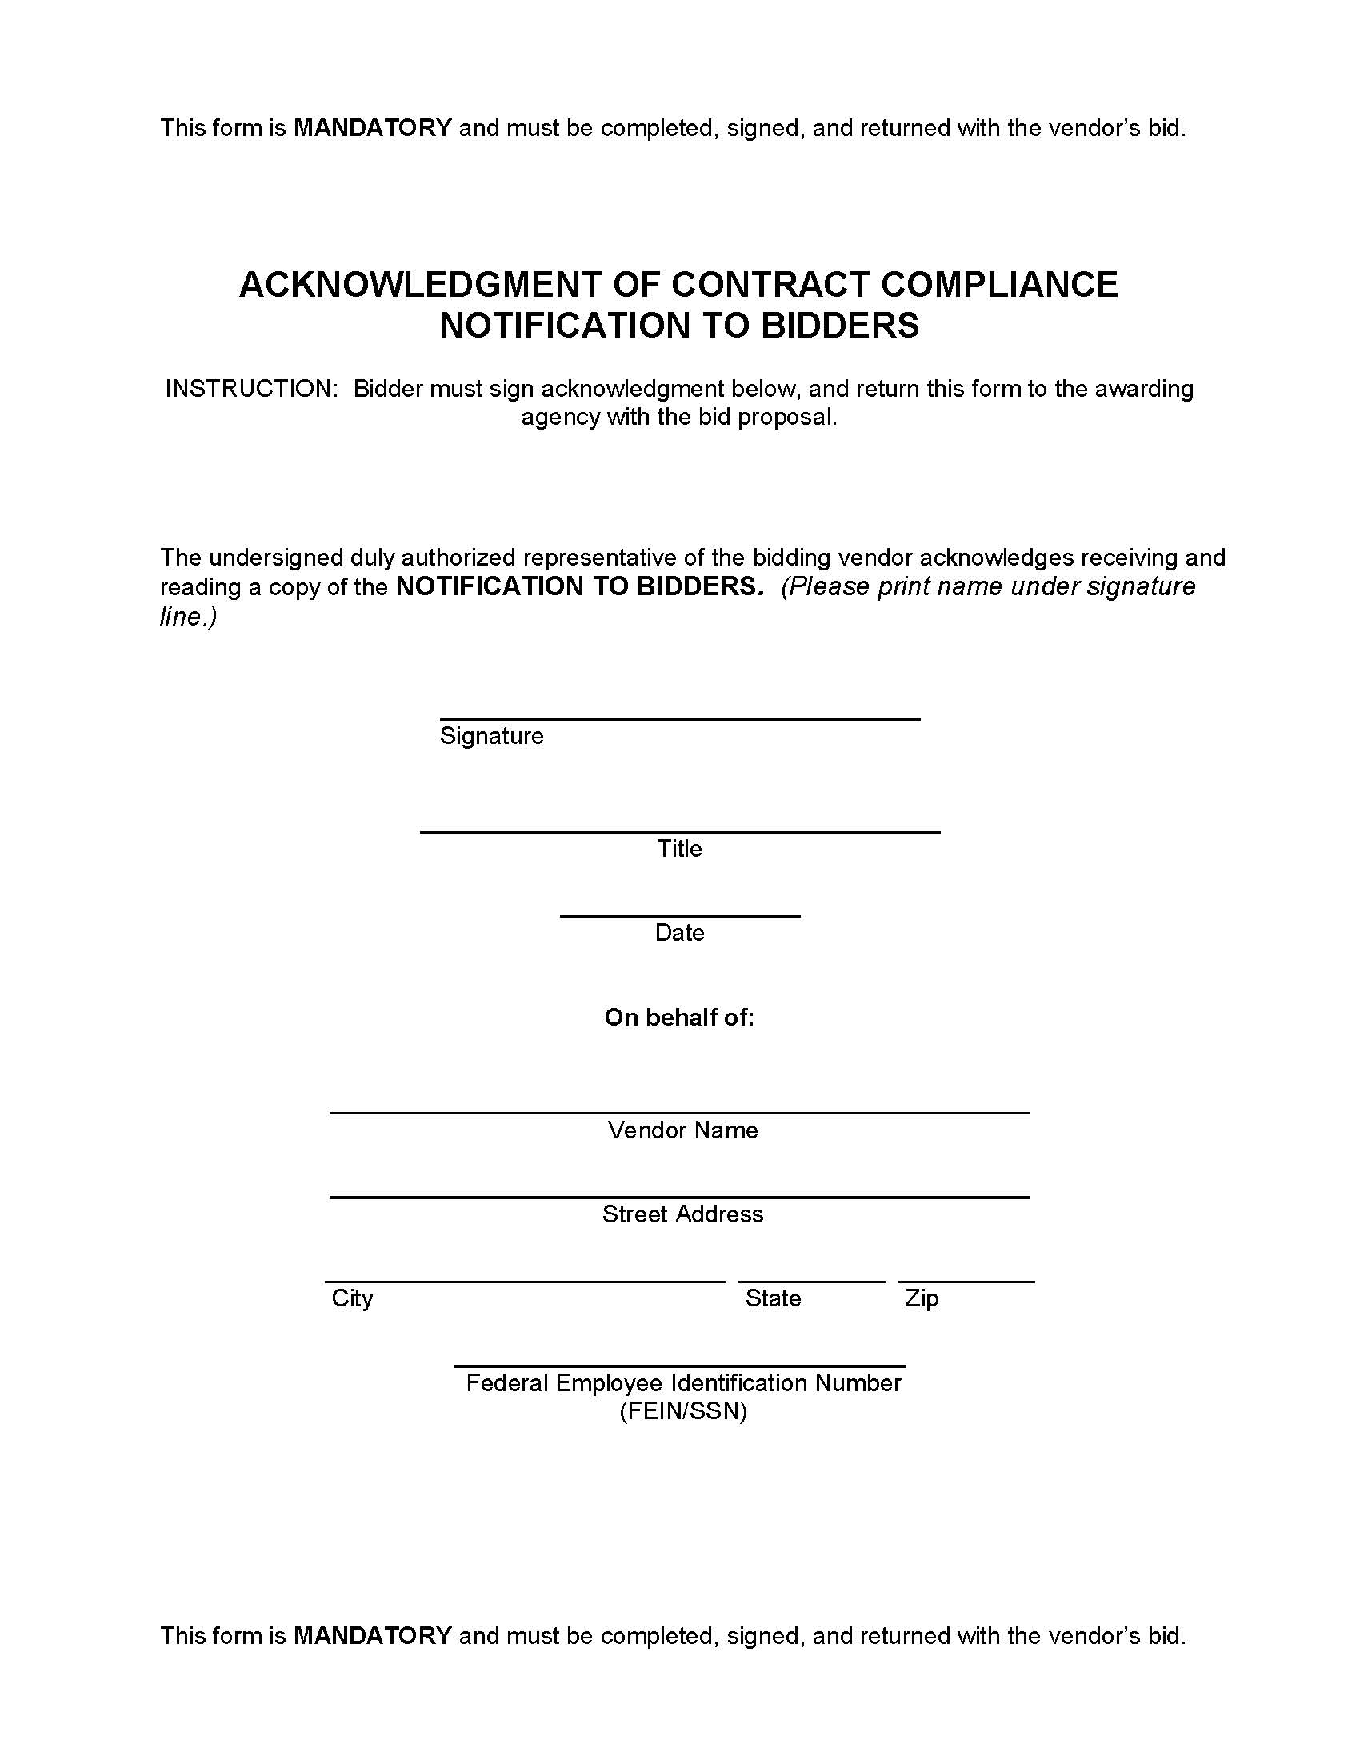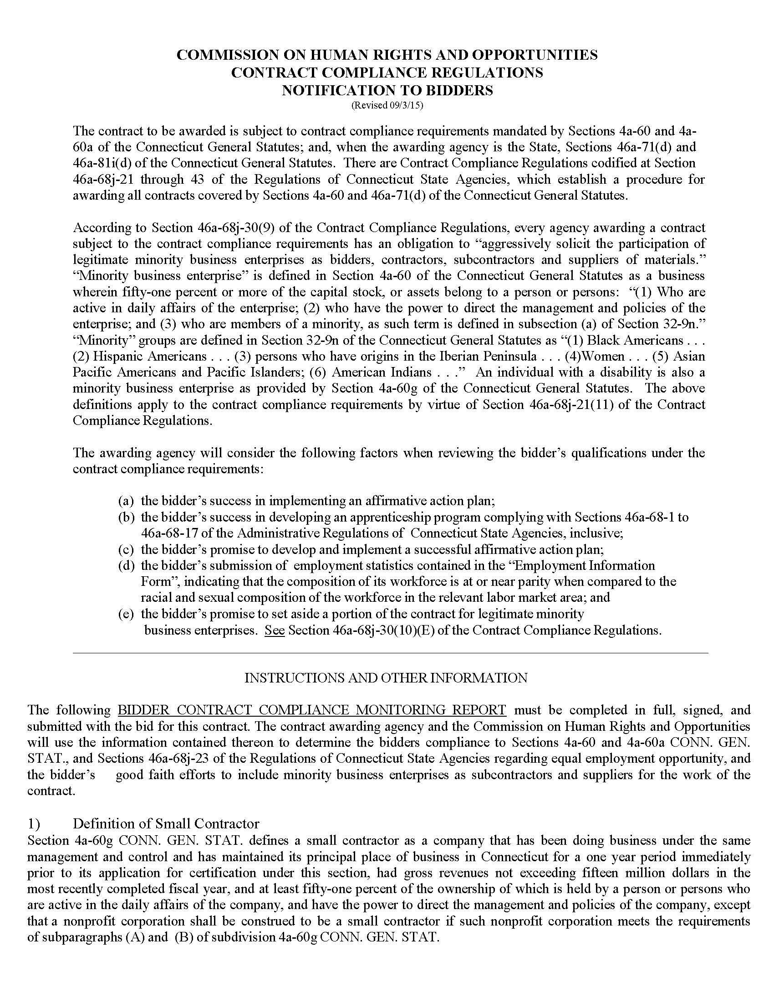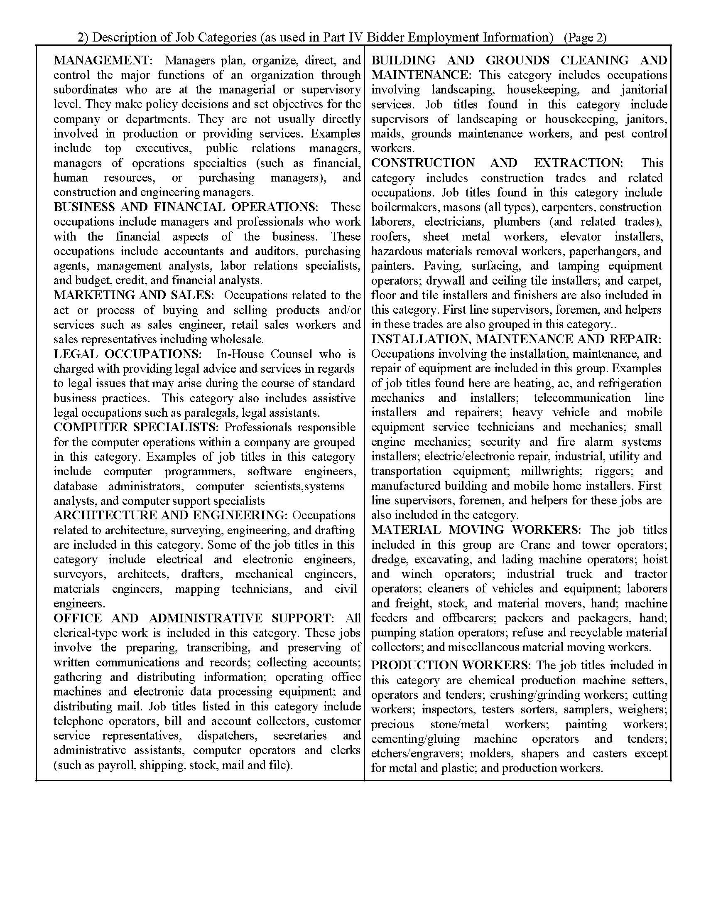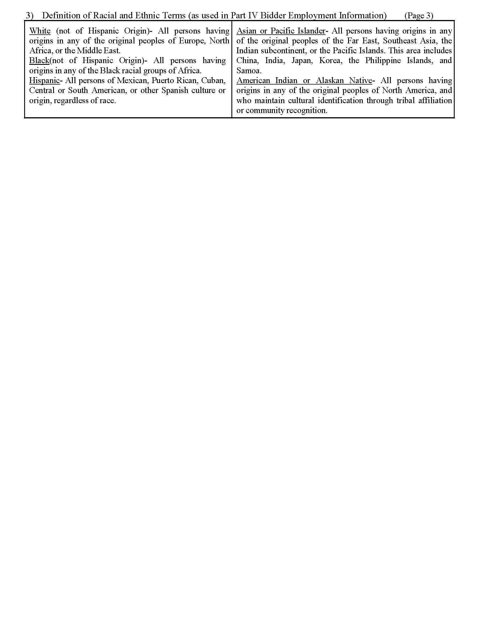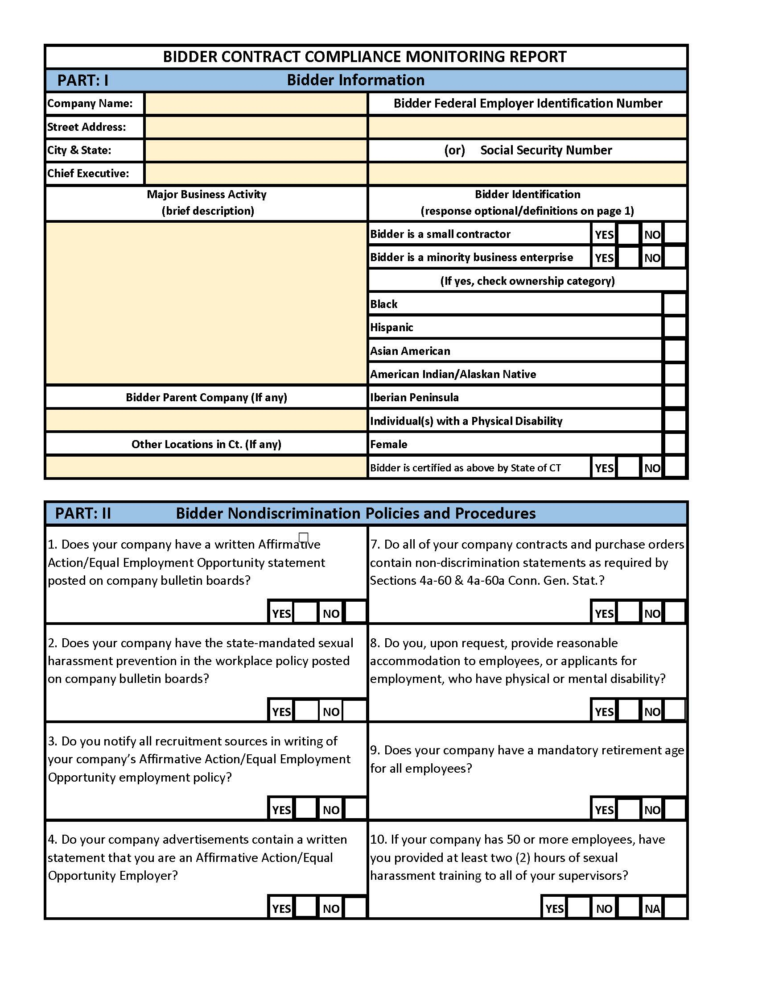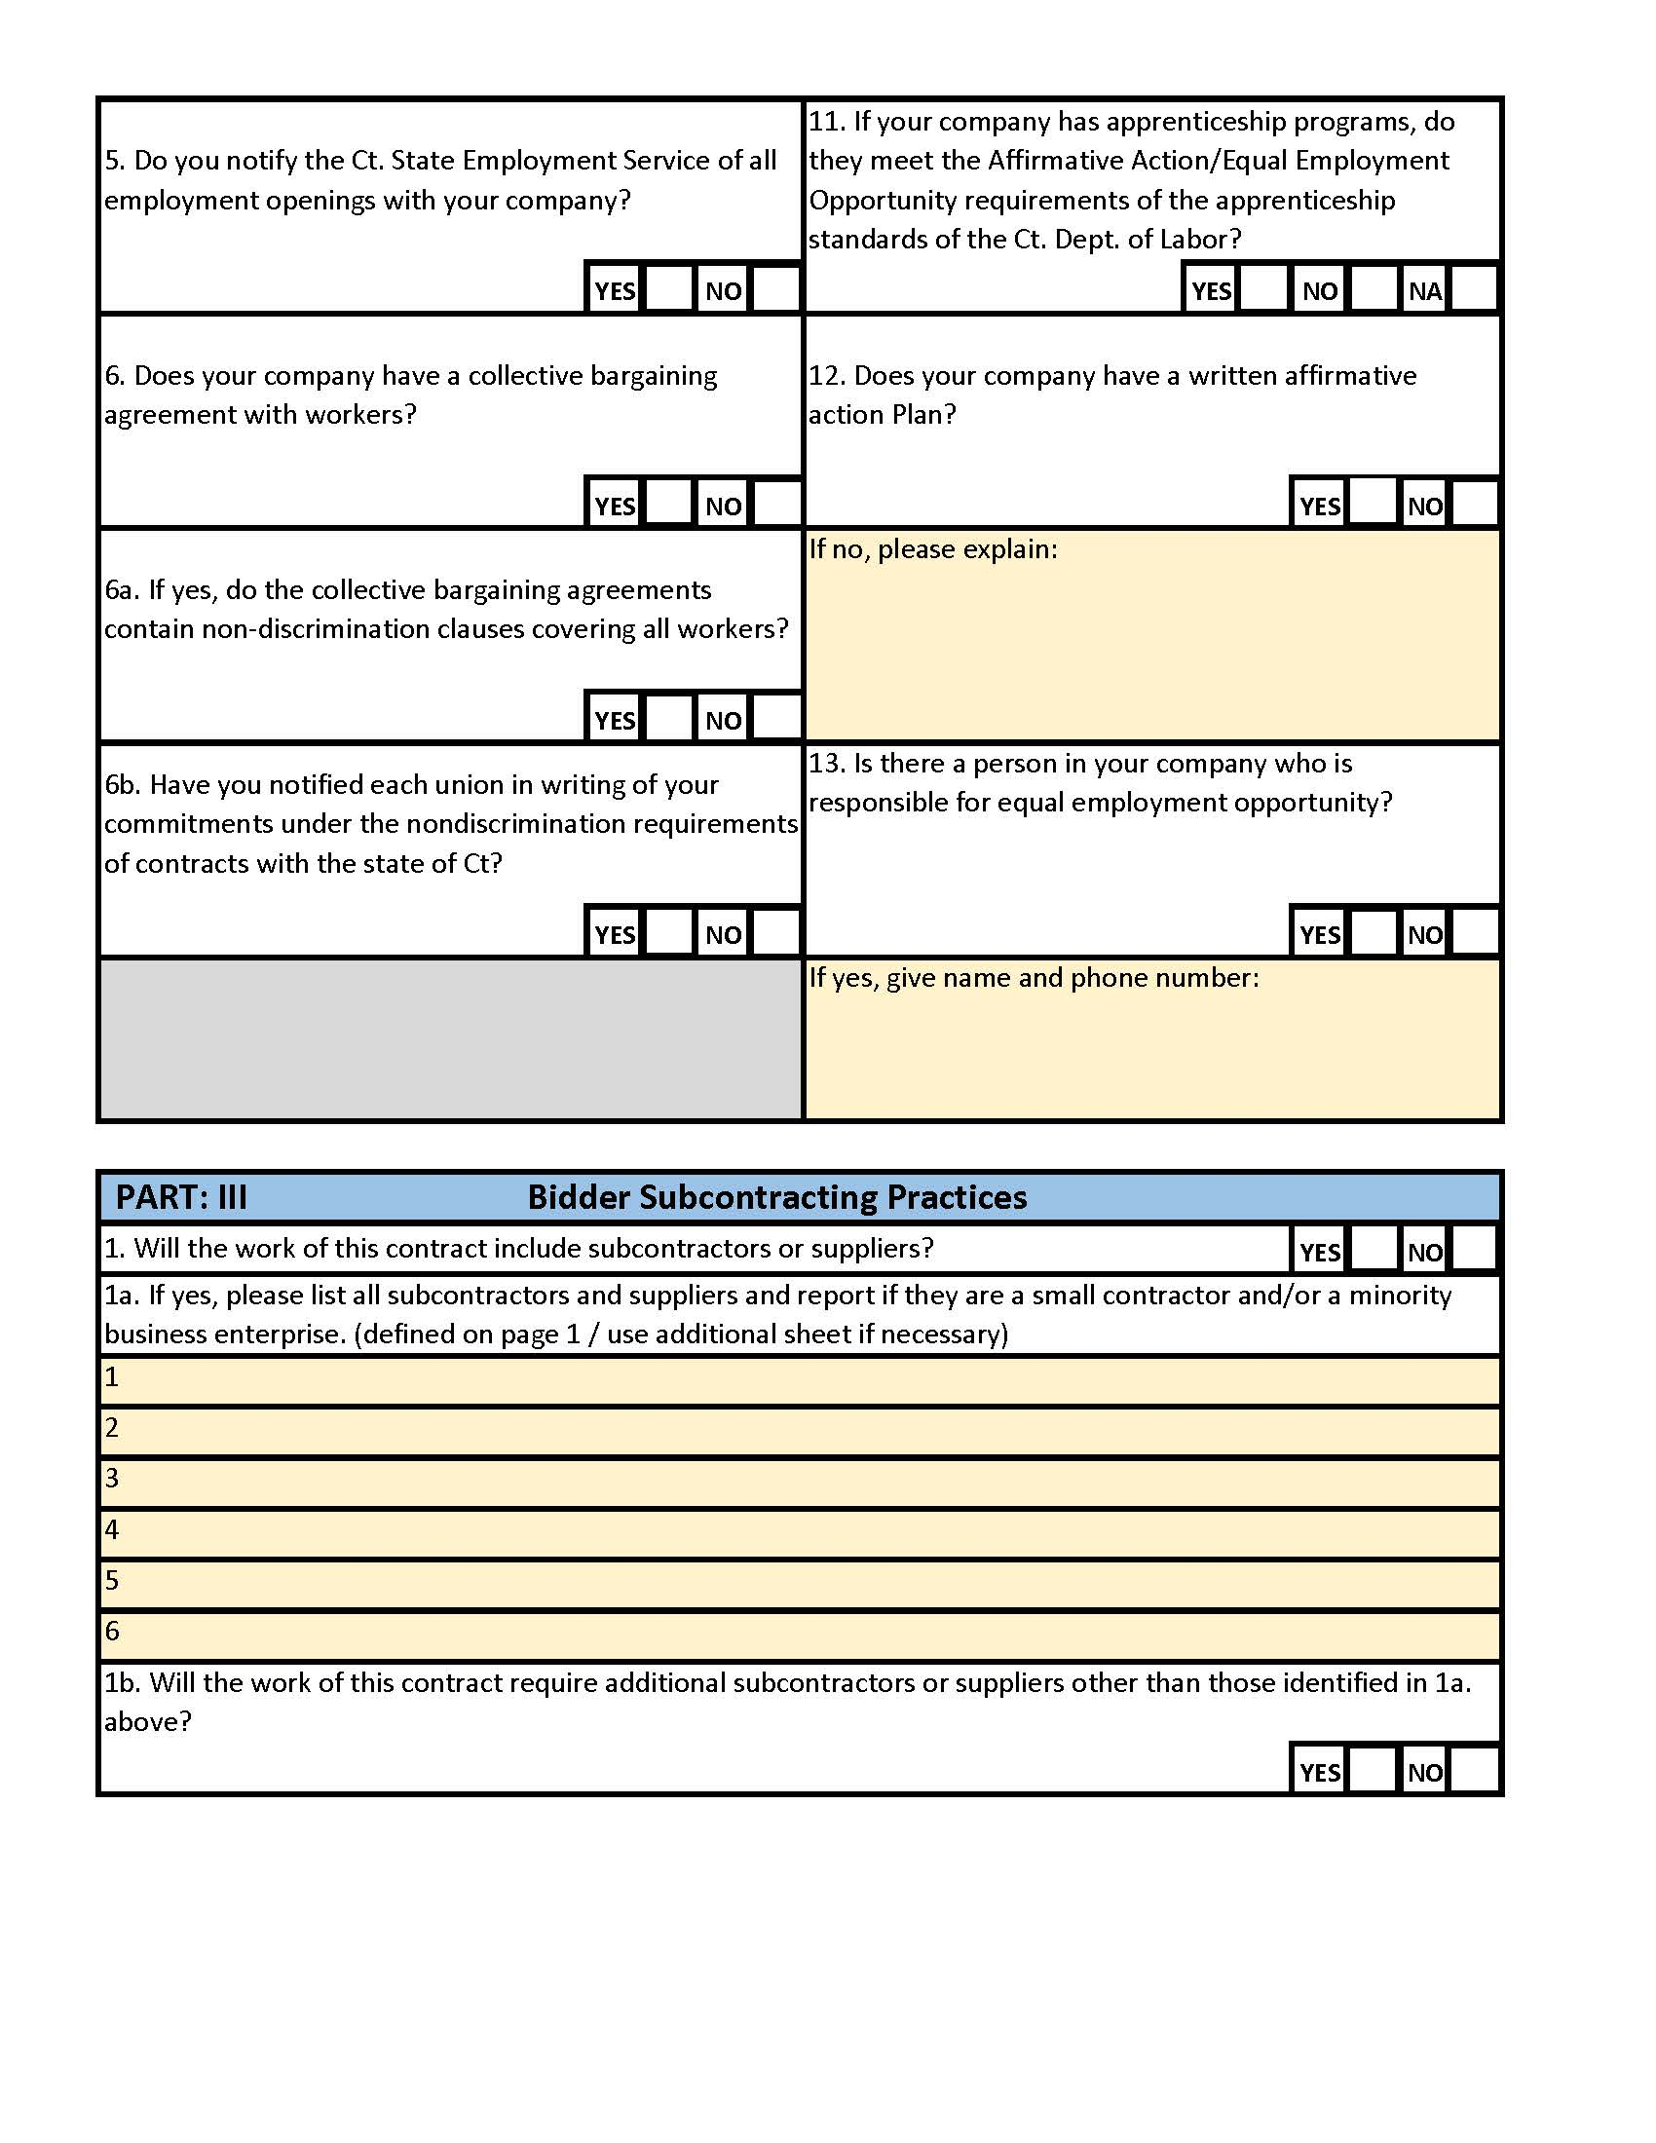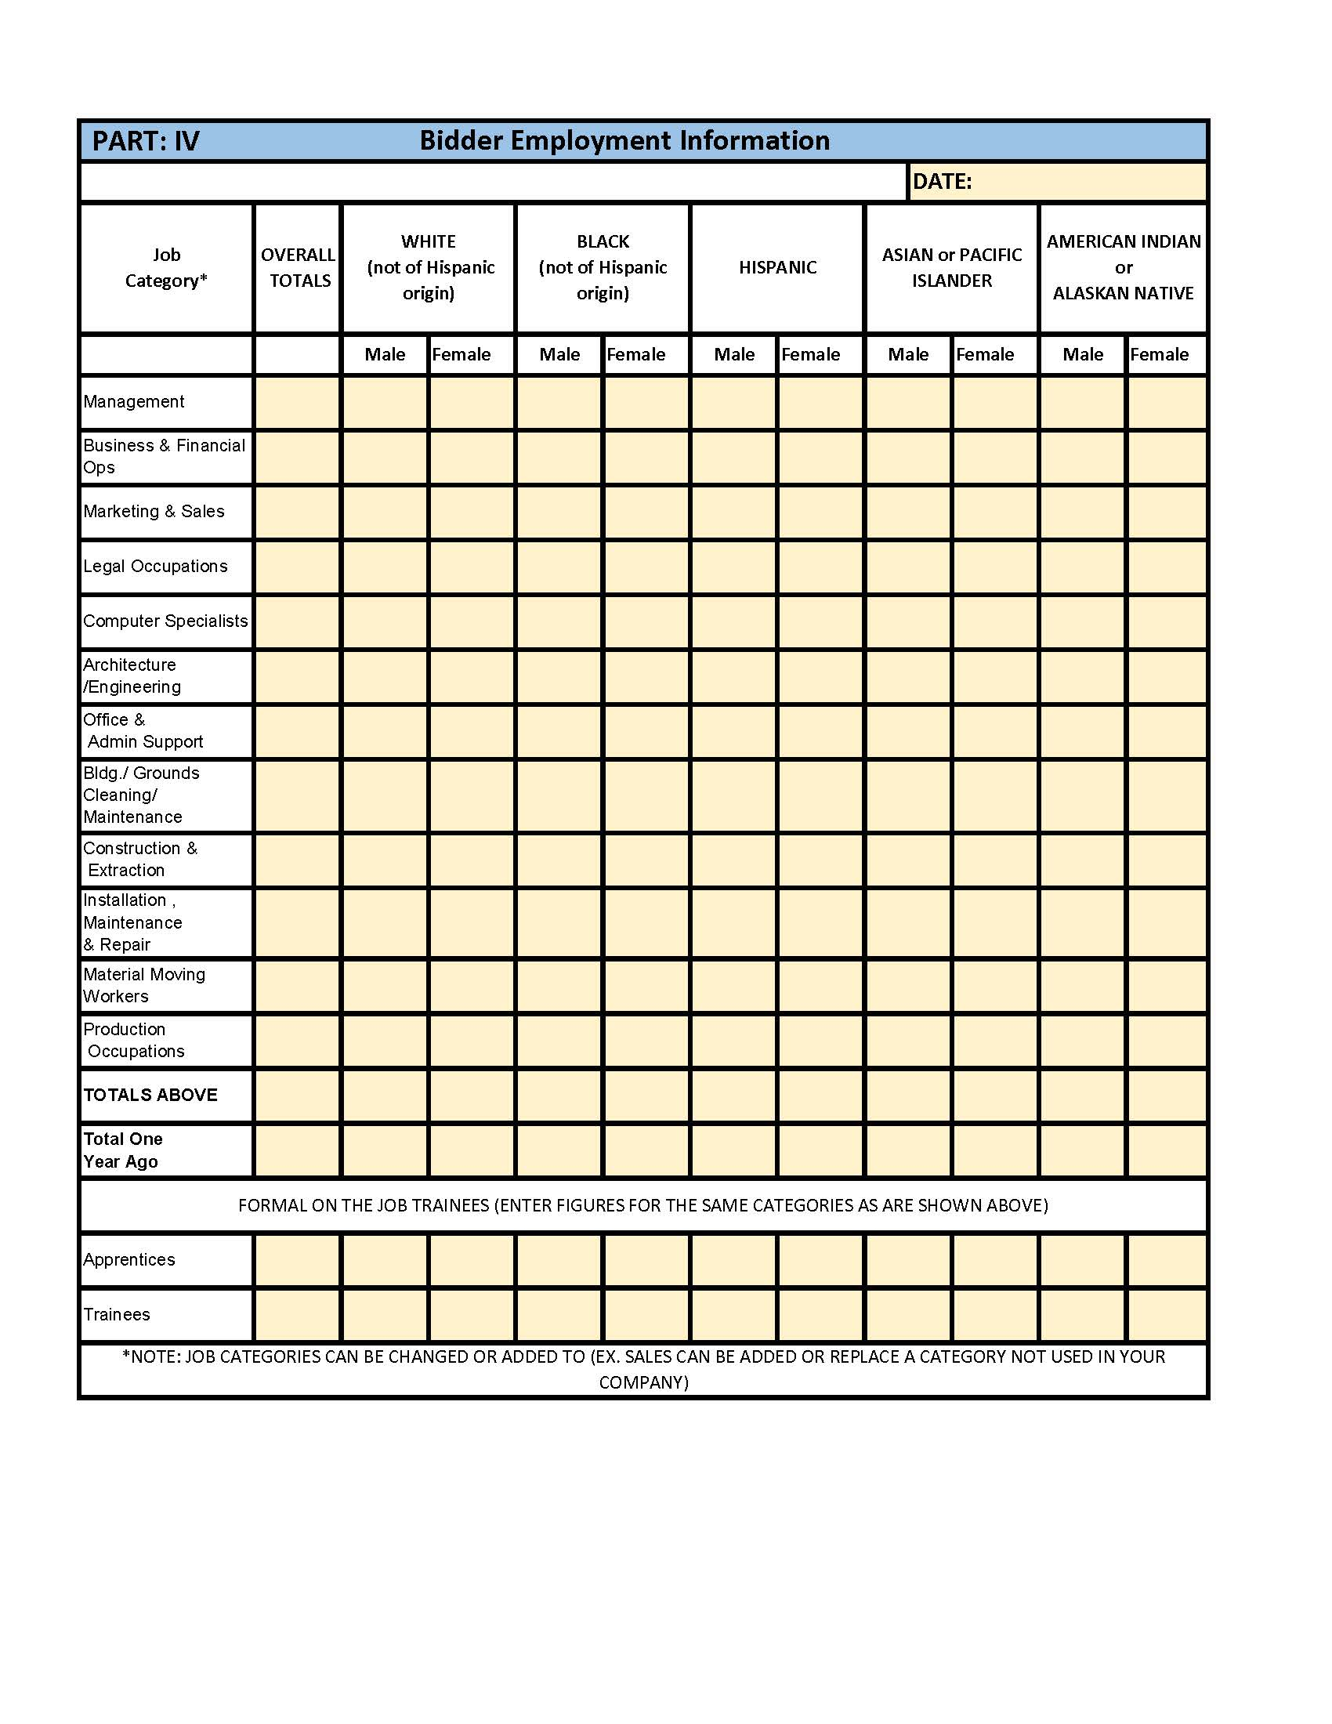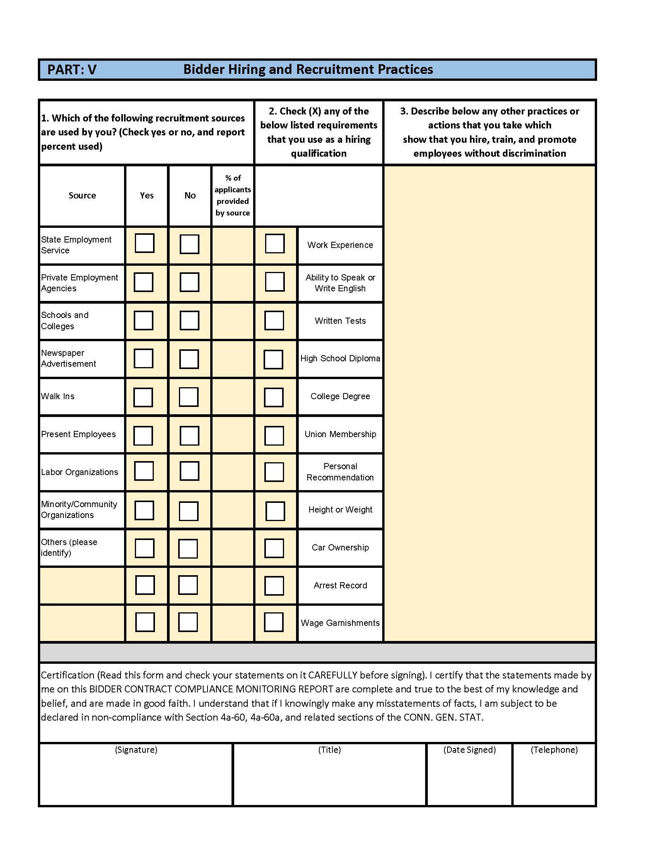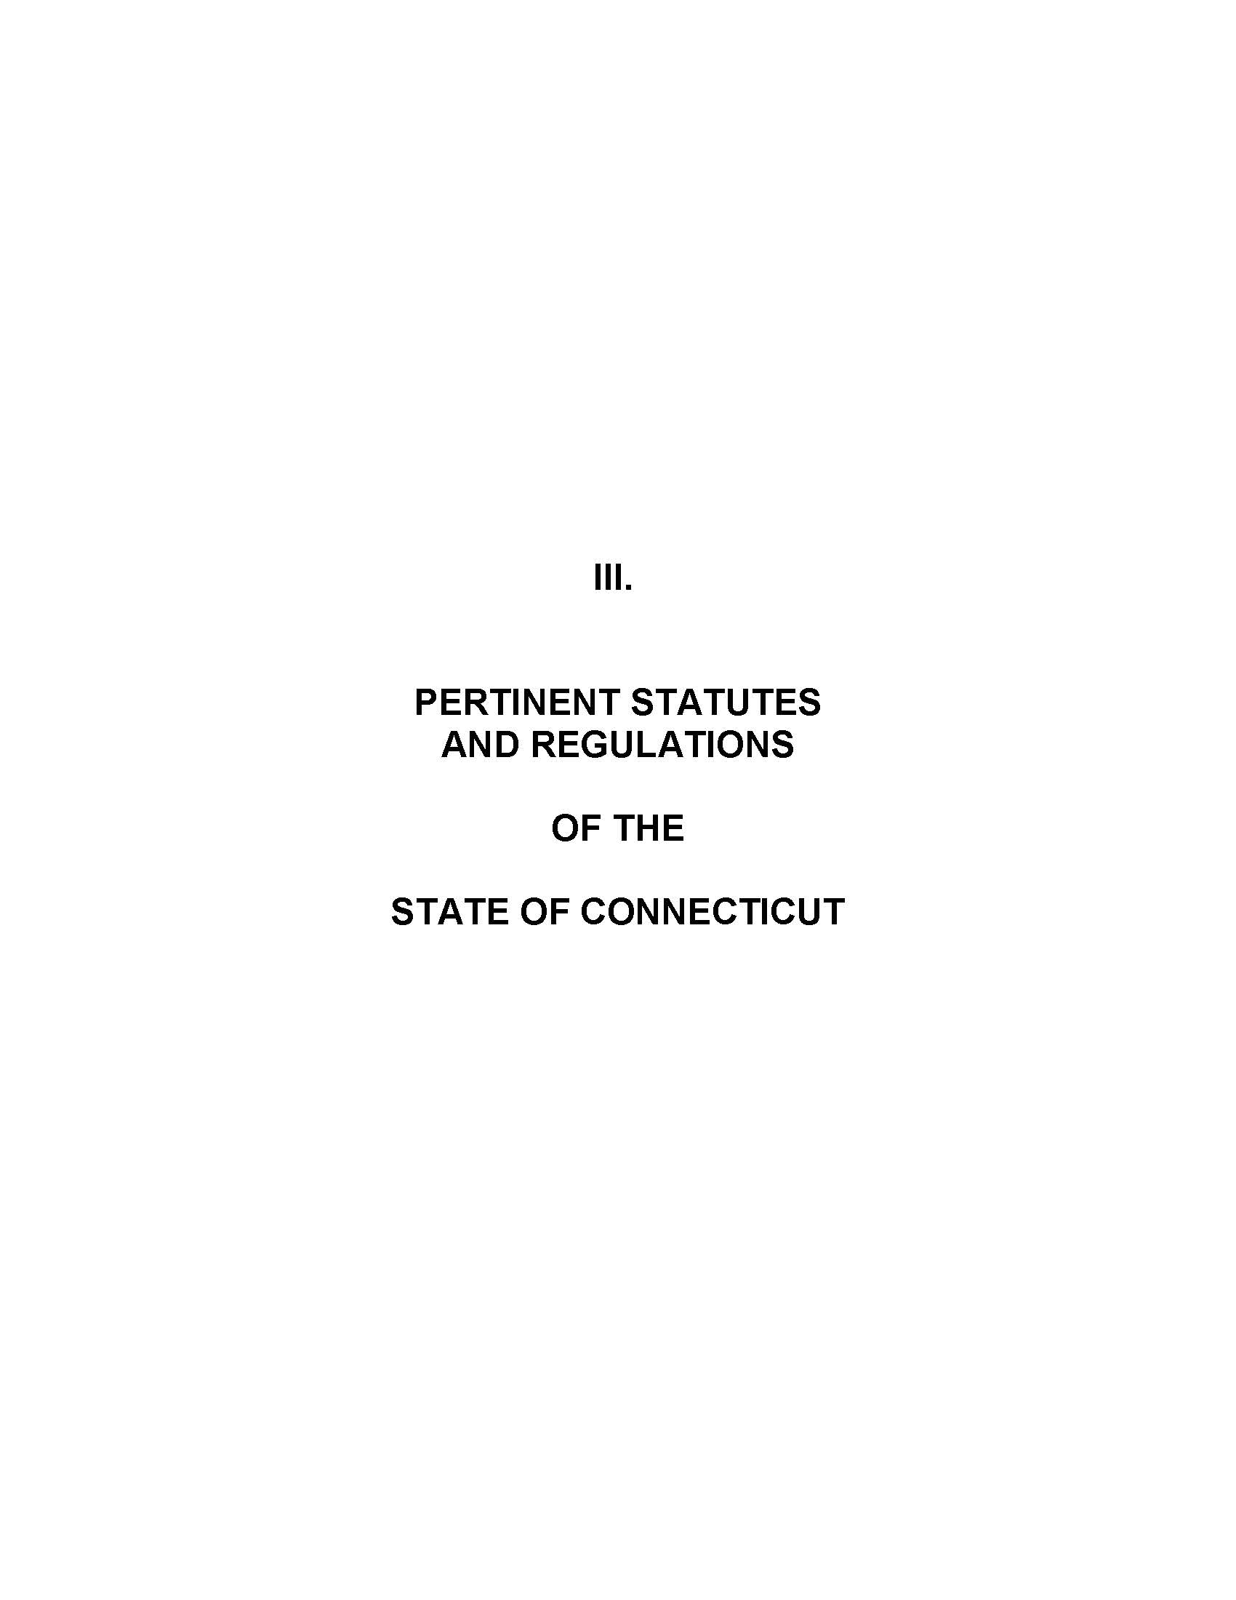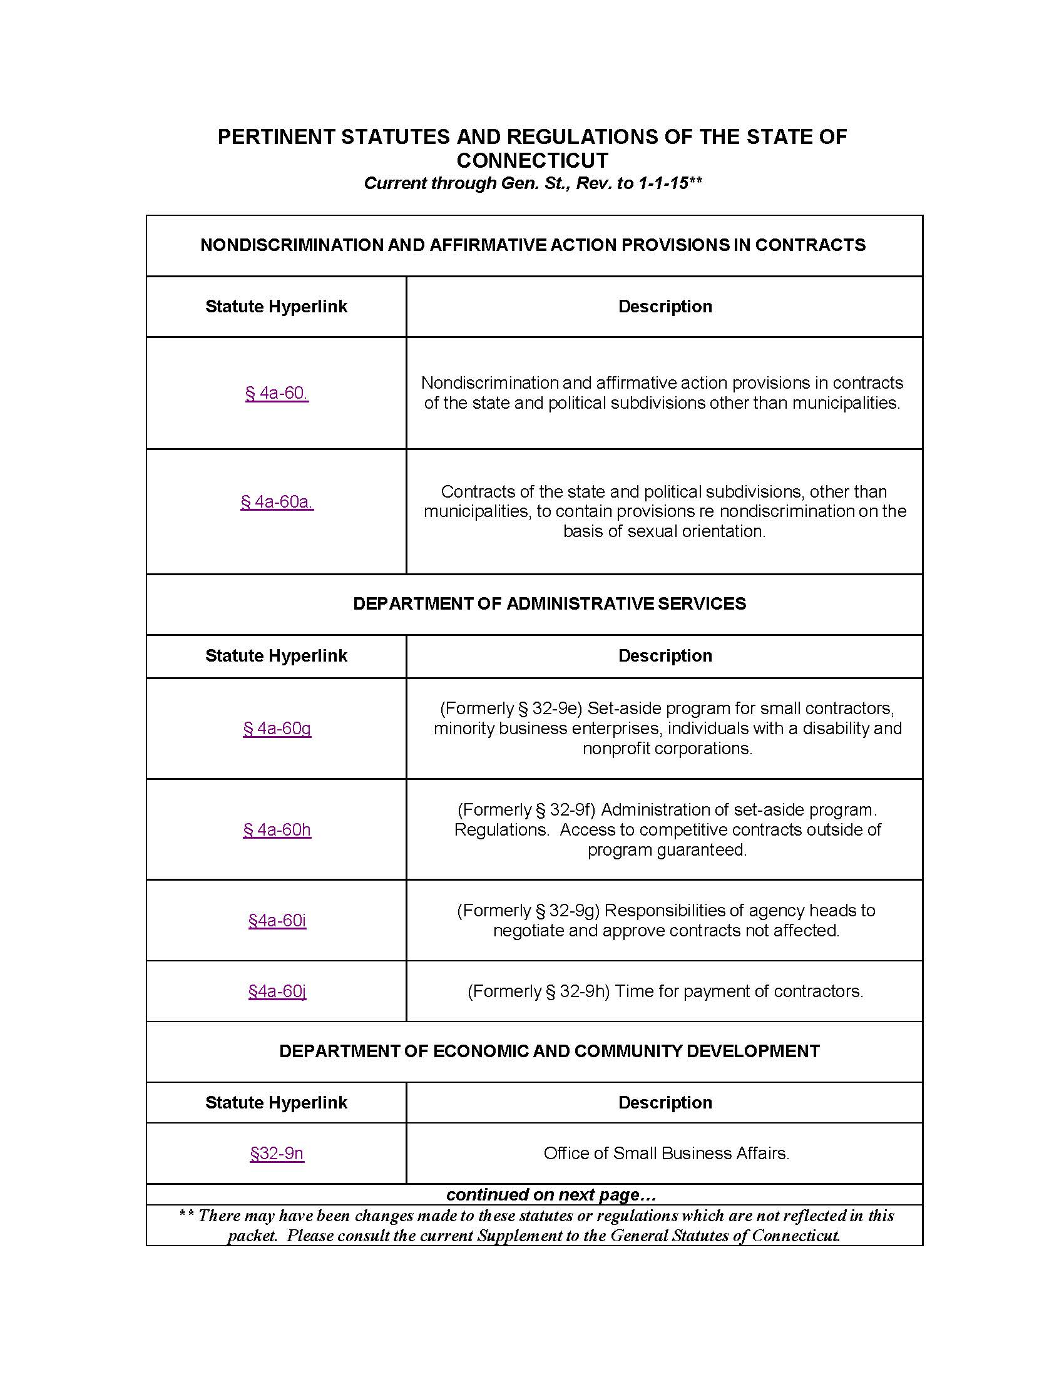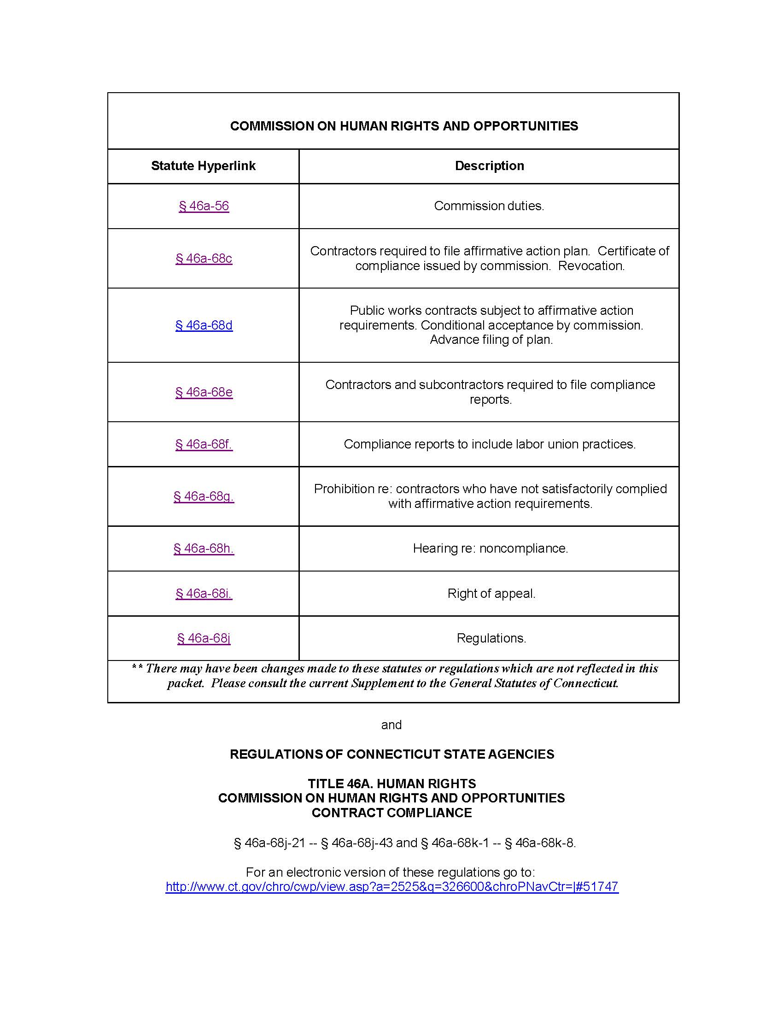

Relevant photographs: *Please note a site visit is required.
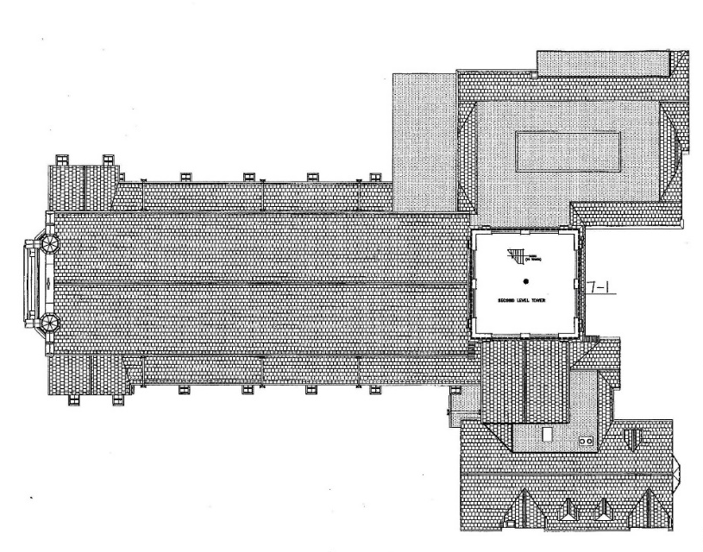

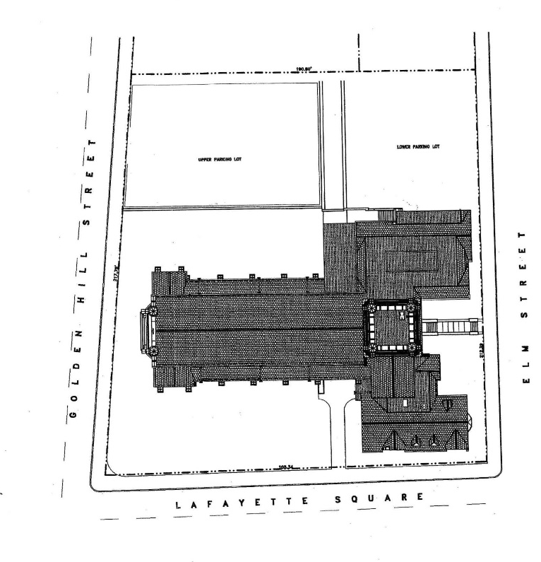

Slate roof over gym, SE
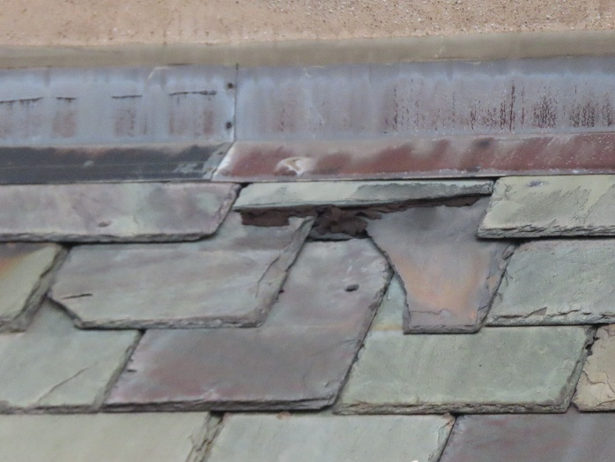
Slate Roof over gym, SE
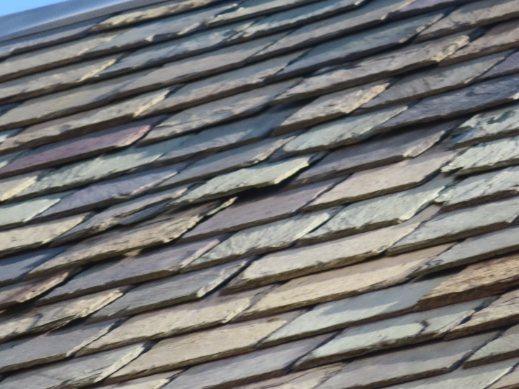

Slate roof over gym, SE

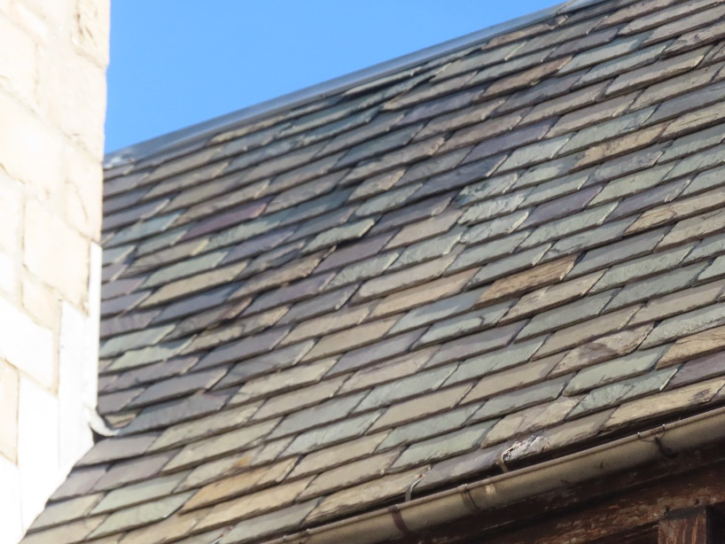

Damaged area below window above bay window in NW parish house
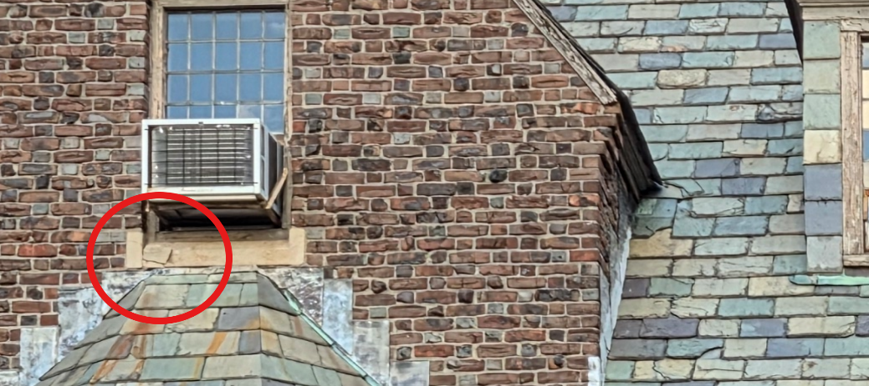

Small buttress, north face, parish house
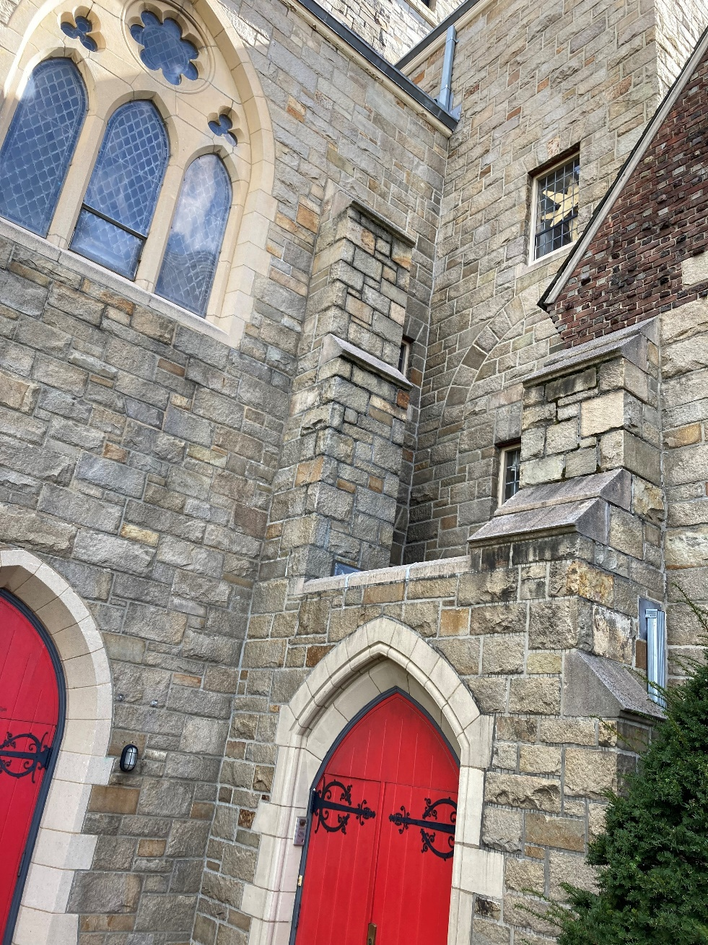

WEST SIDE BUTTRESSES (THIS AND NEXT TWO PHOTOS)
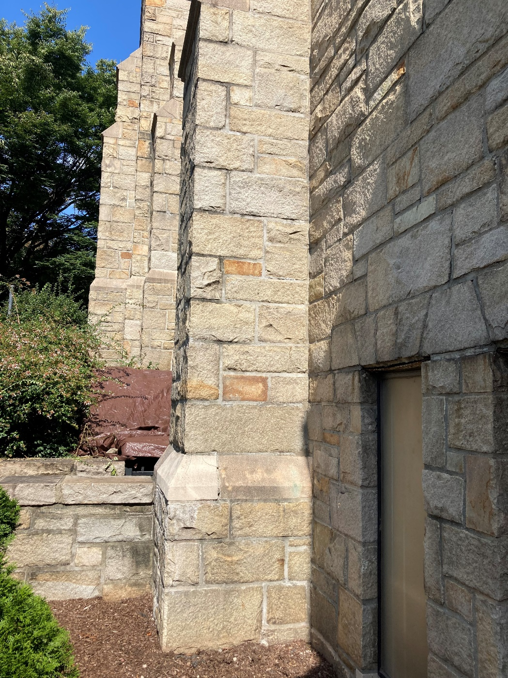

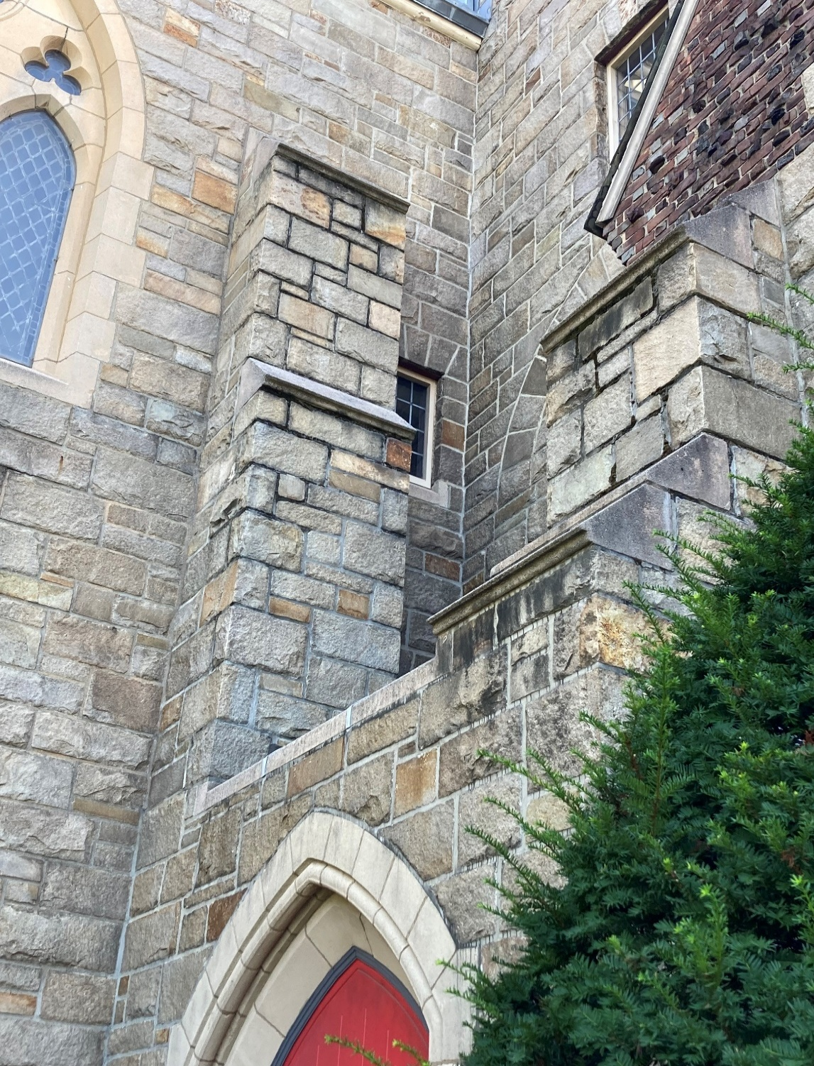

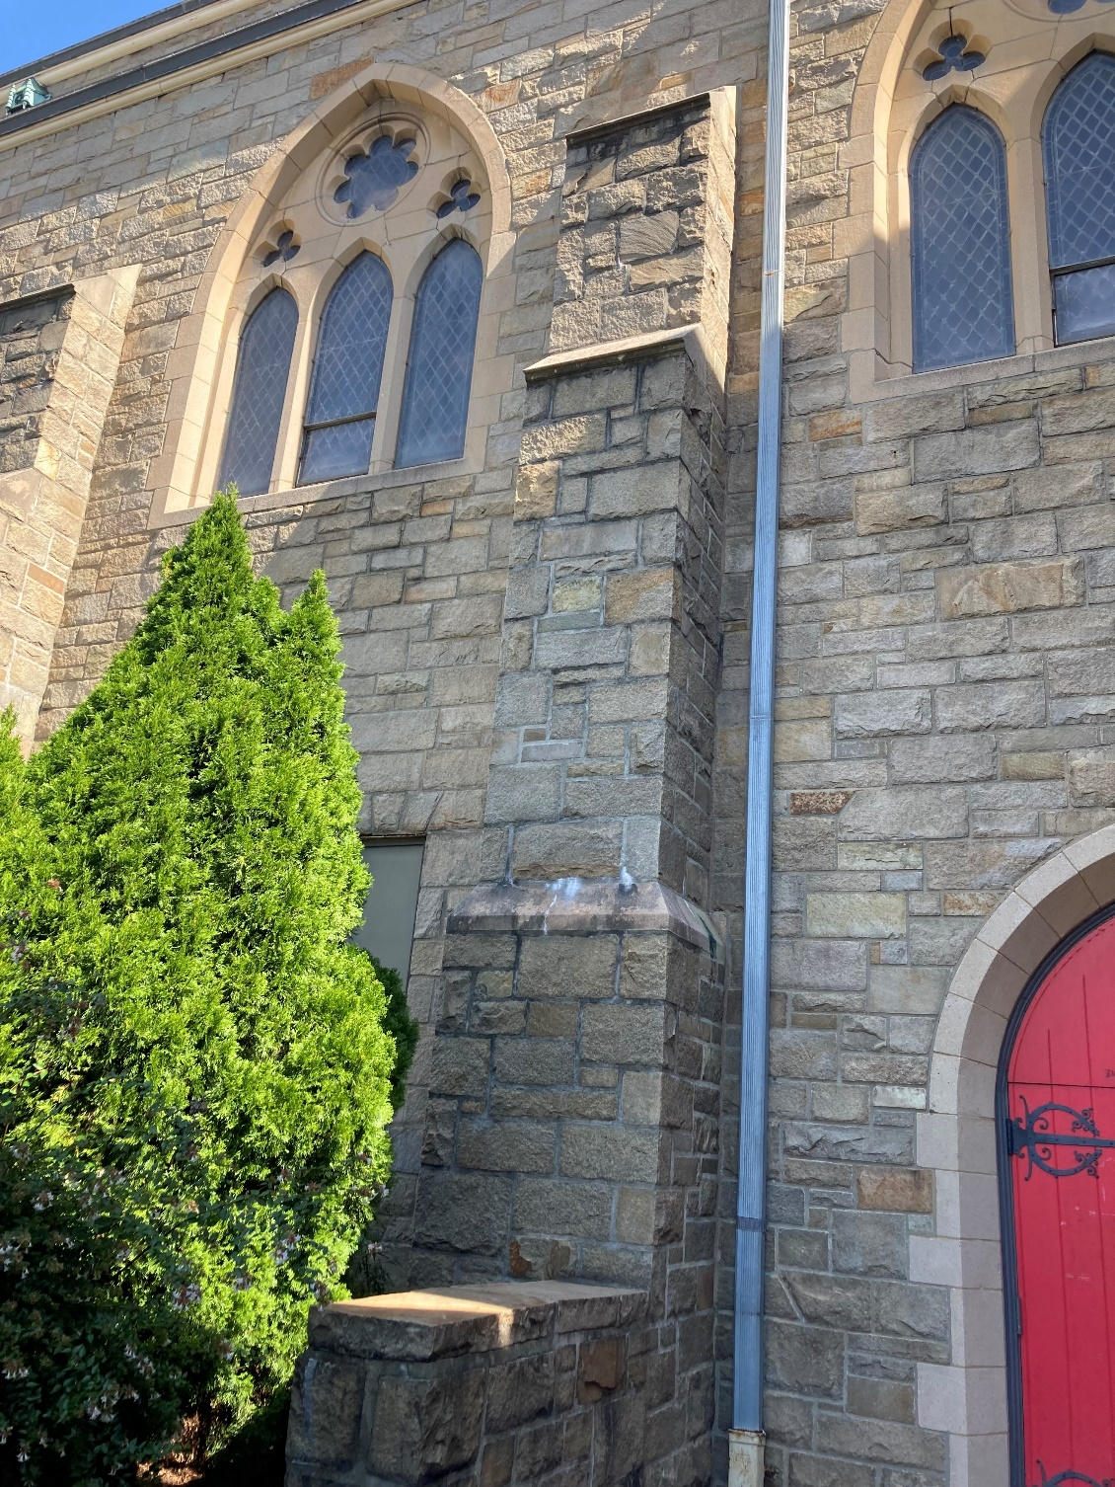
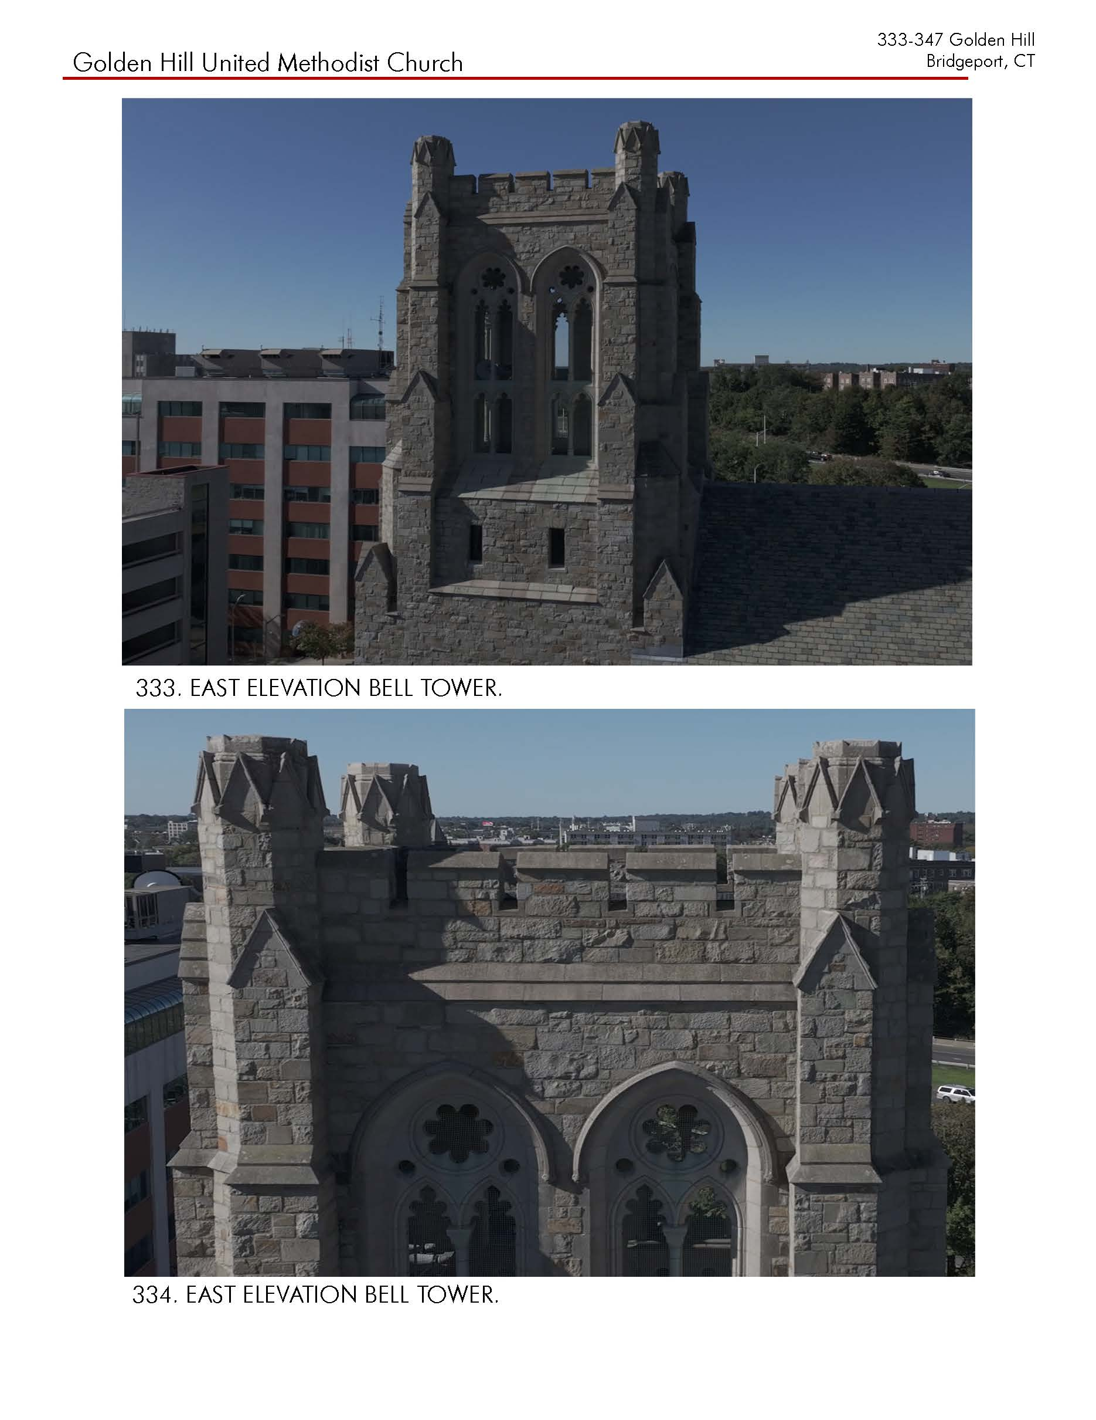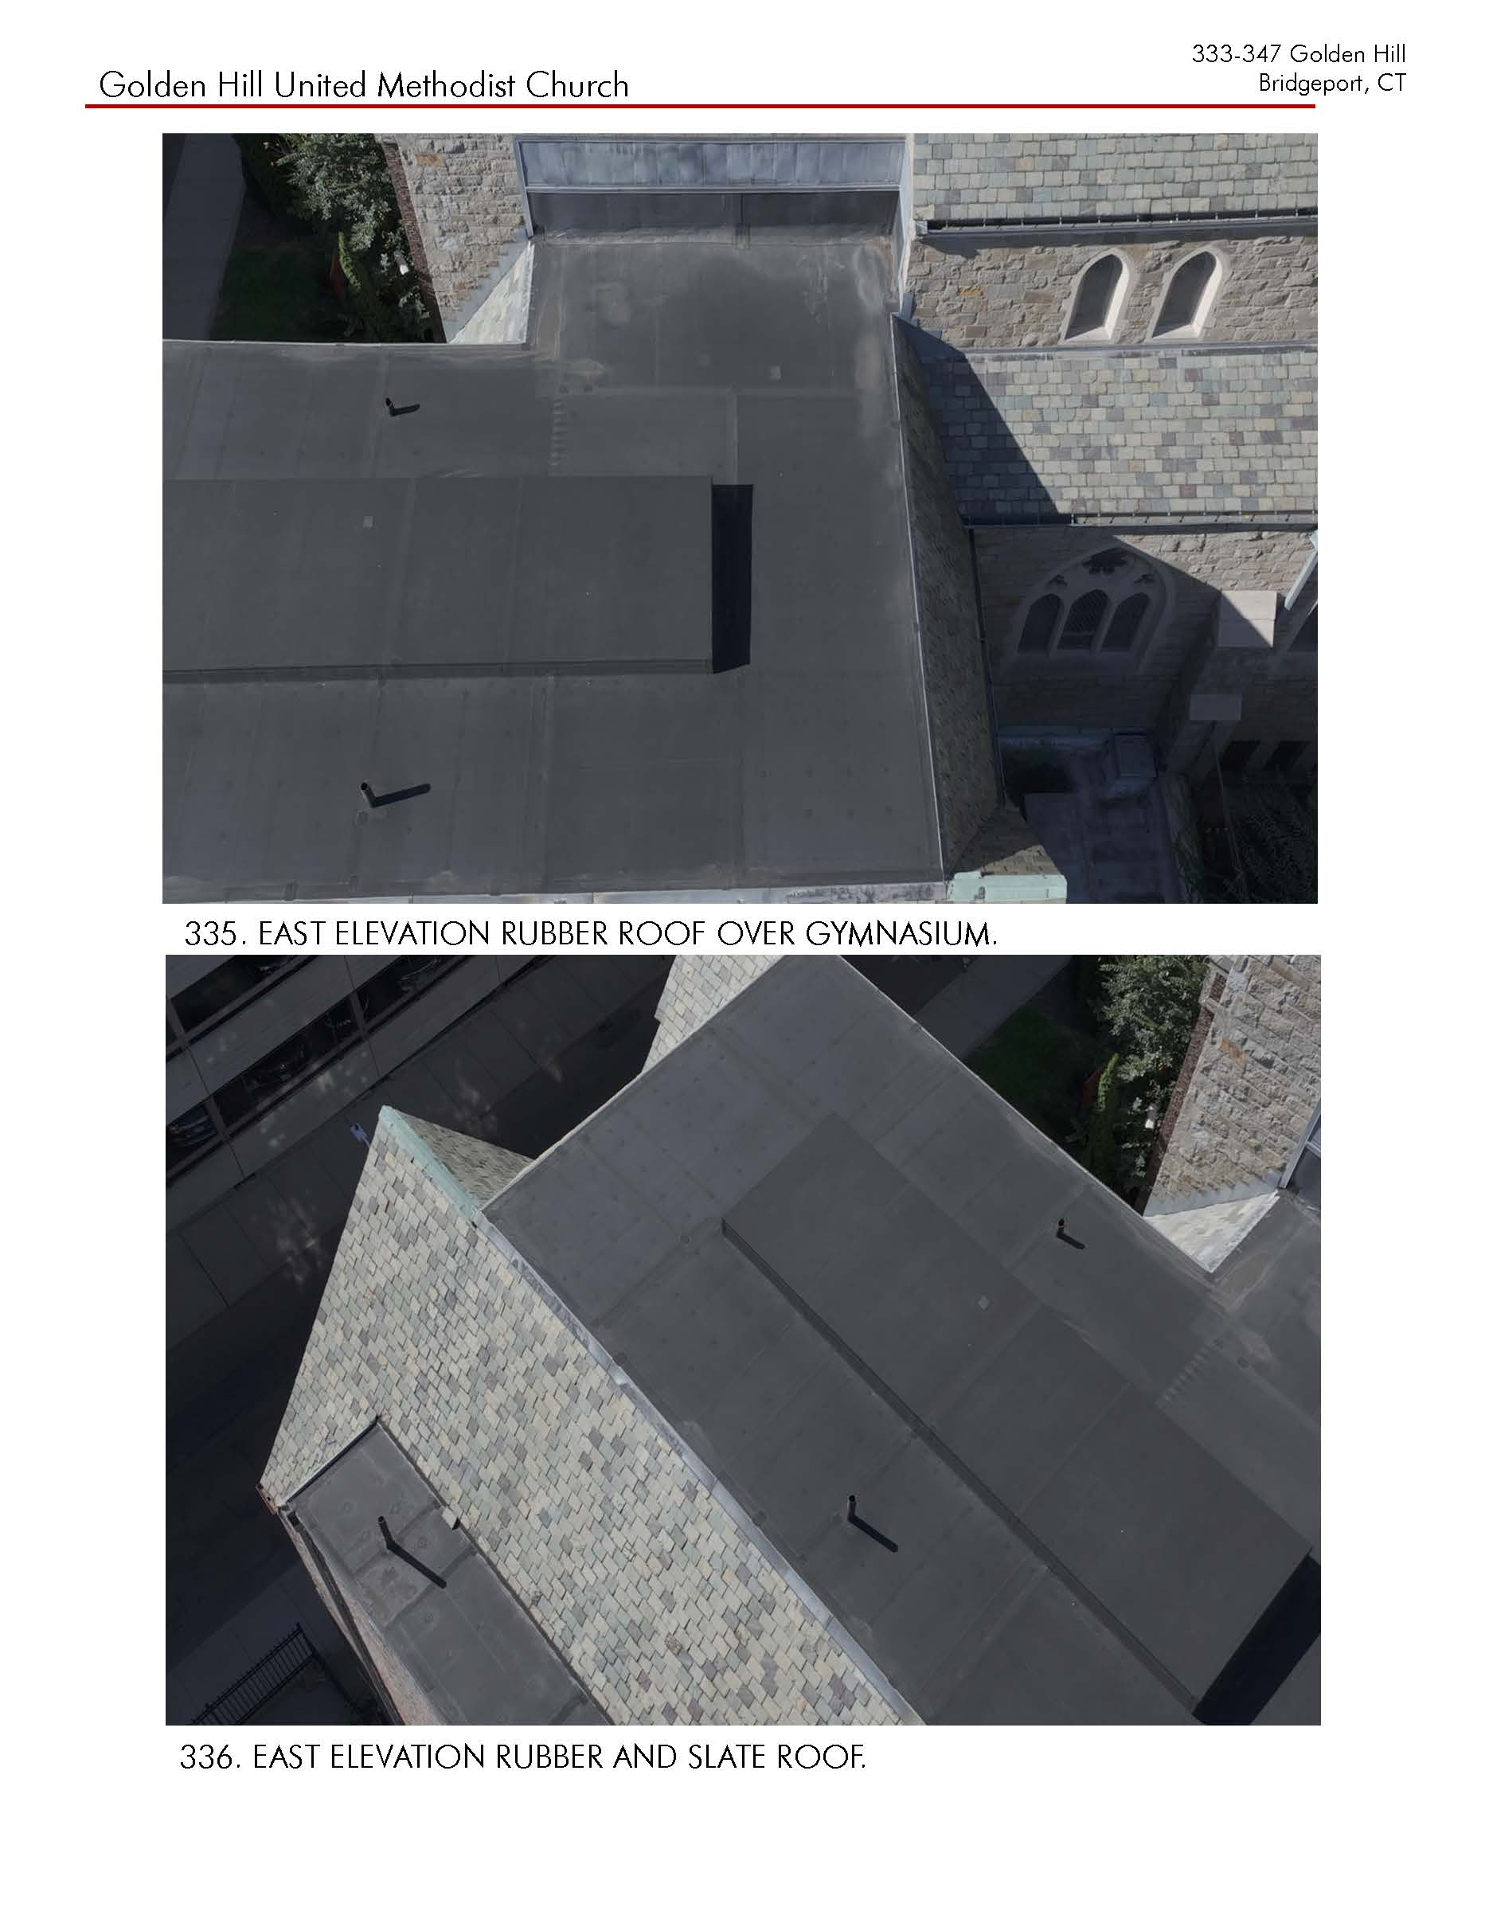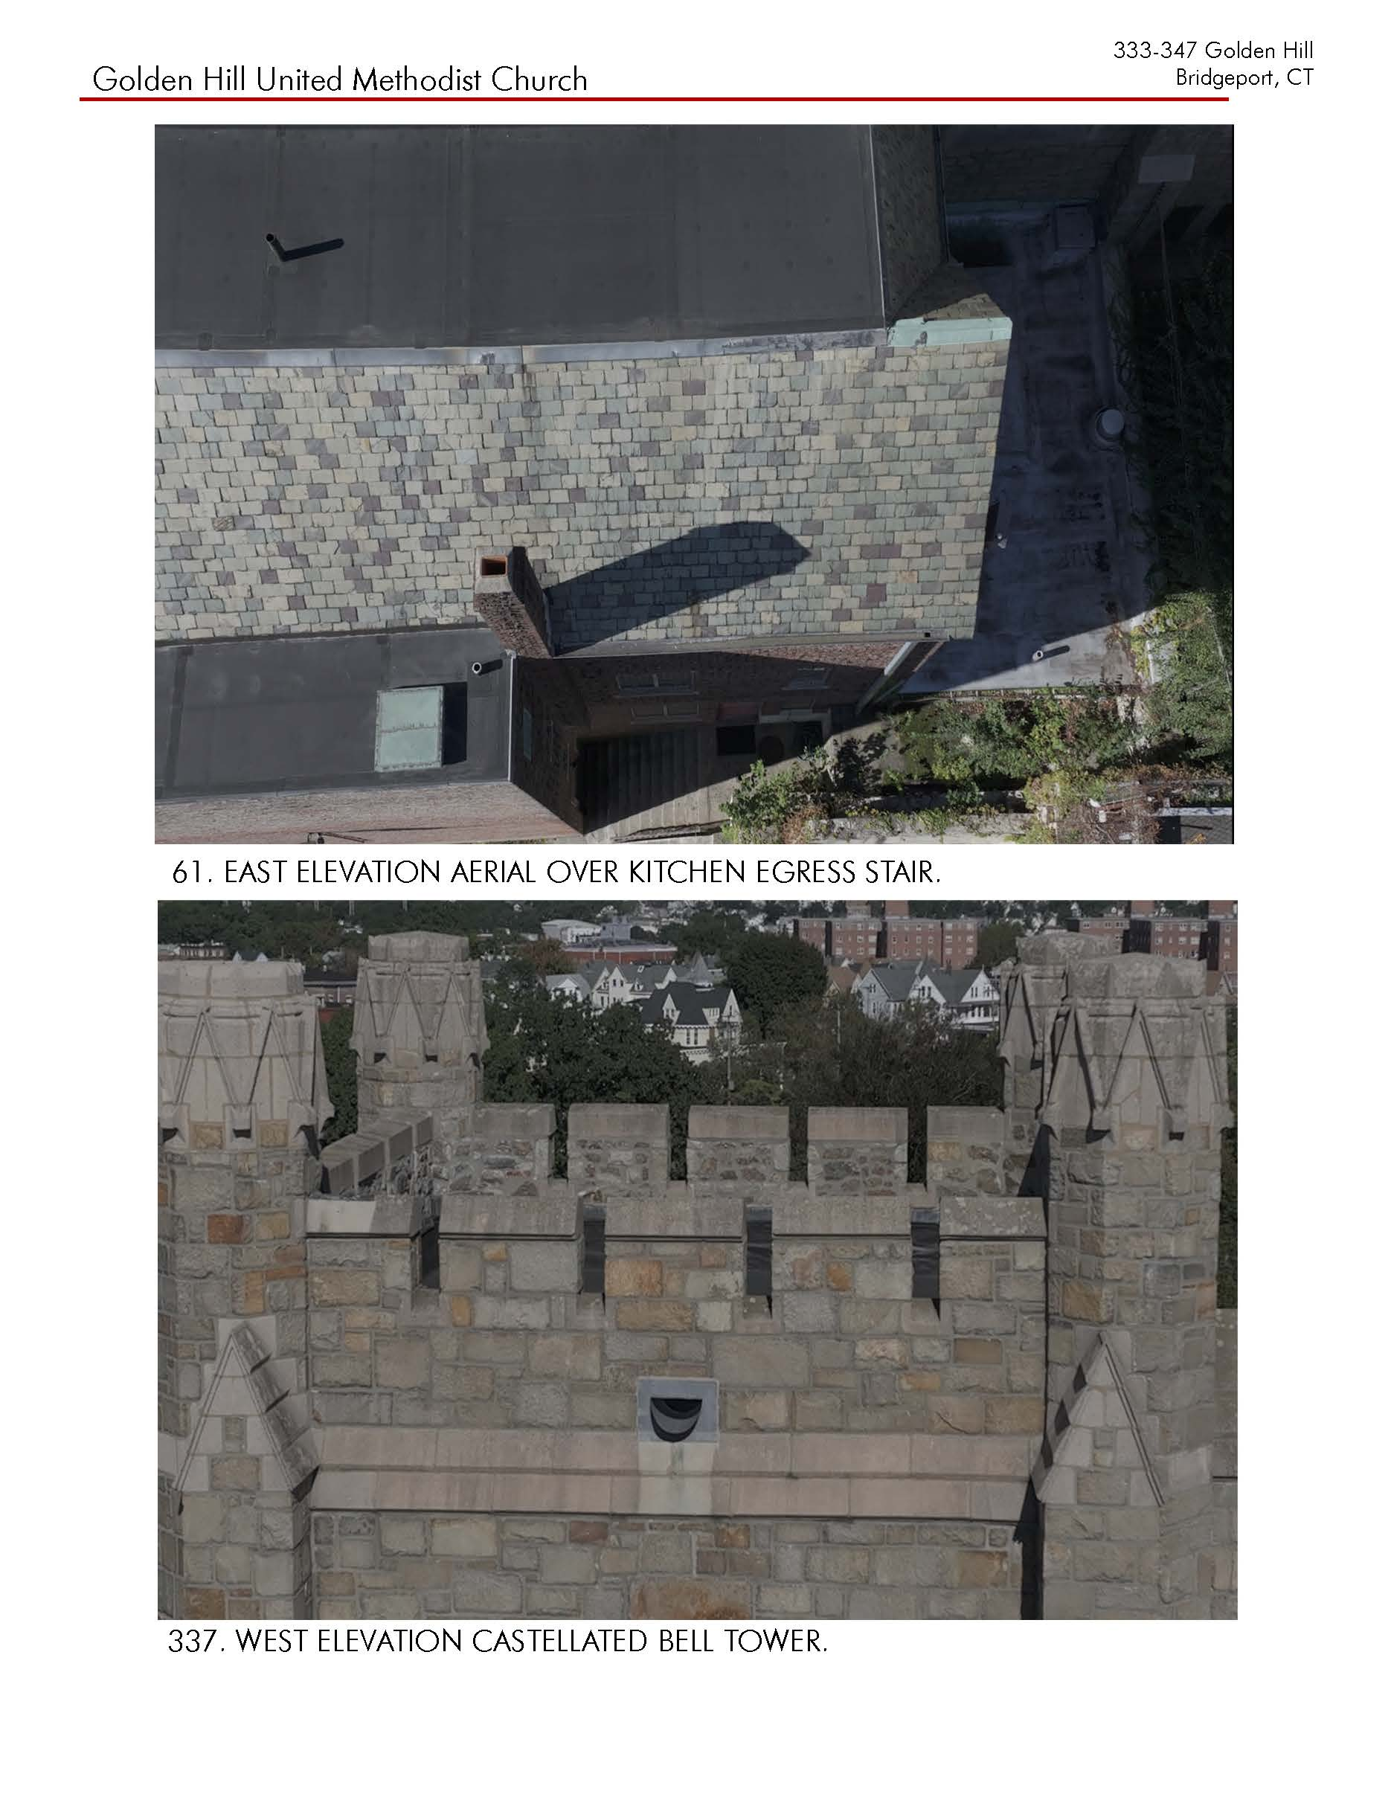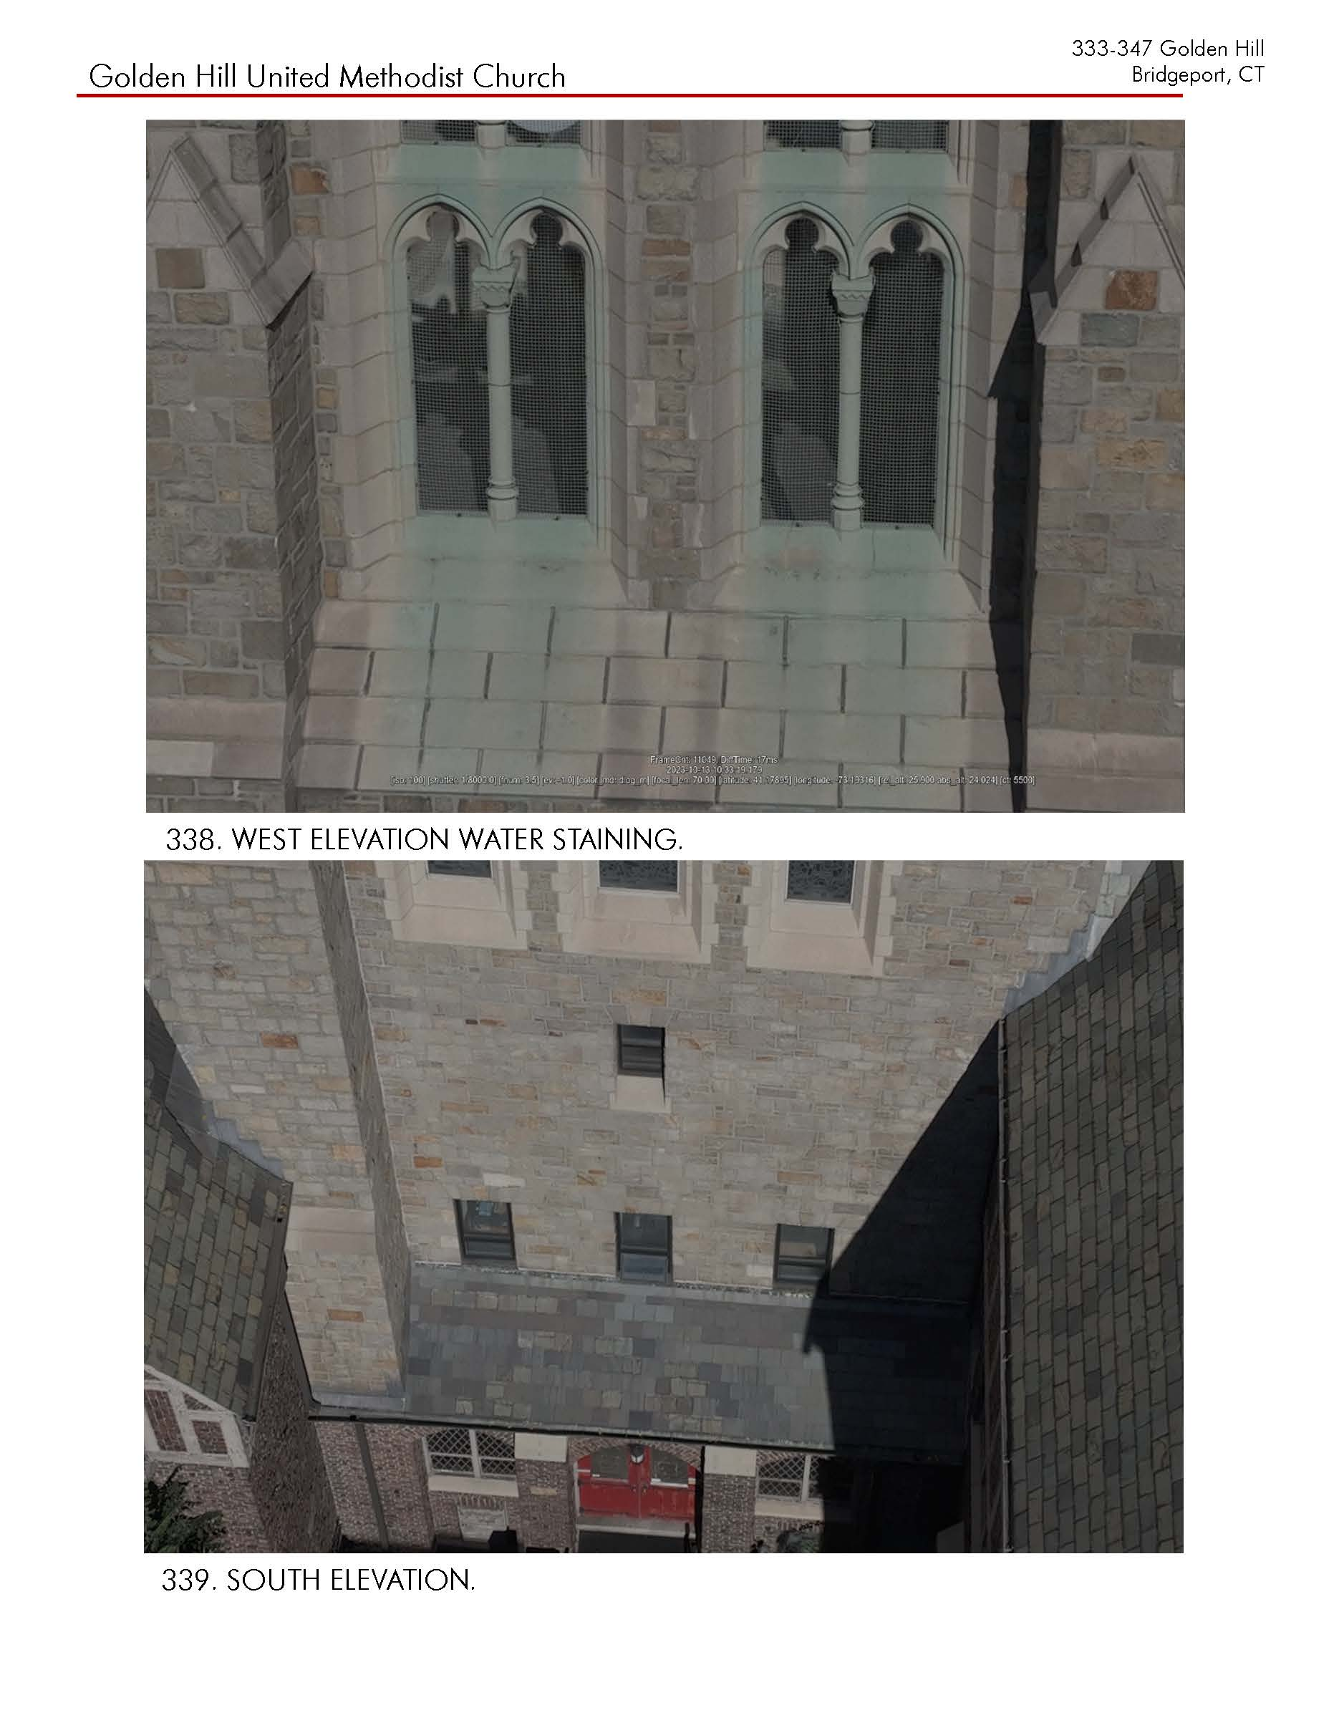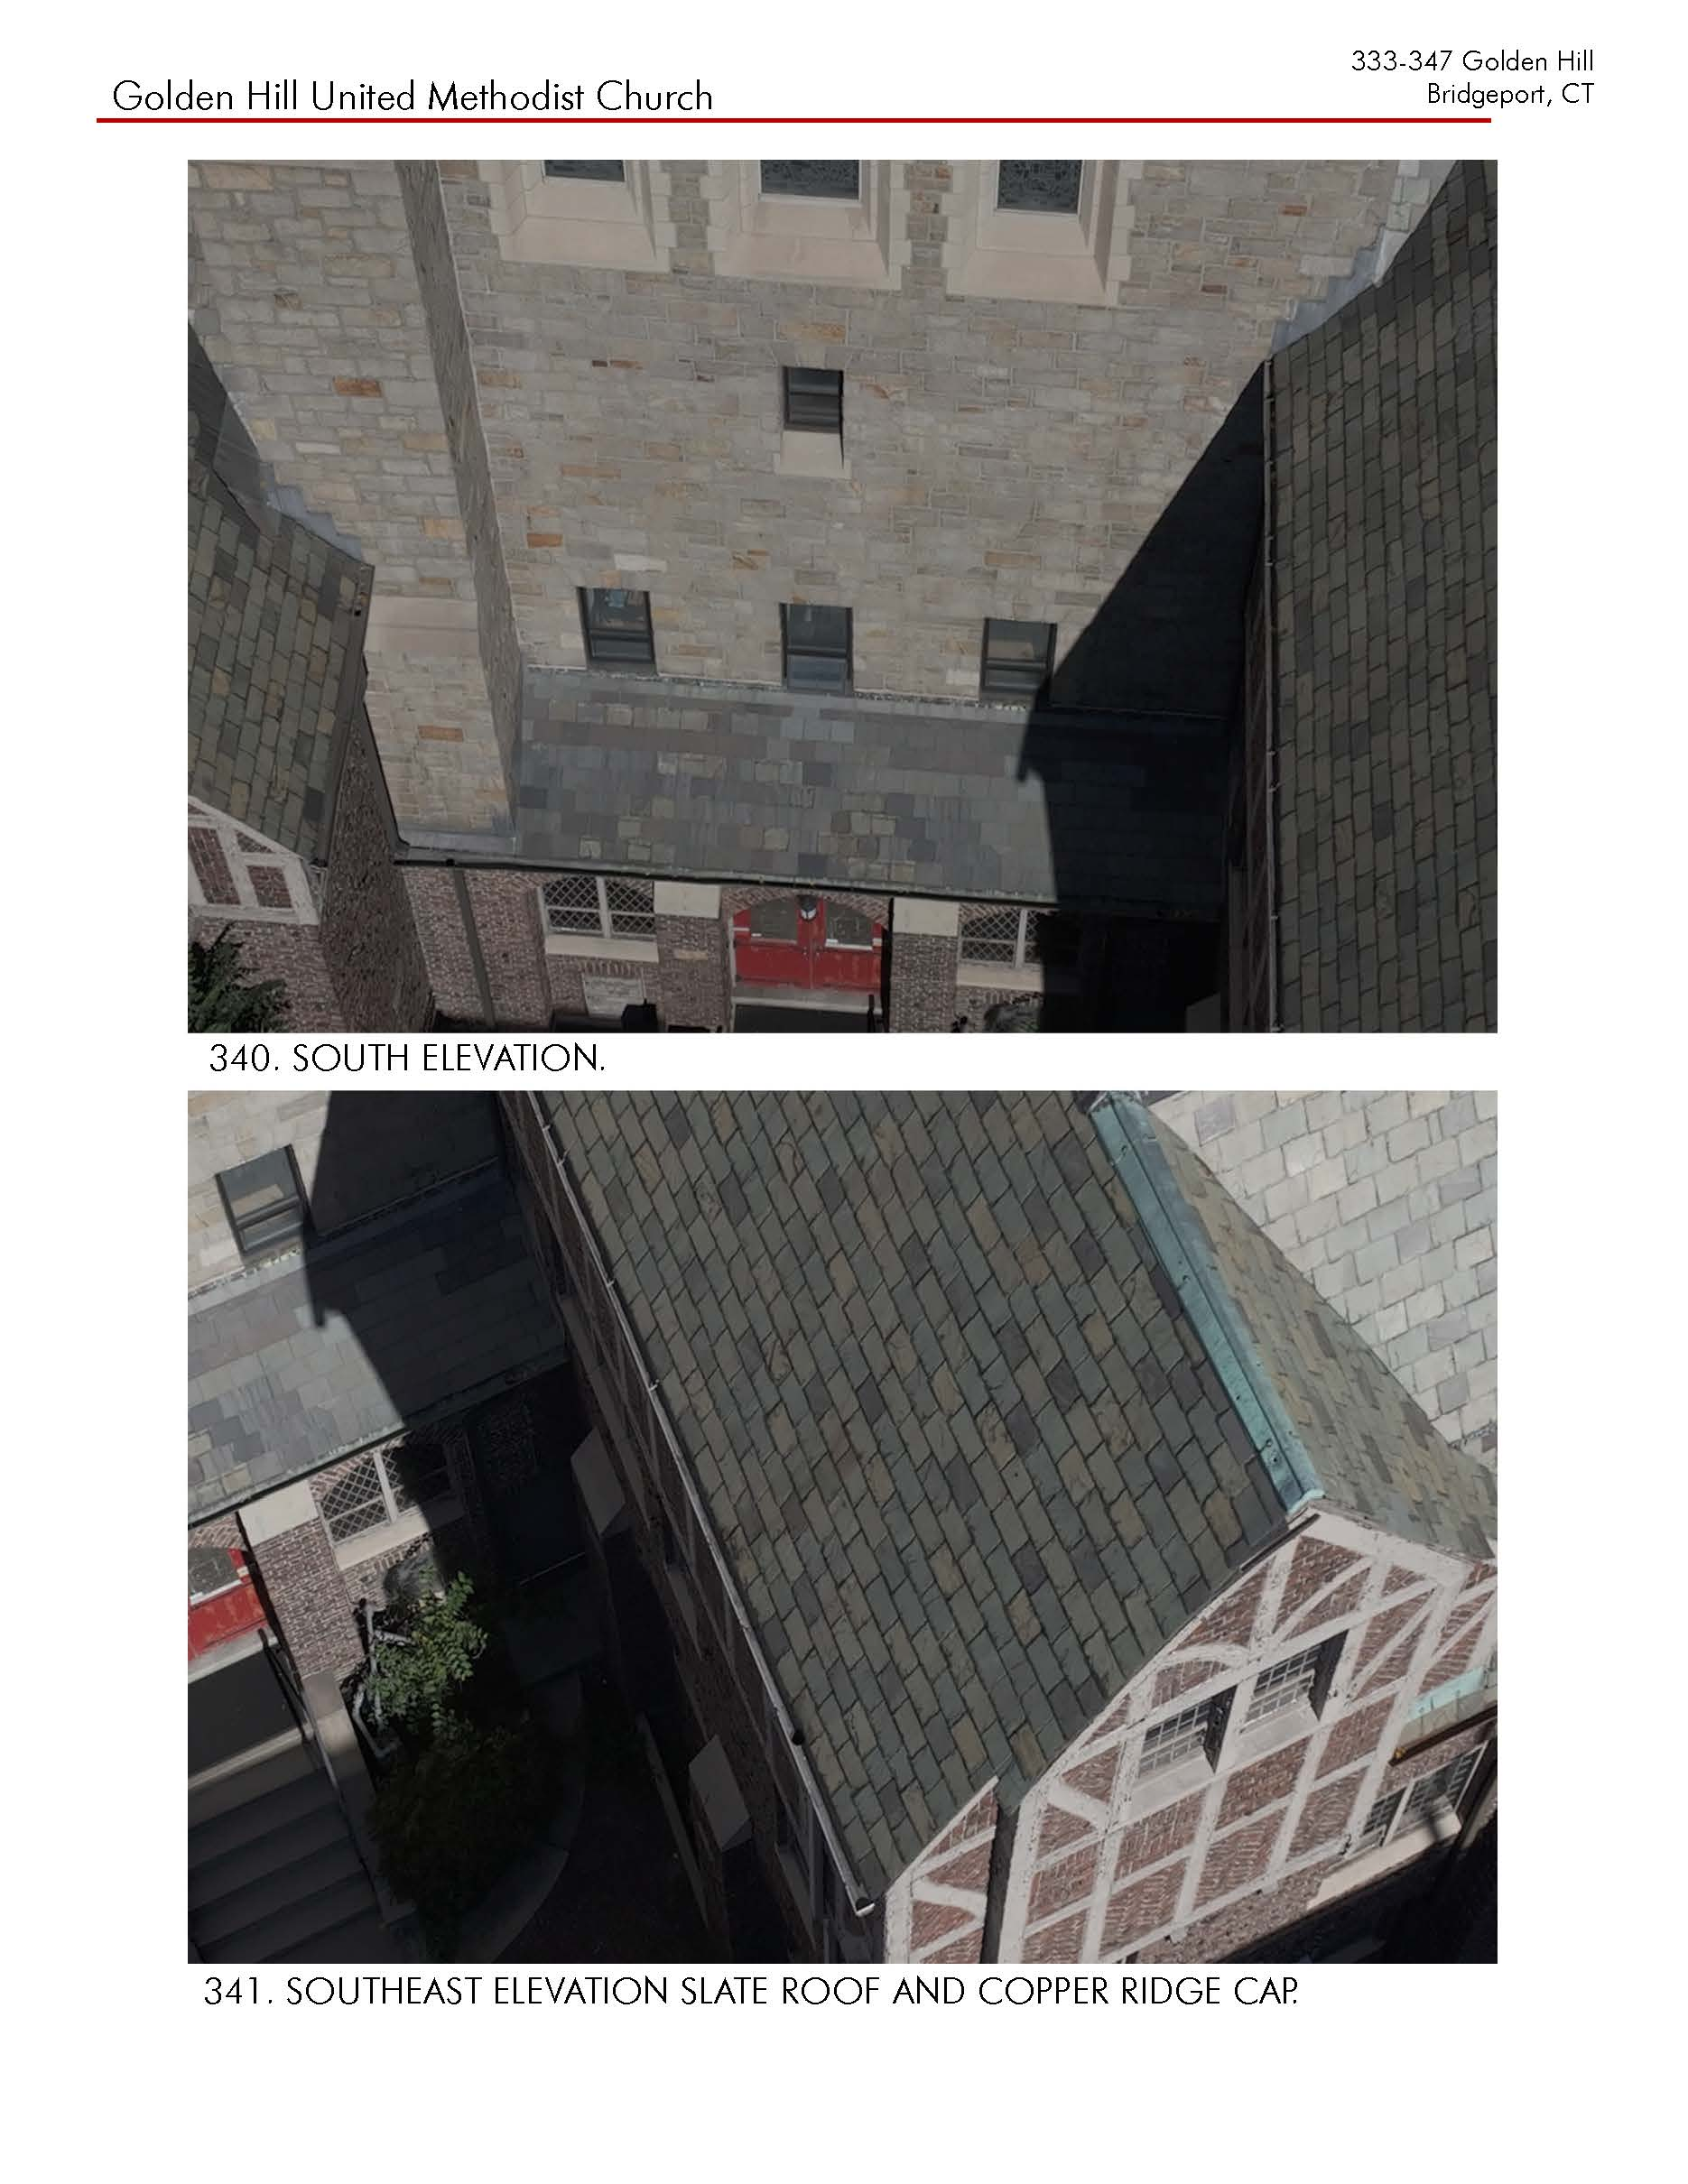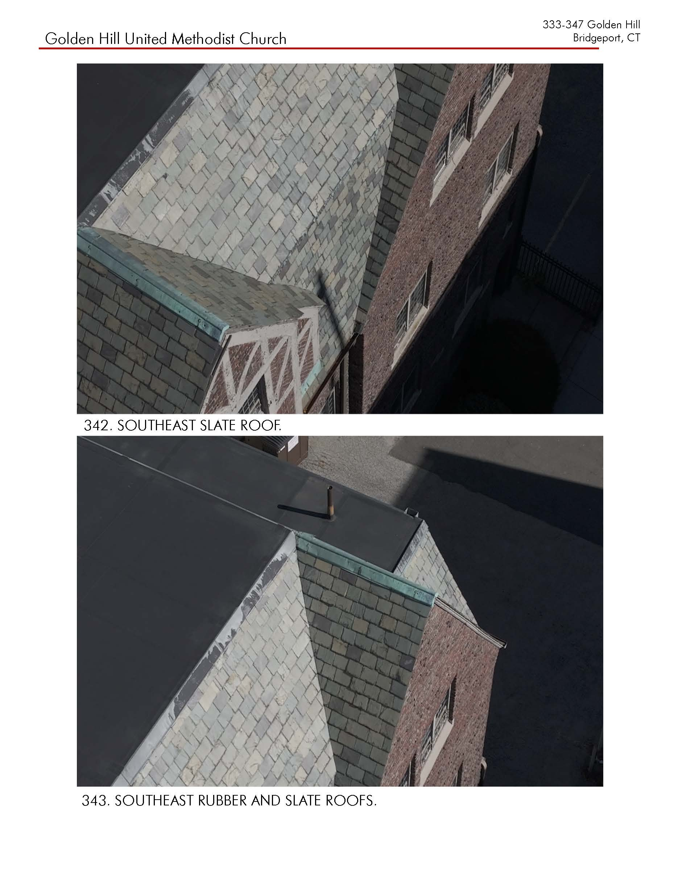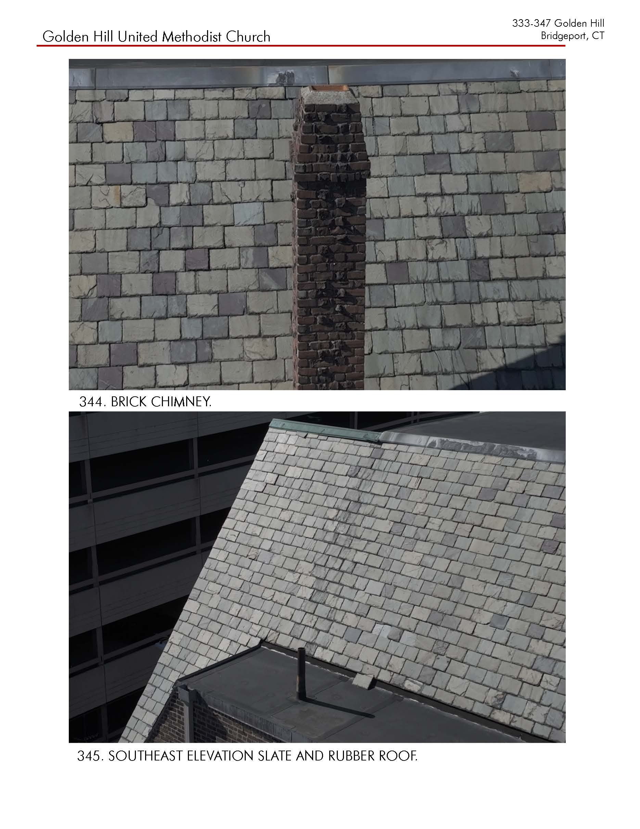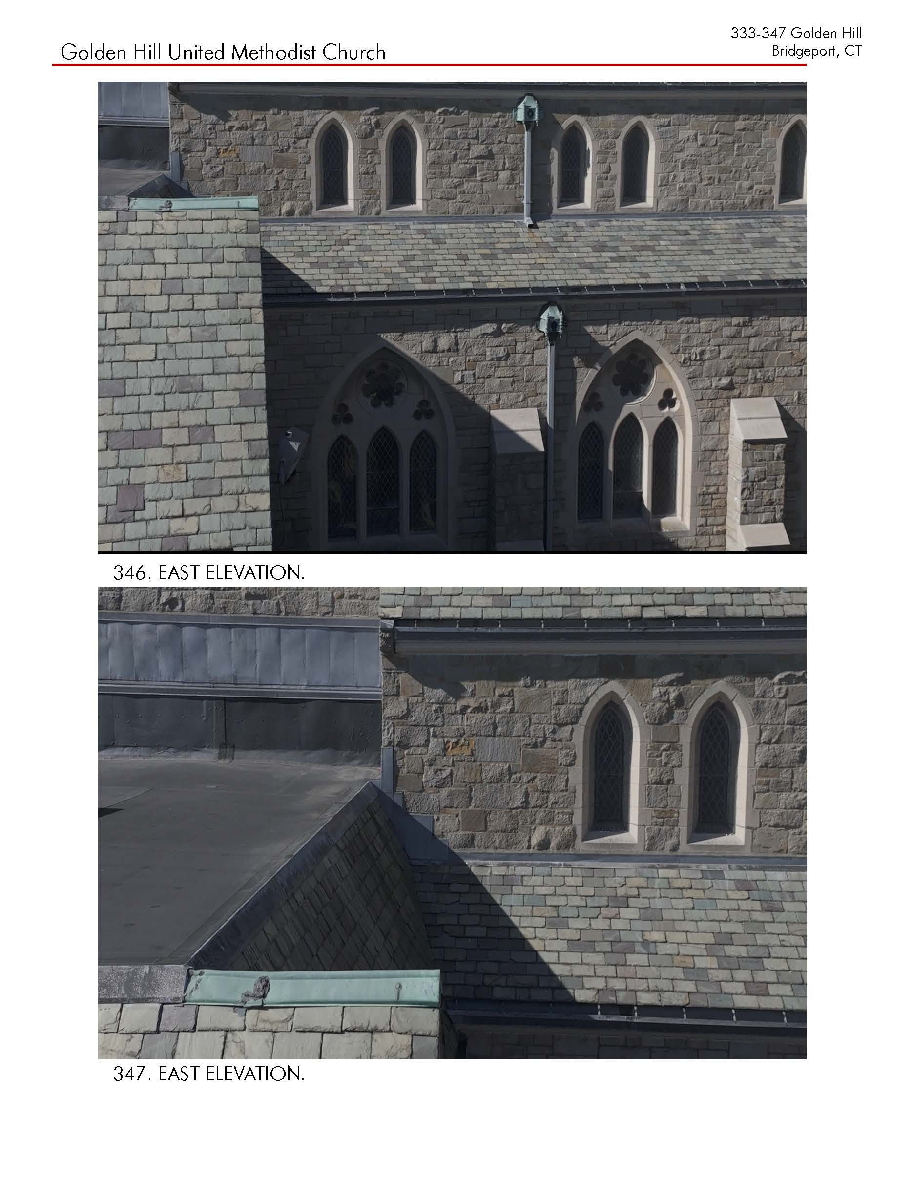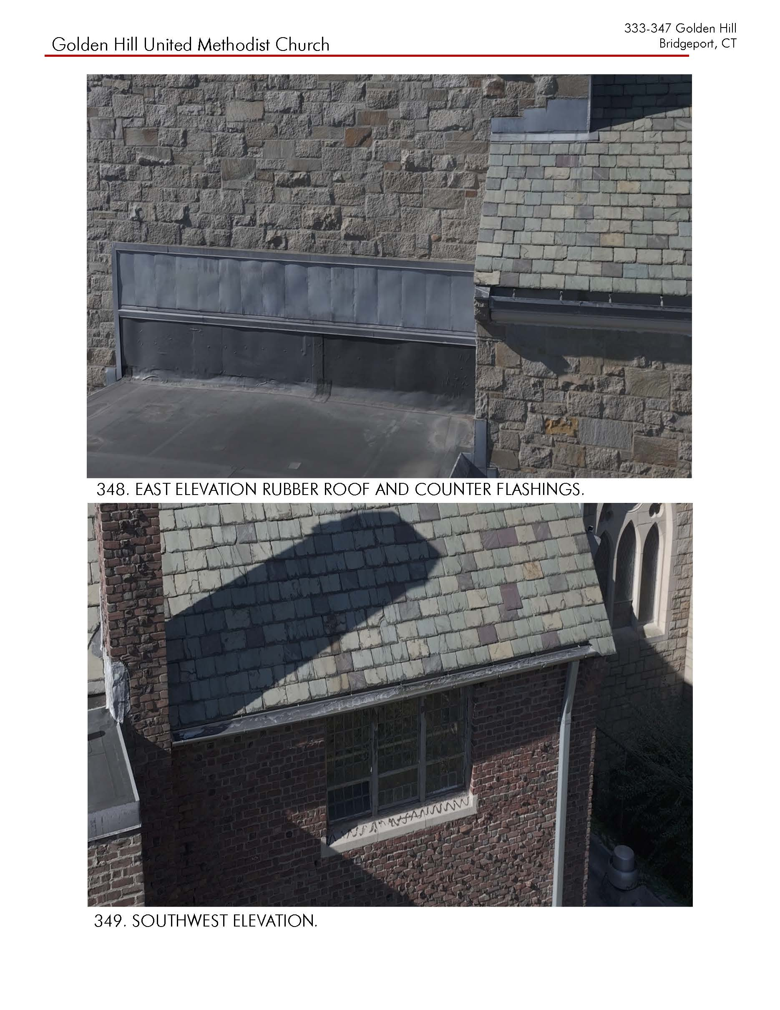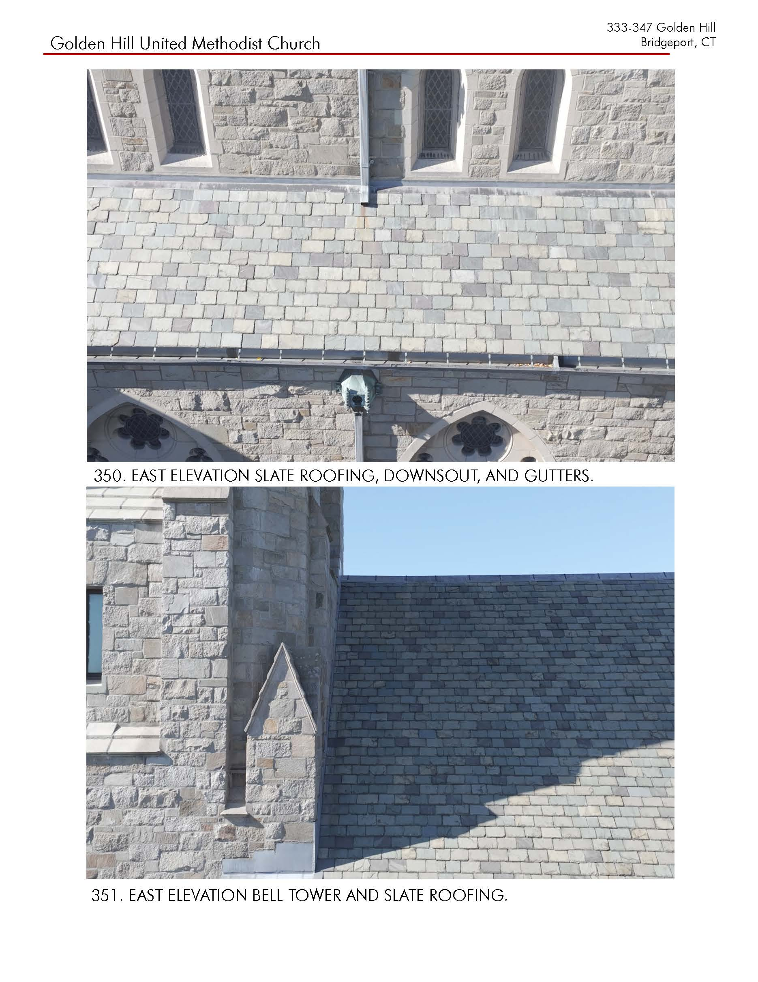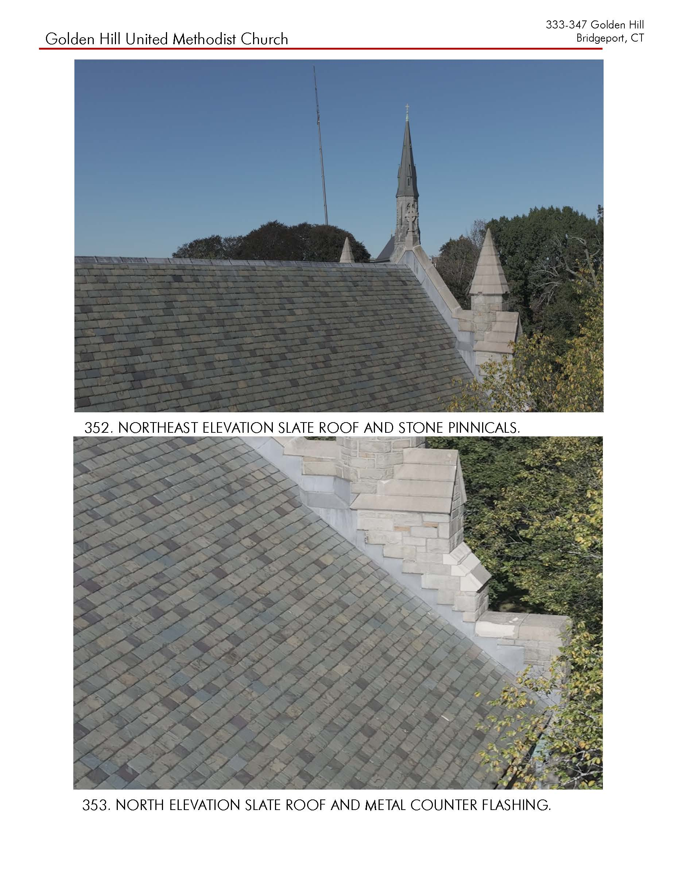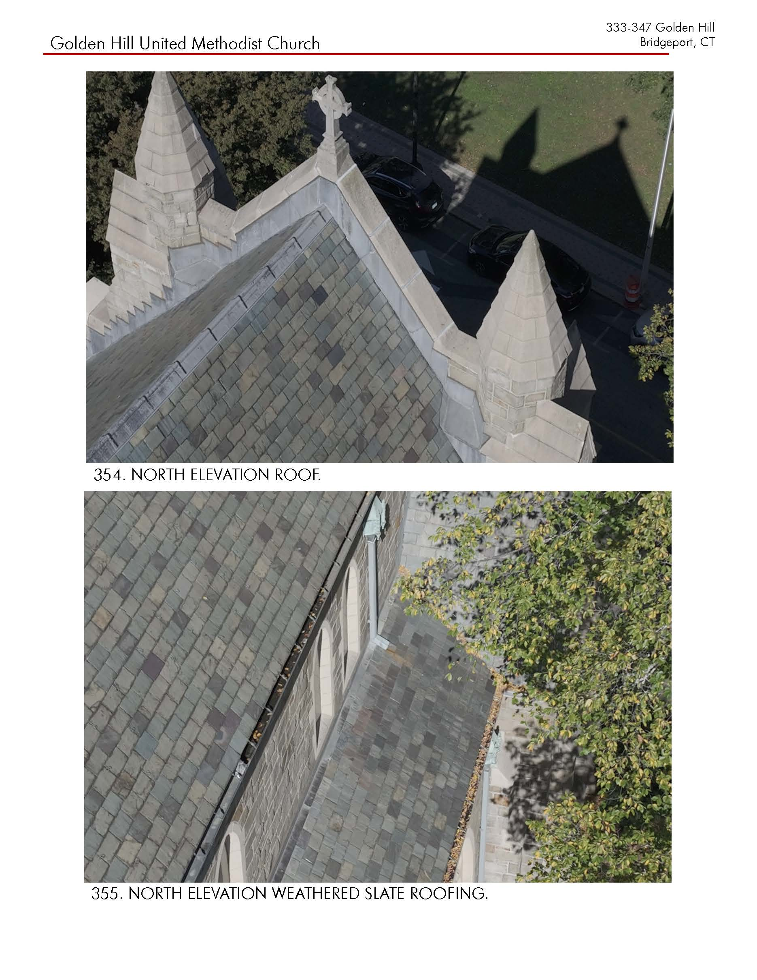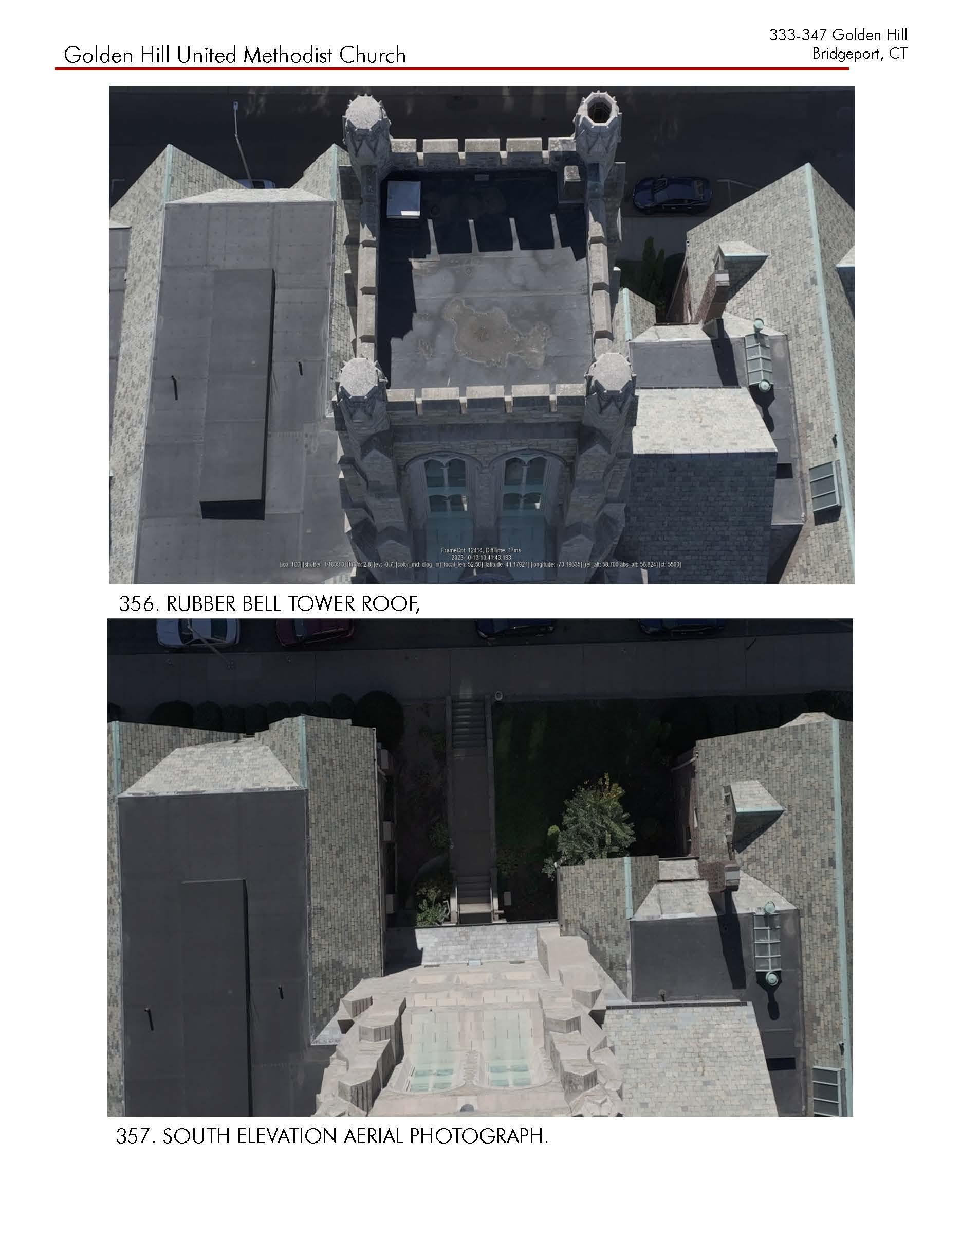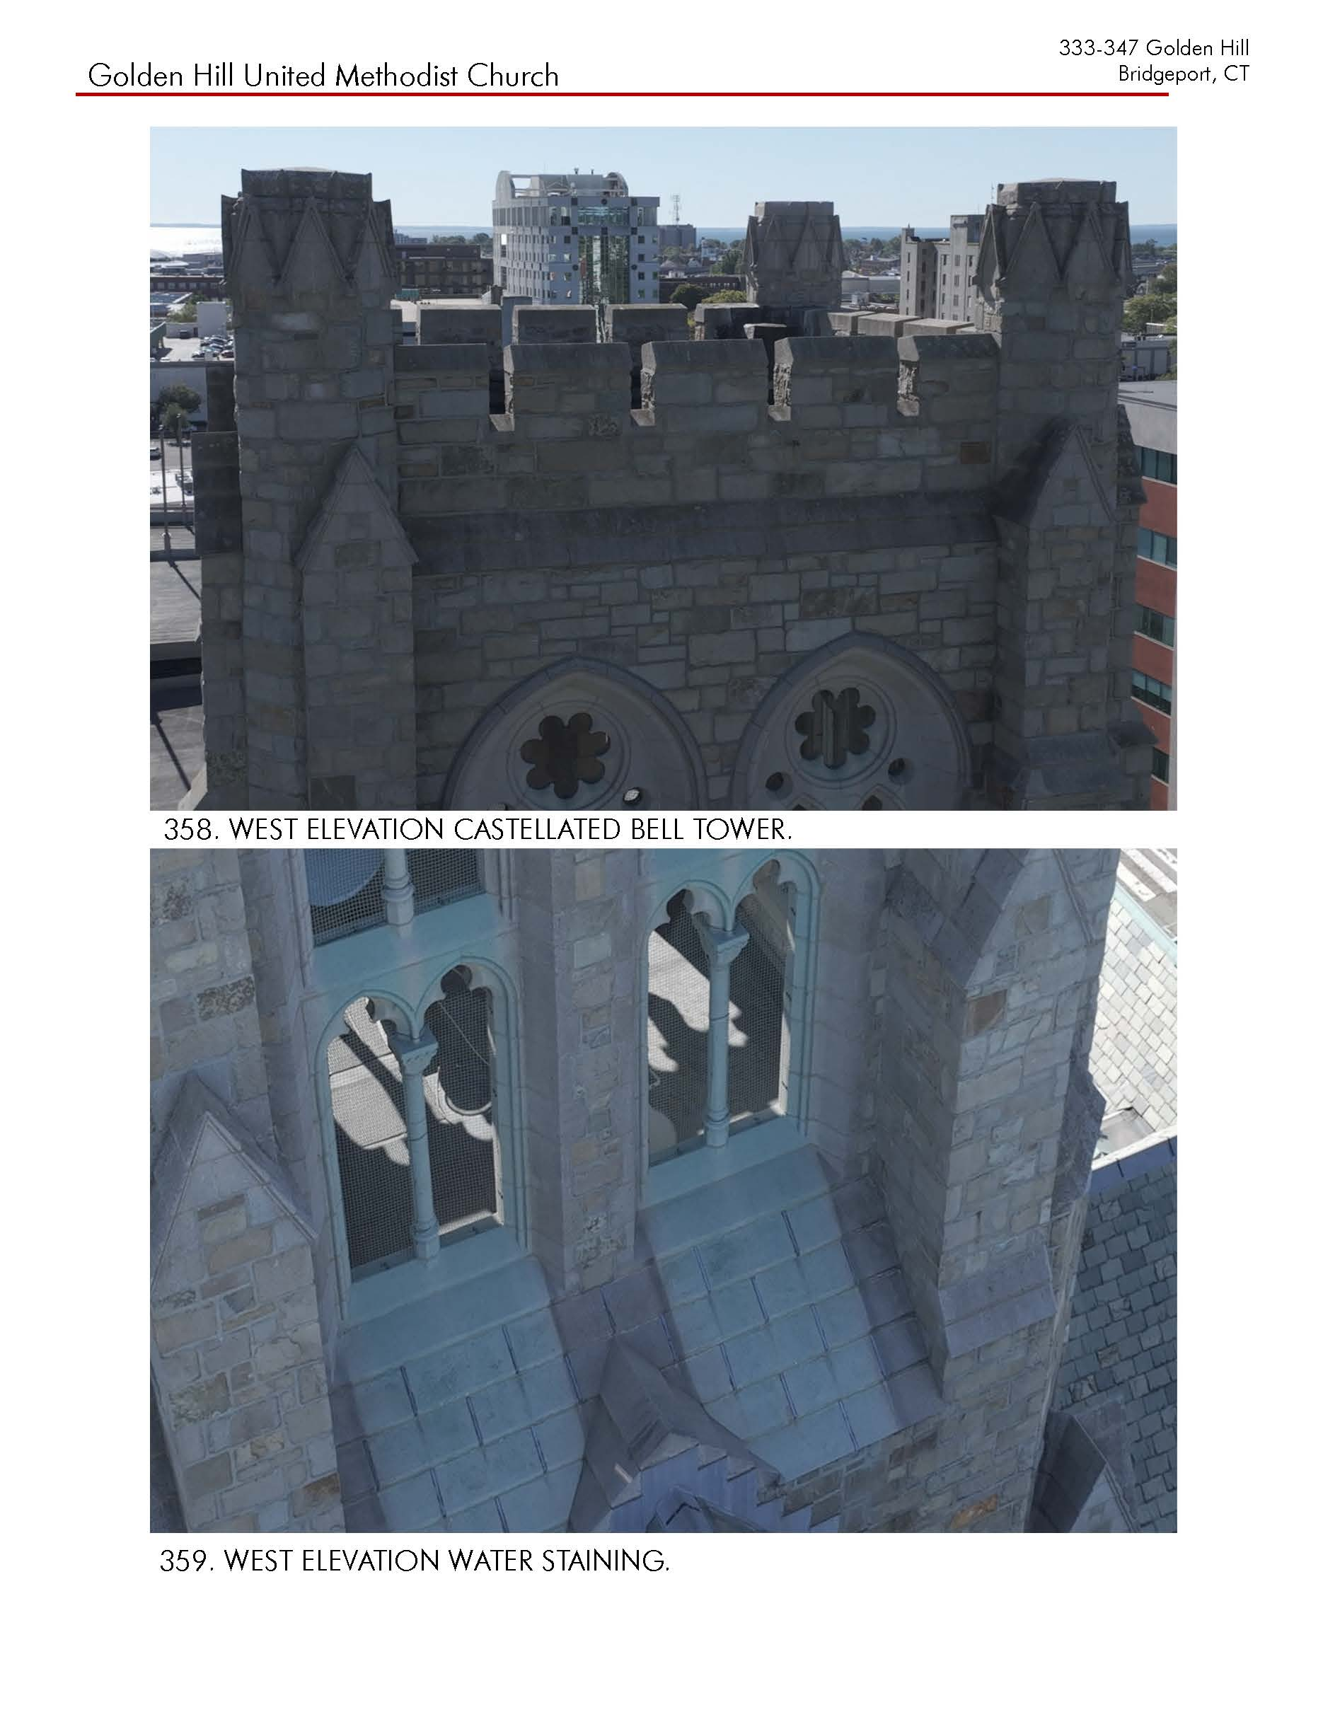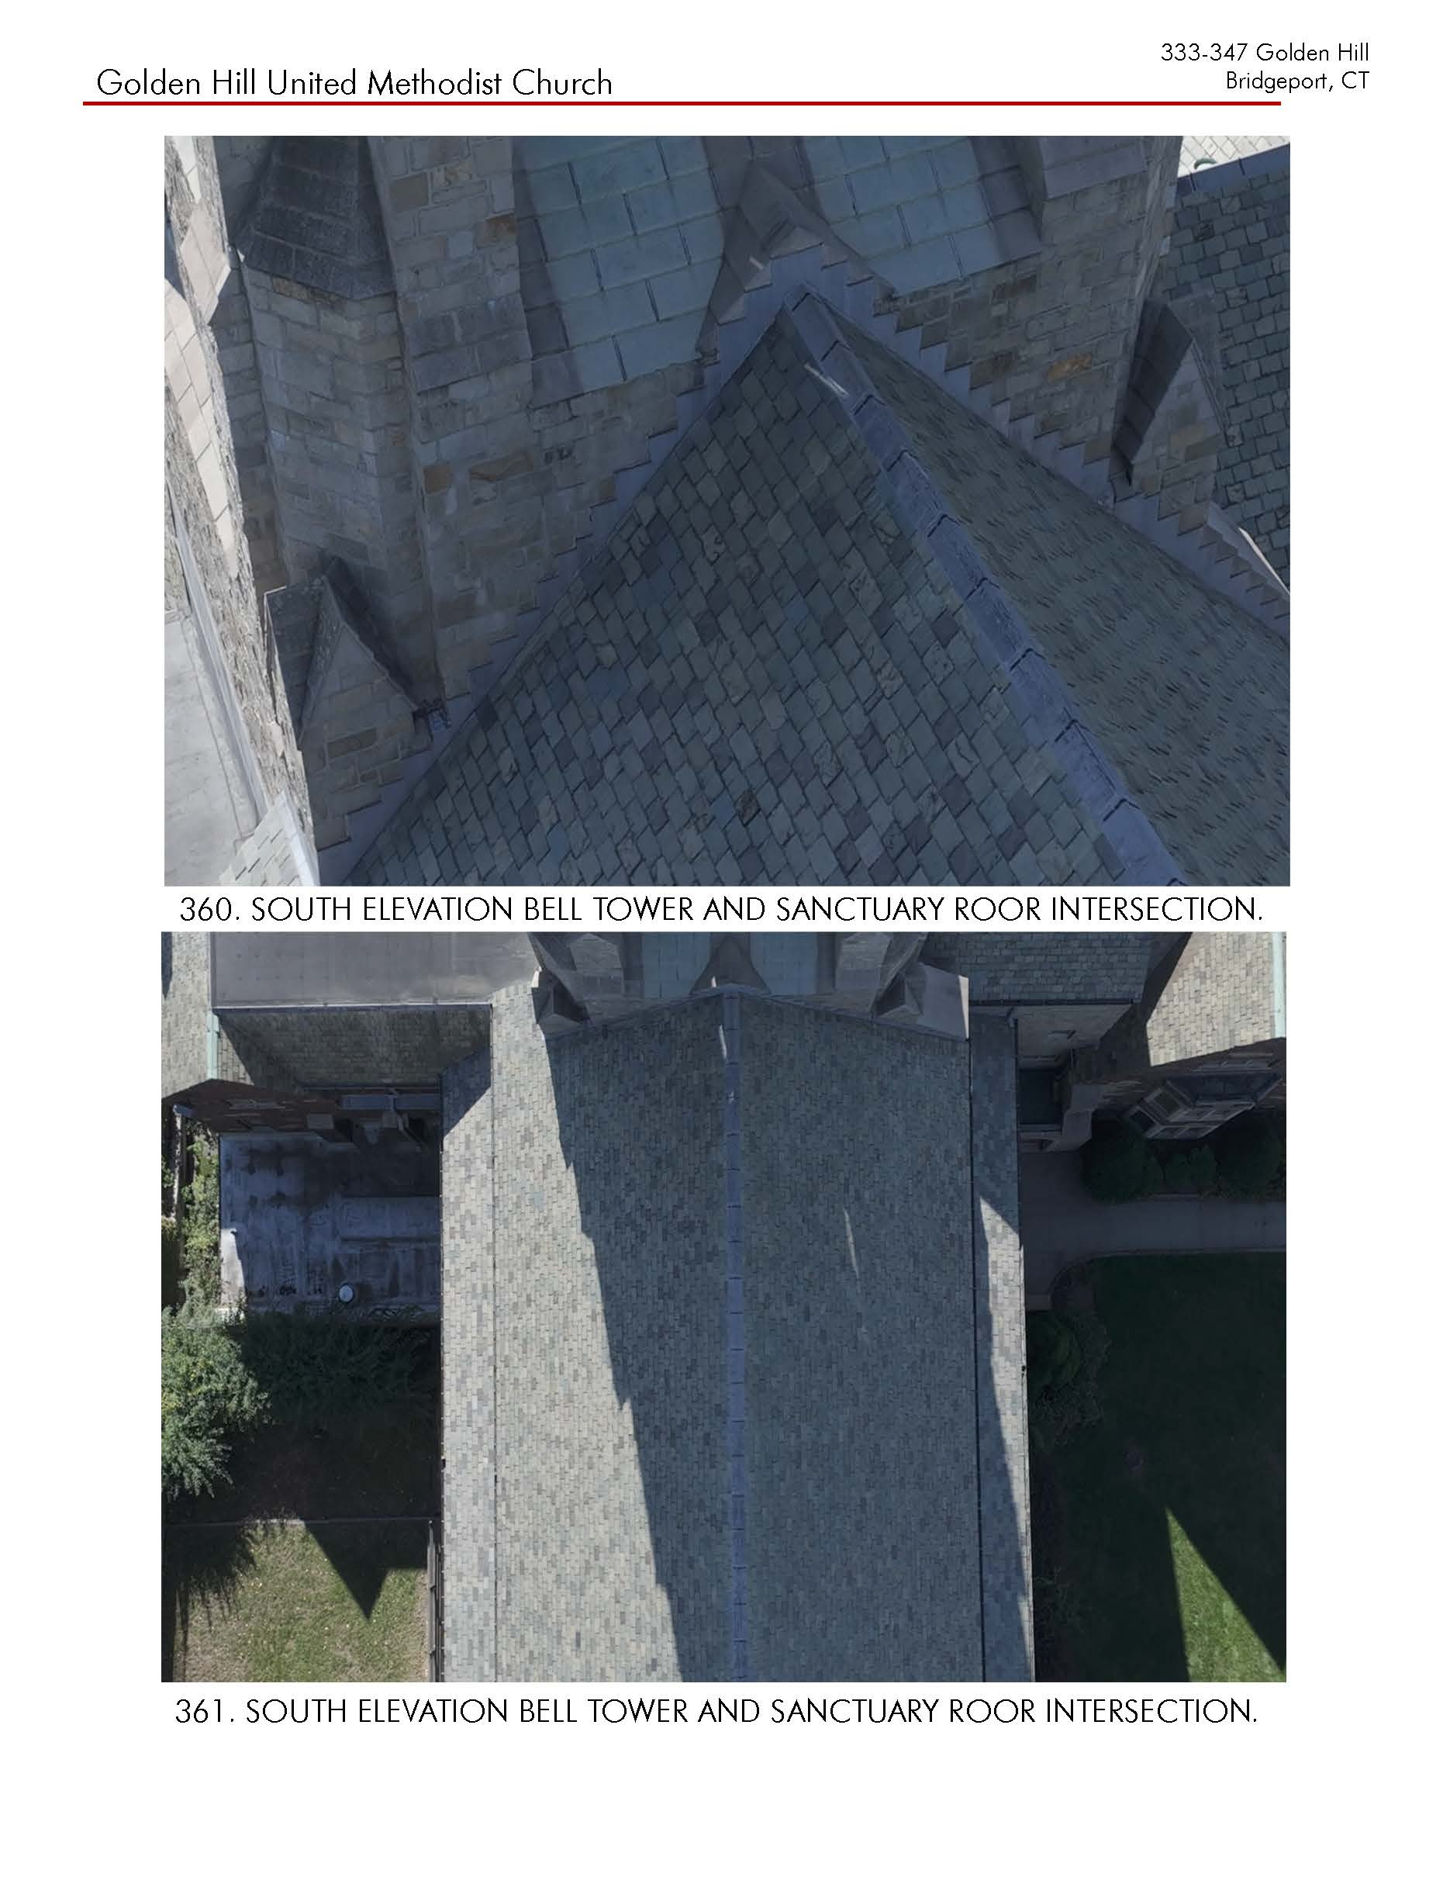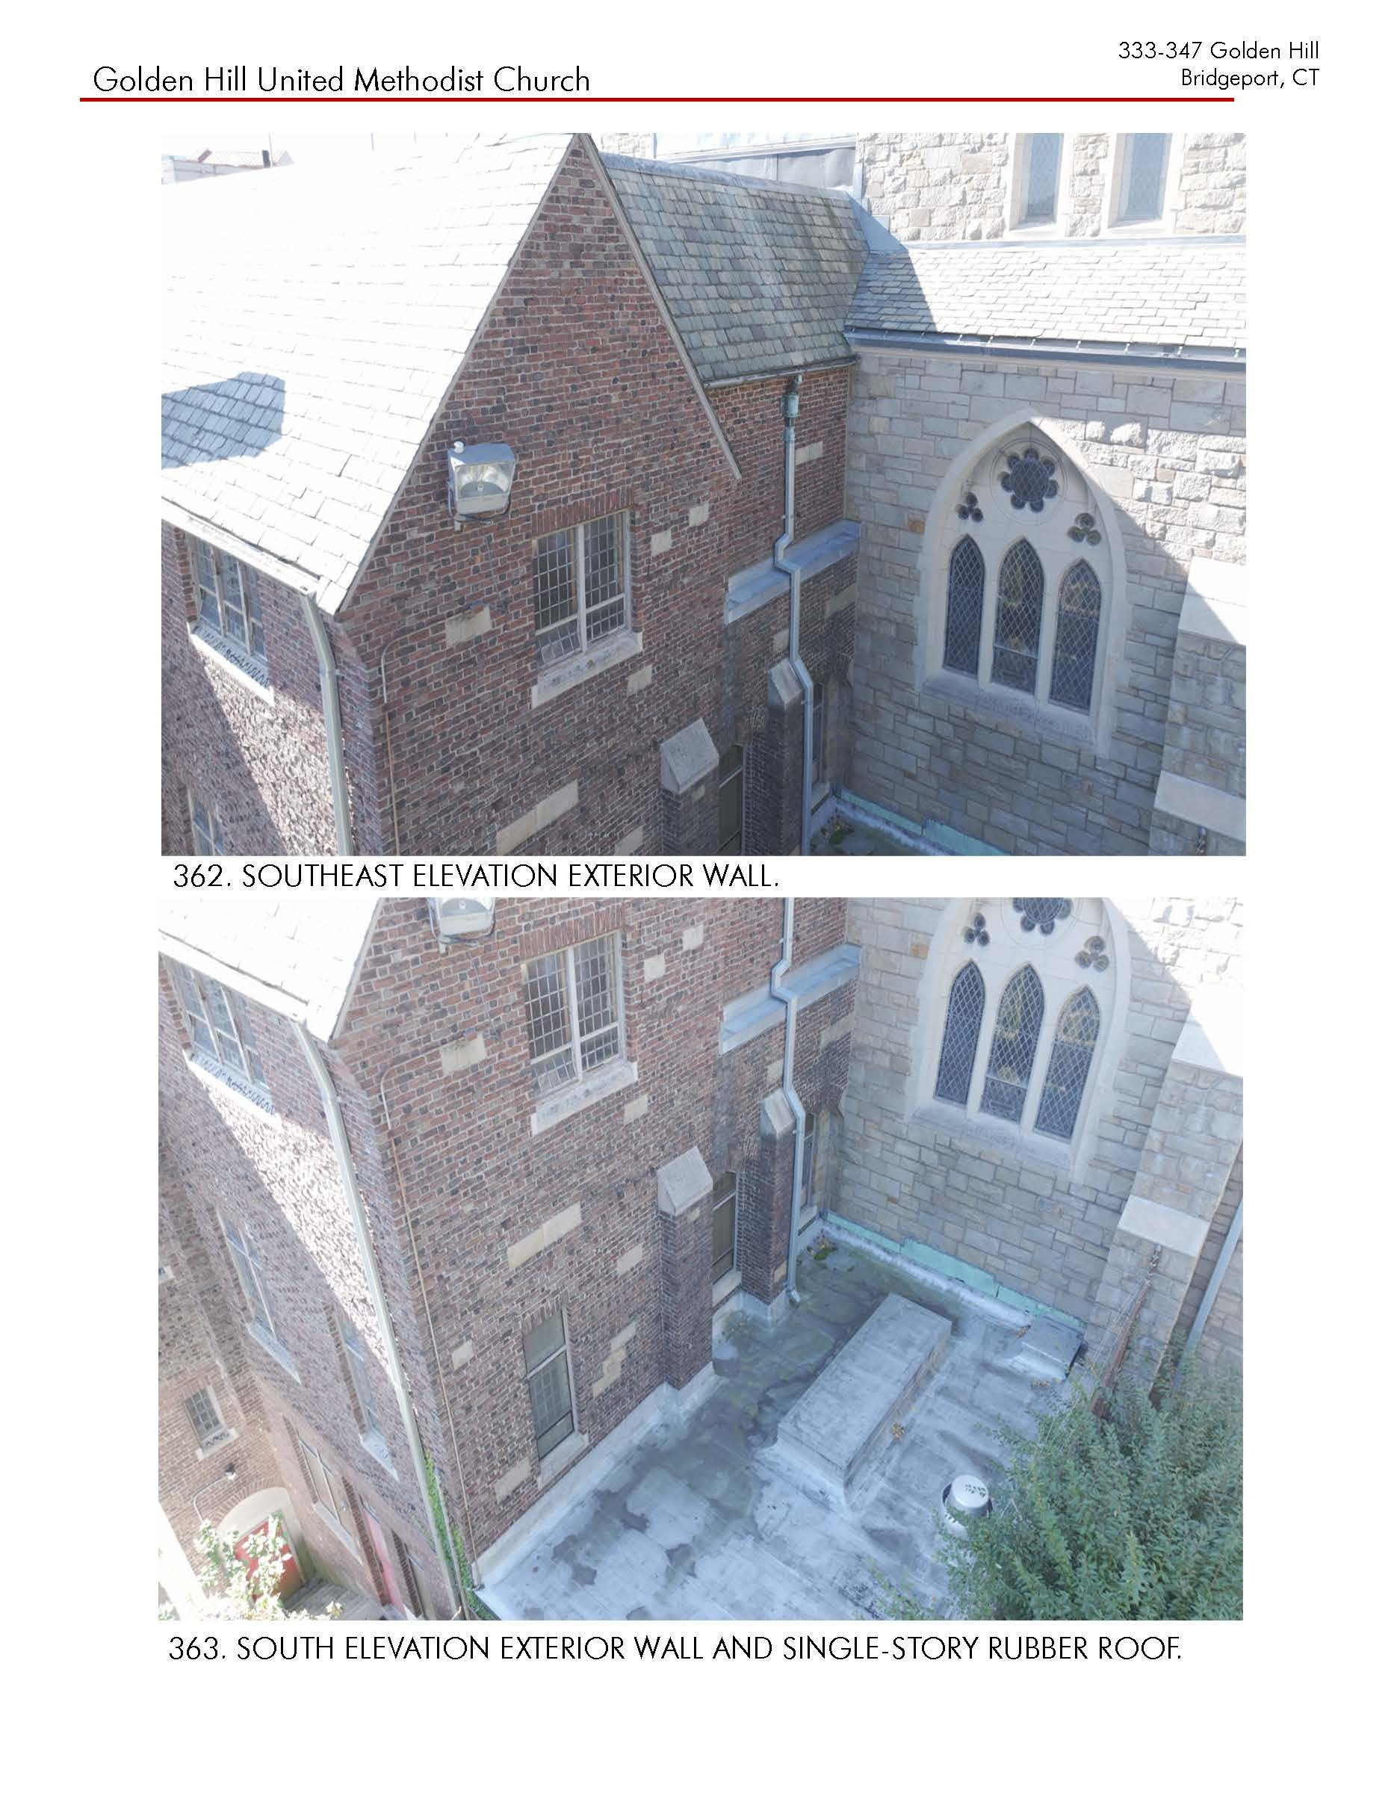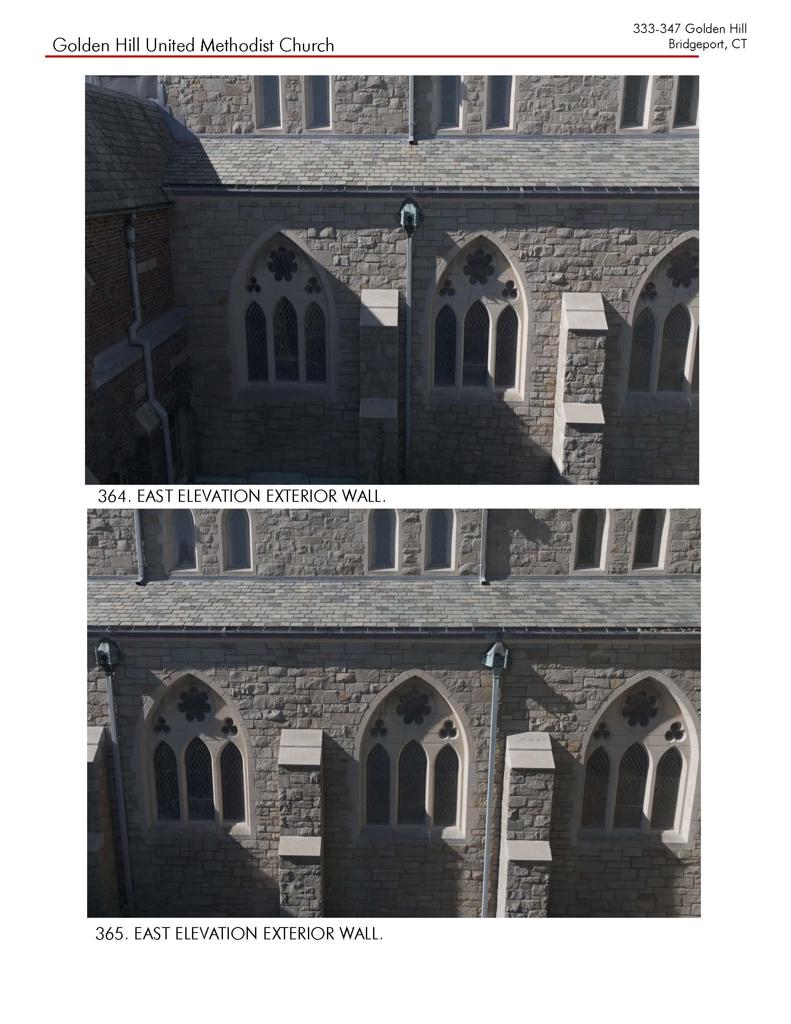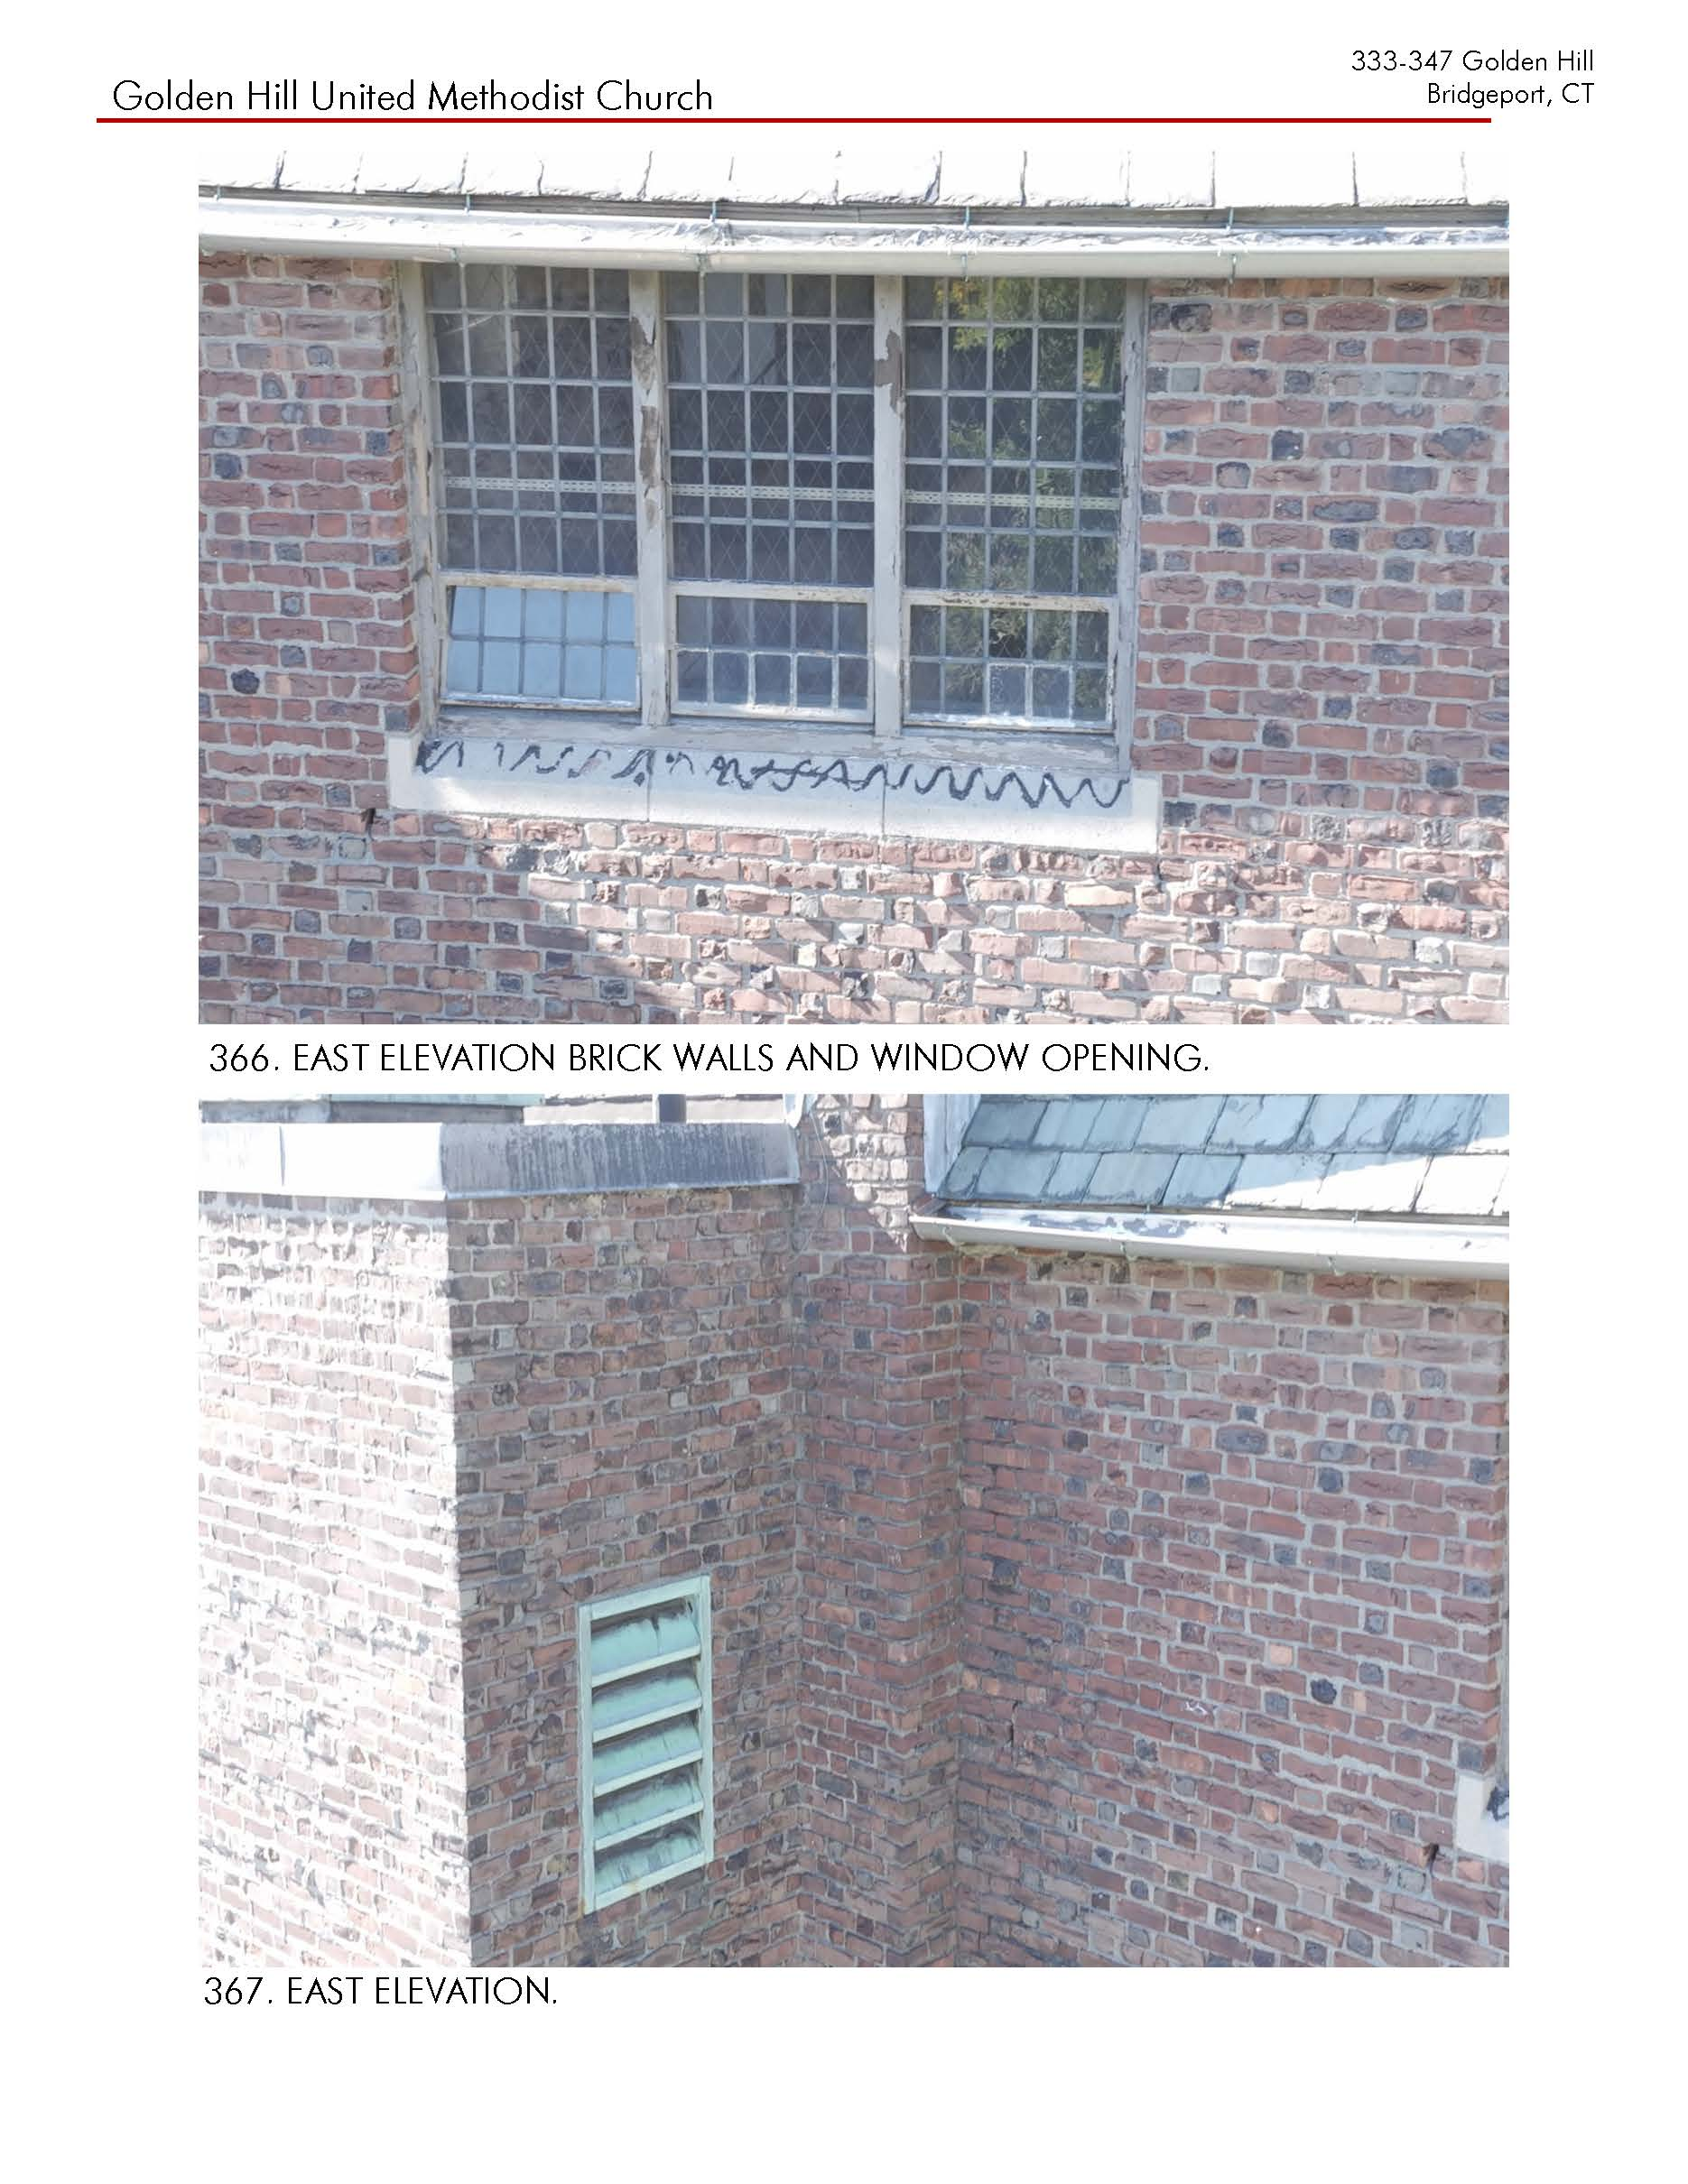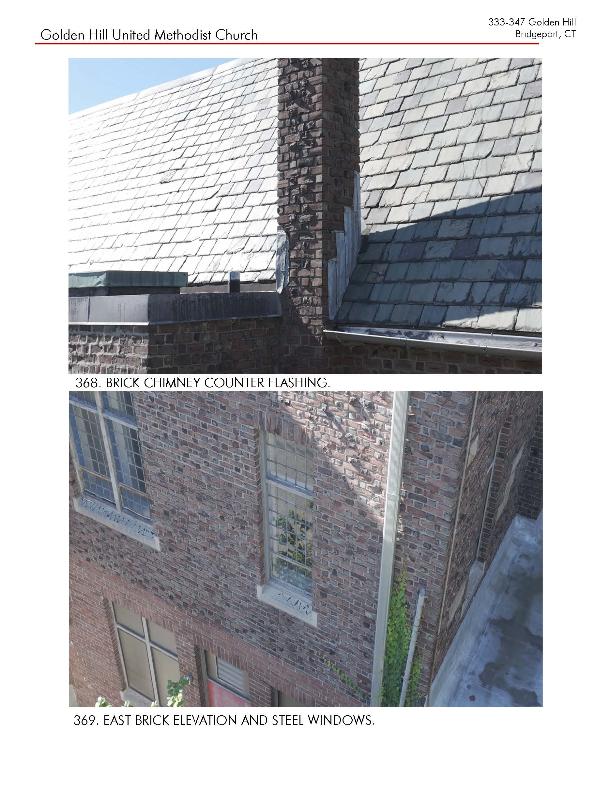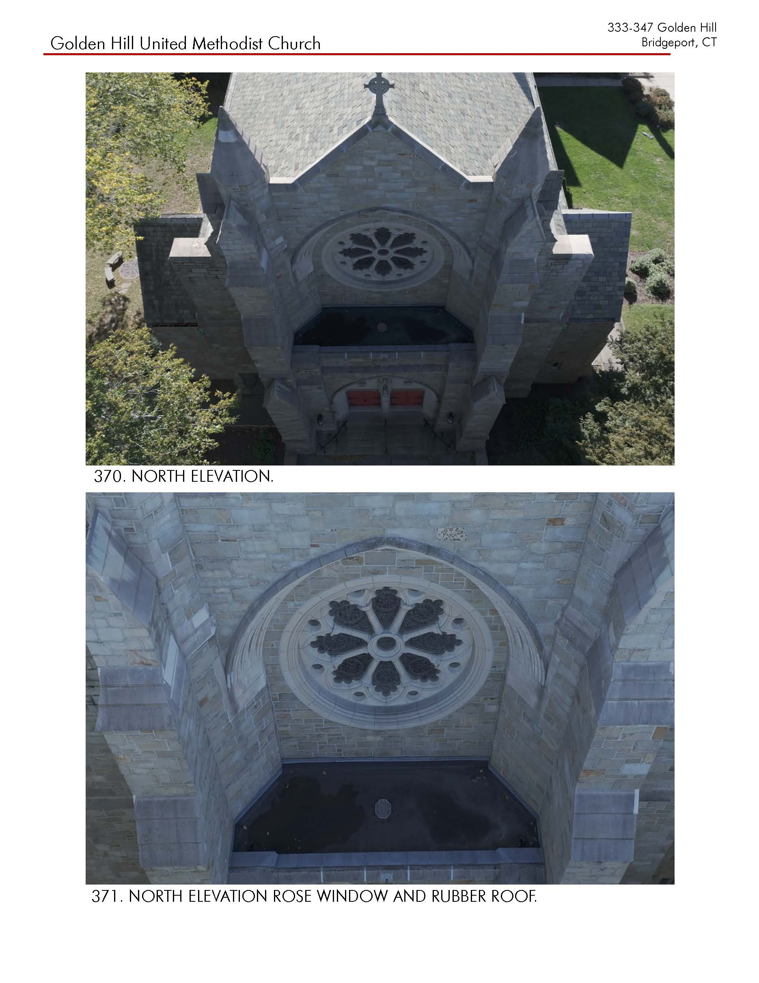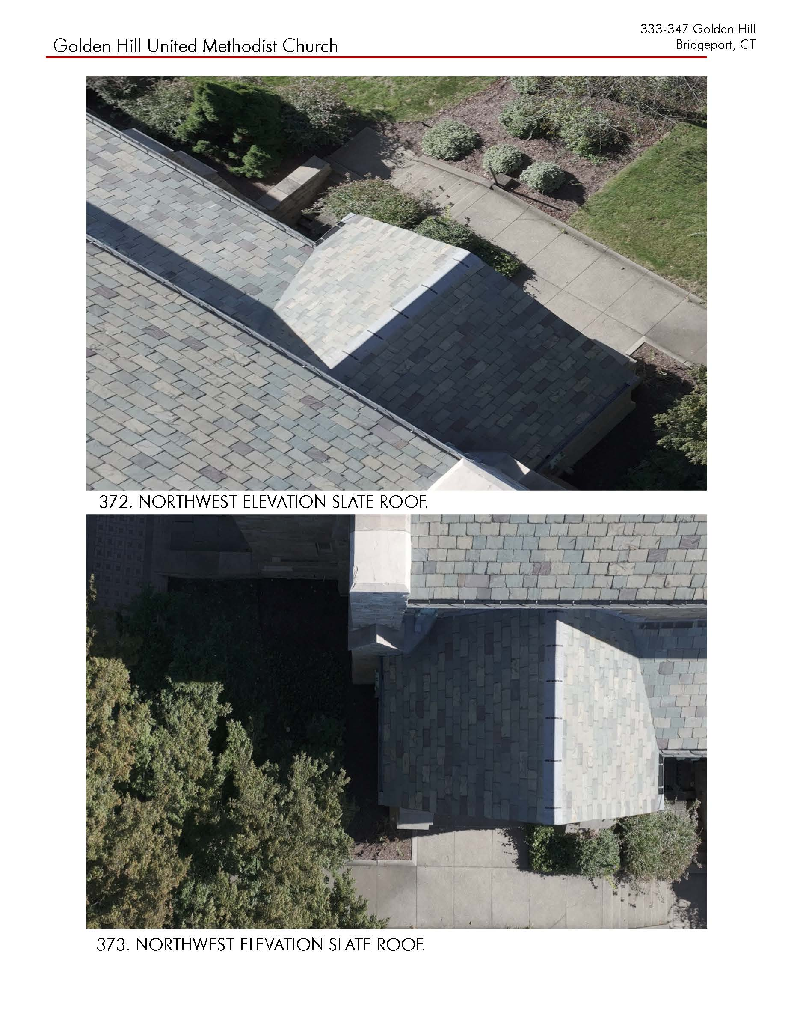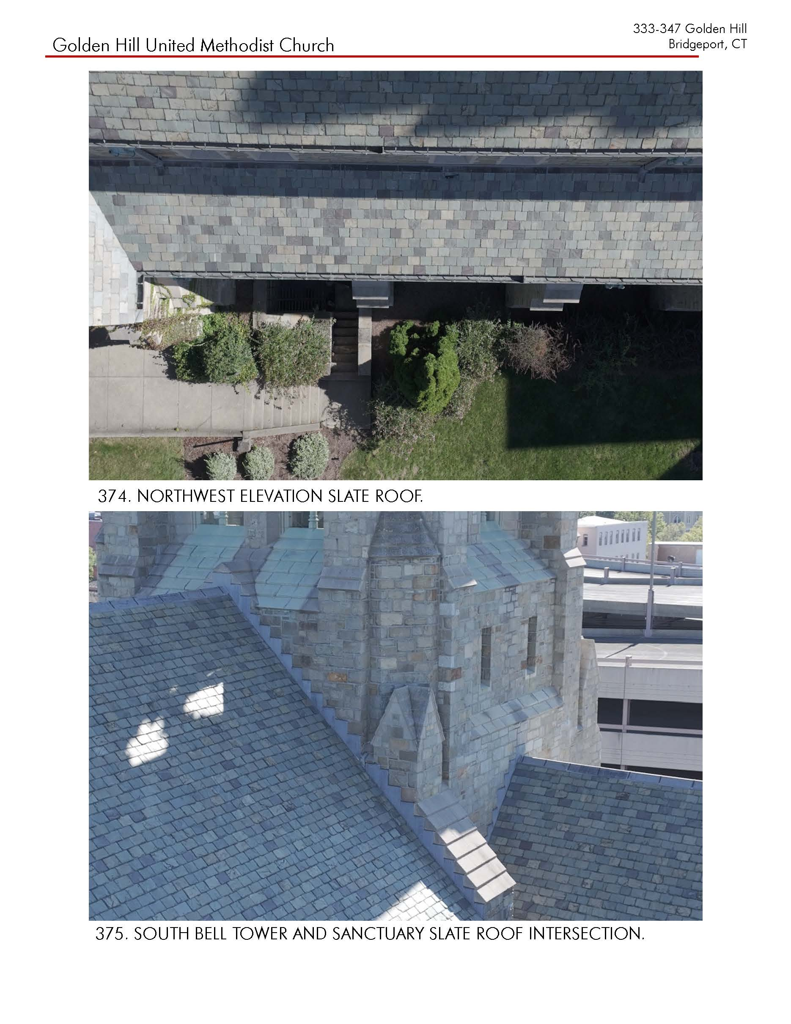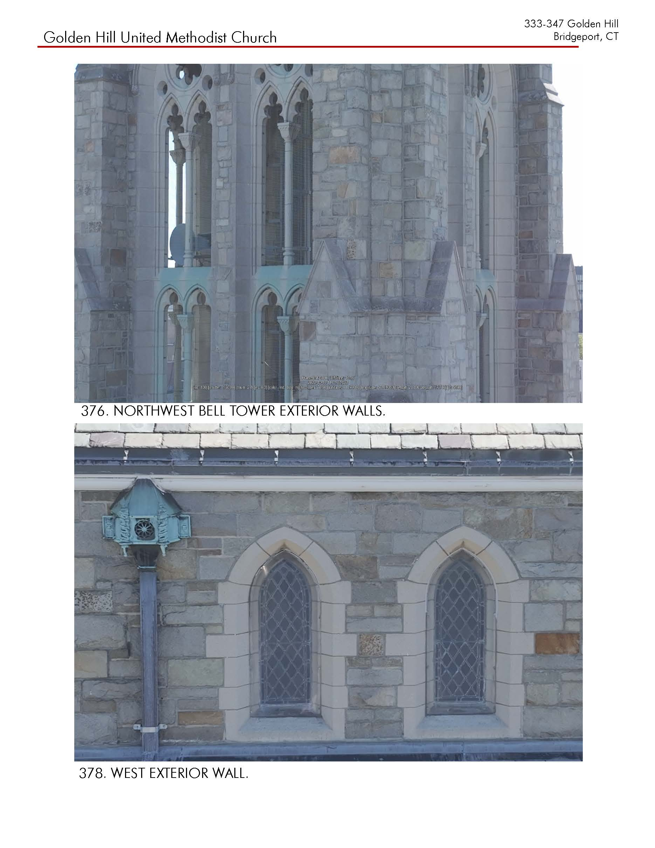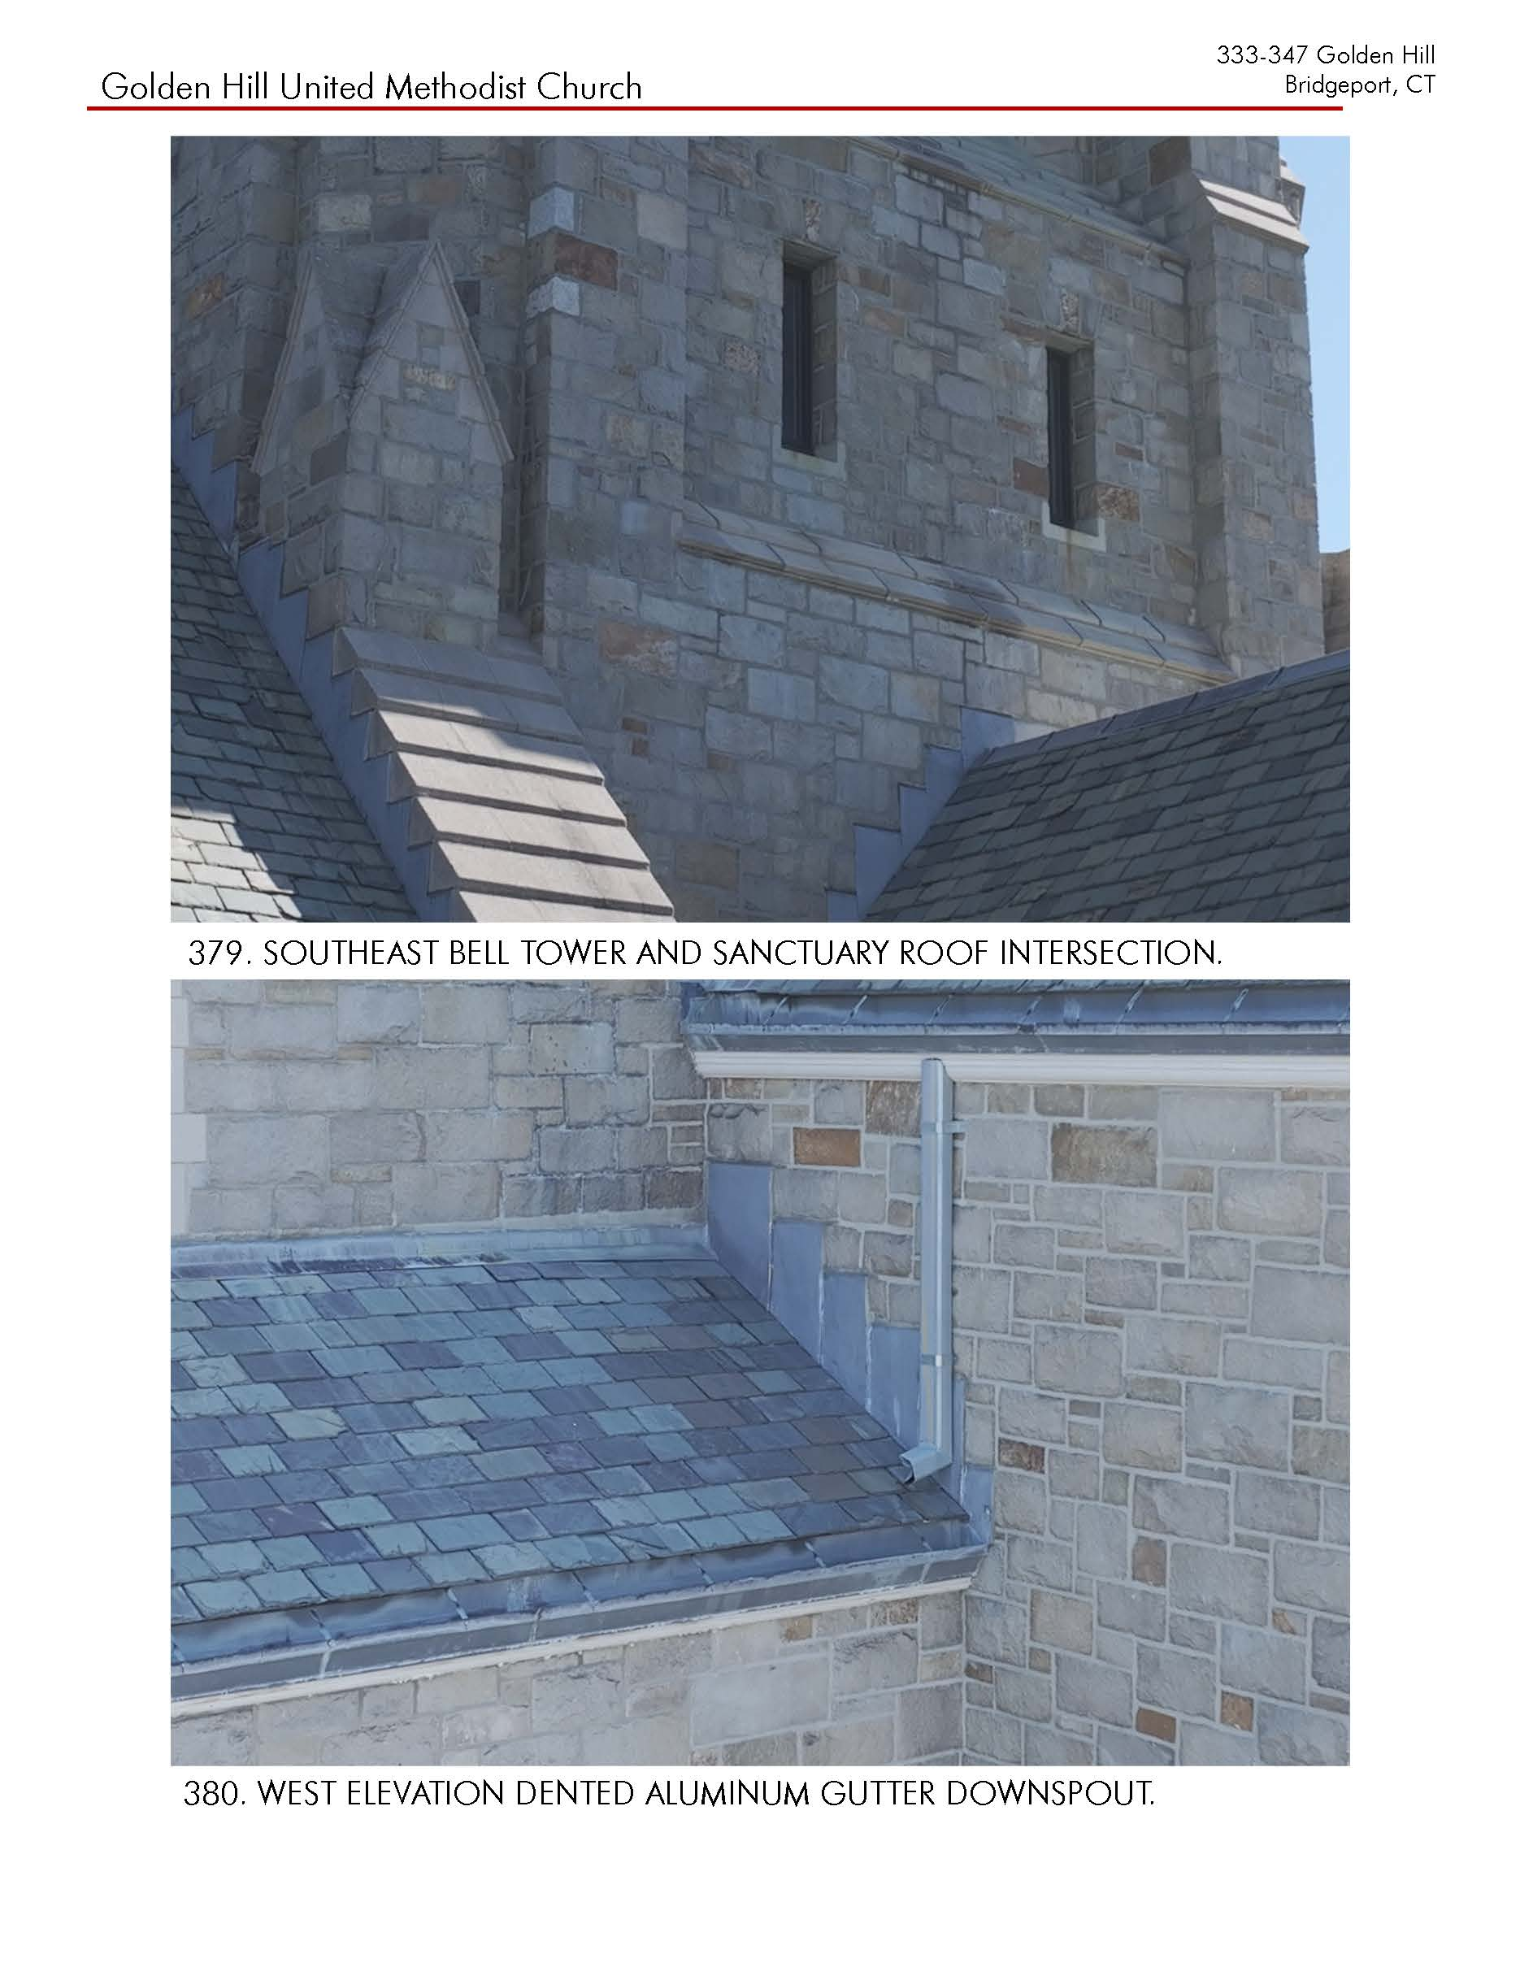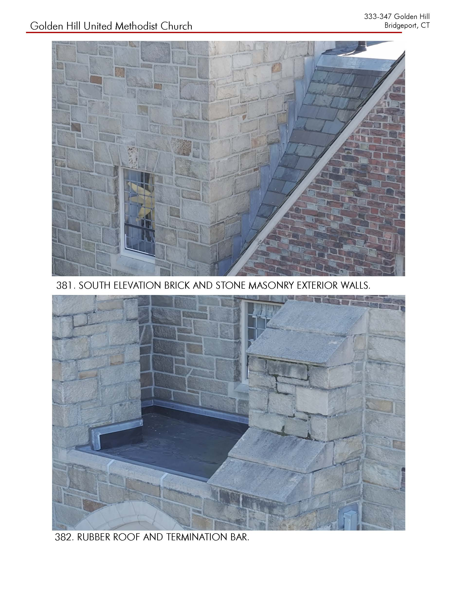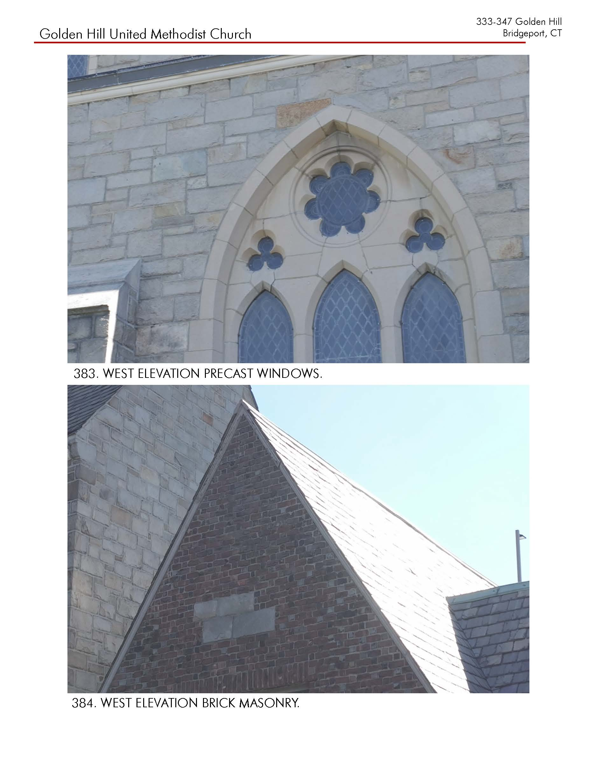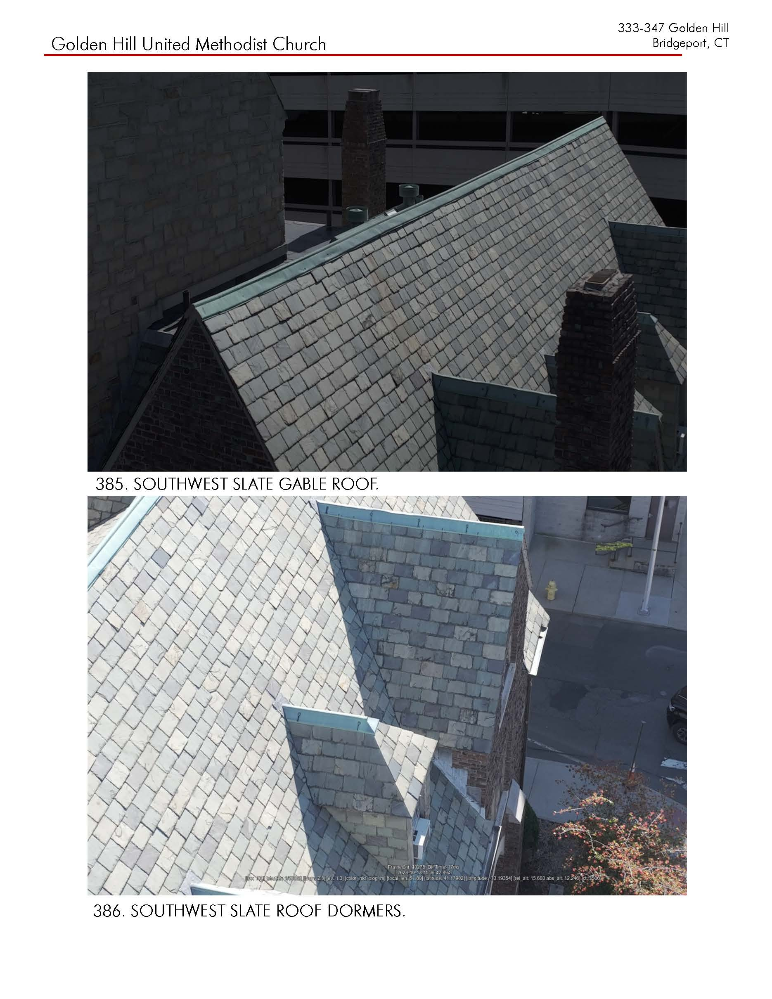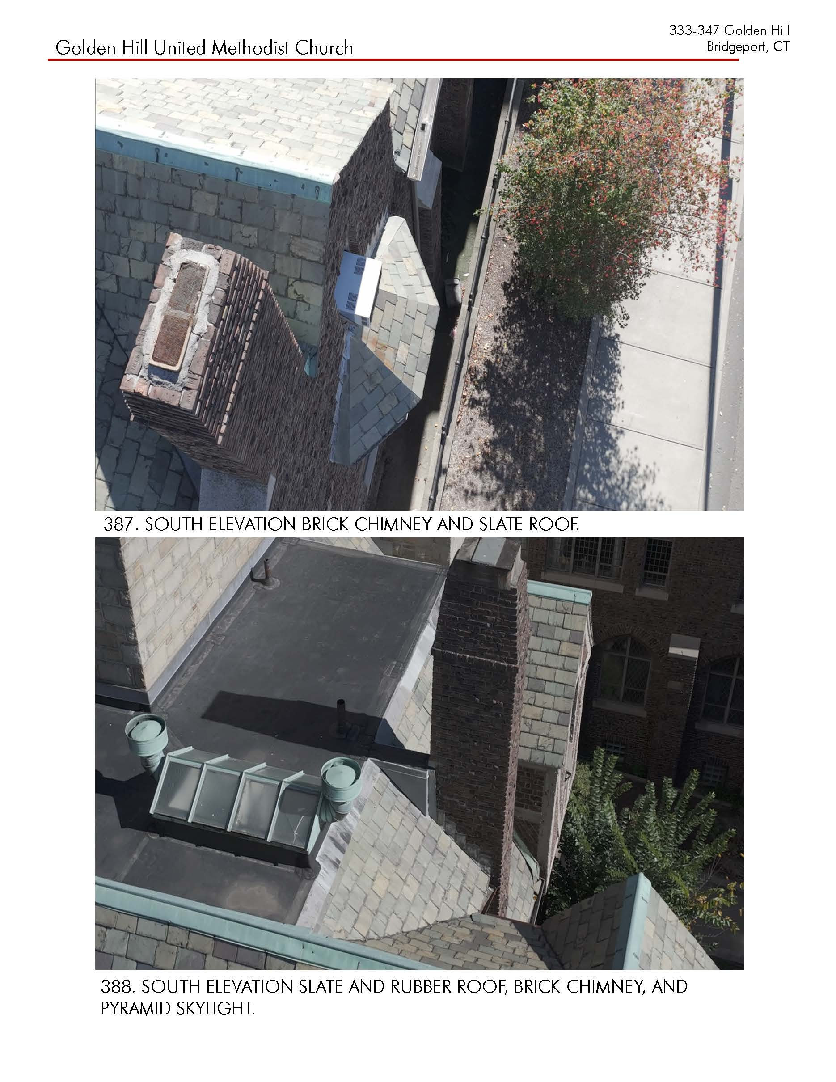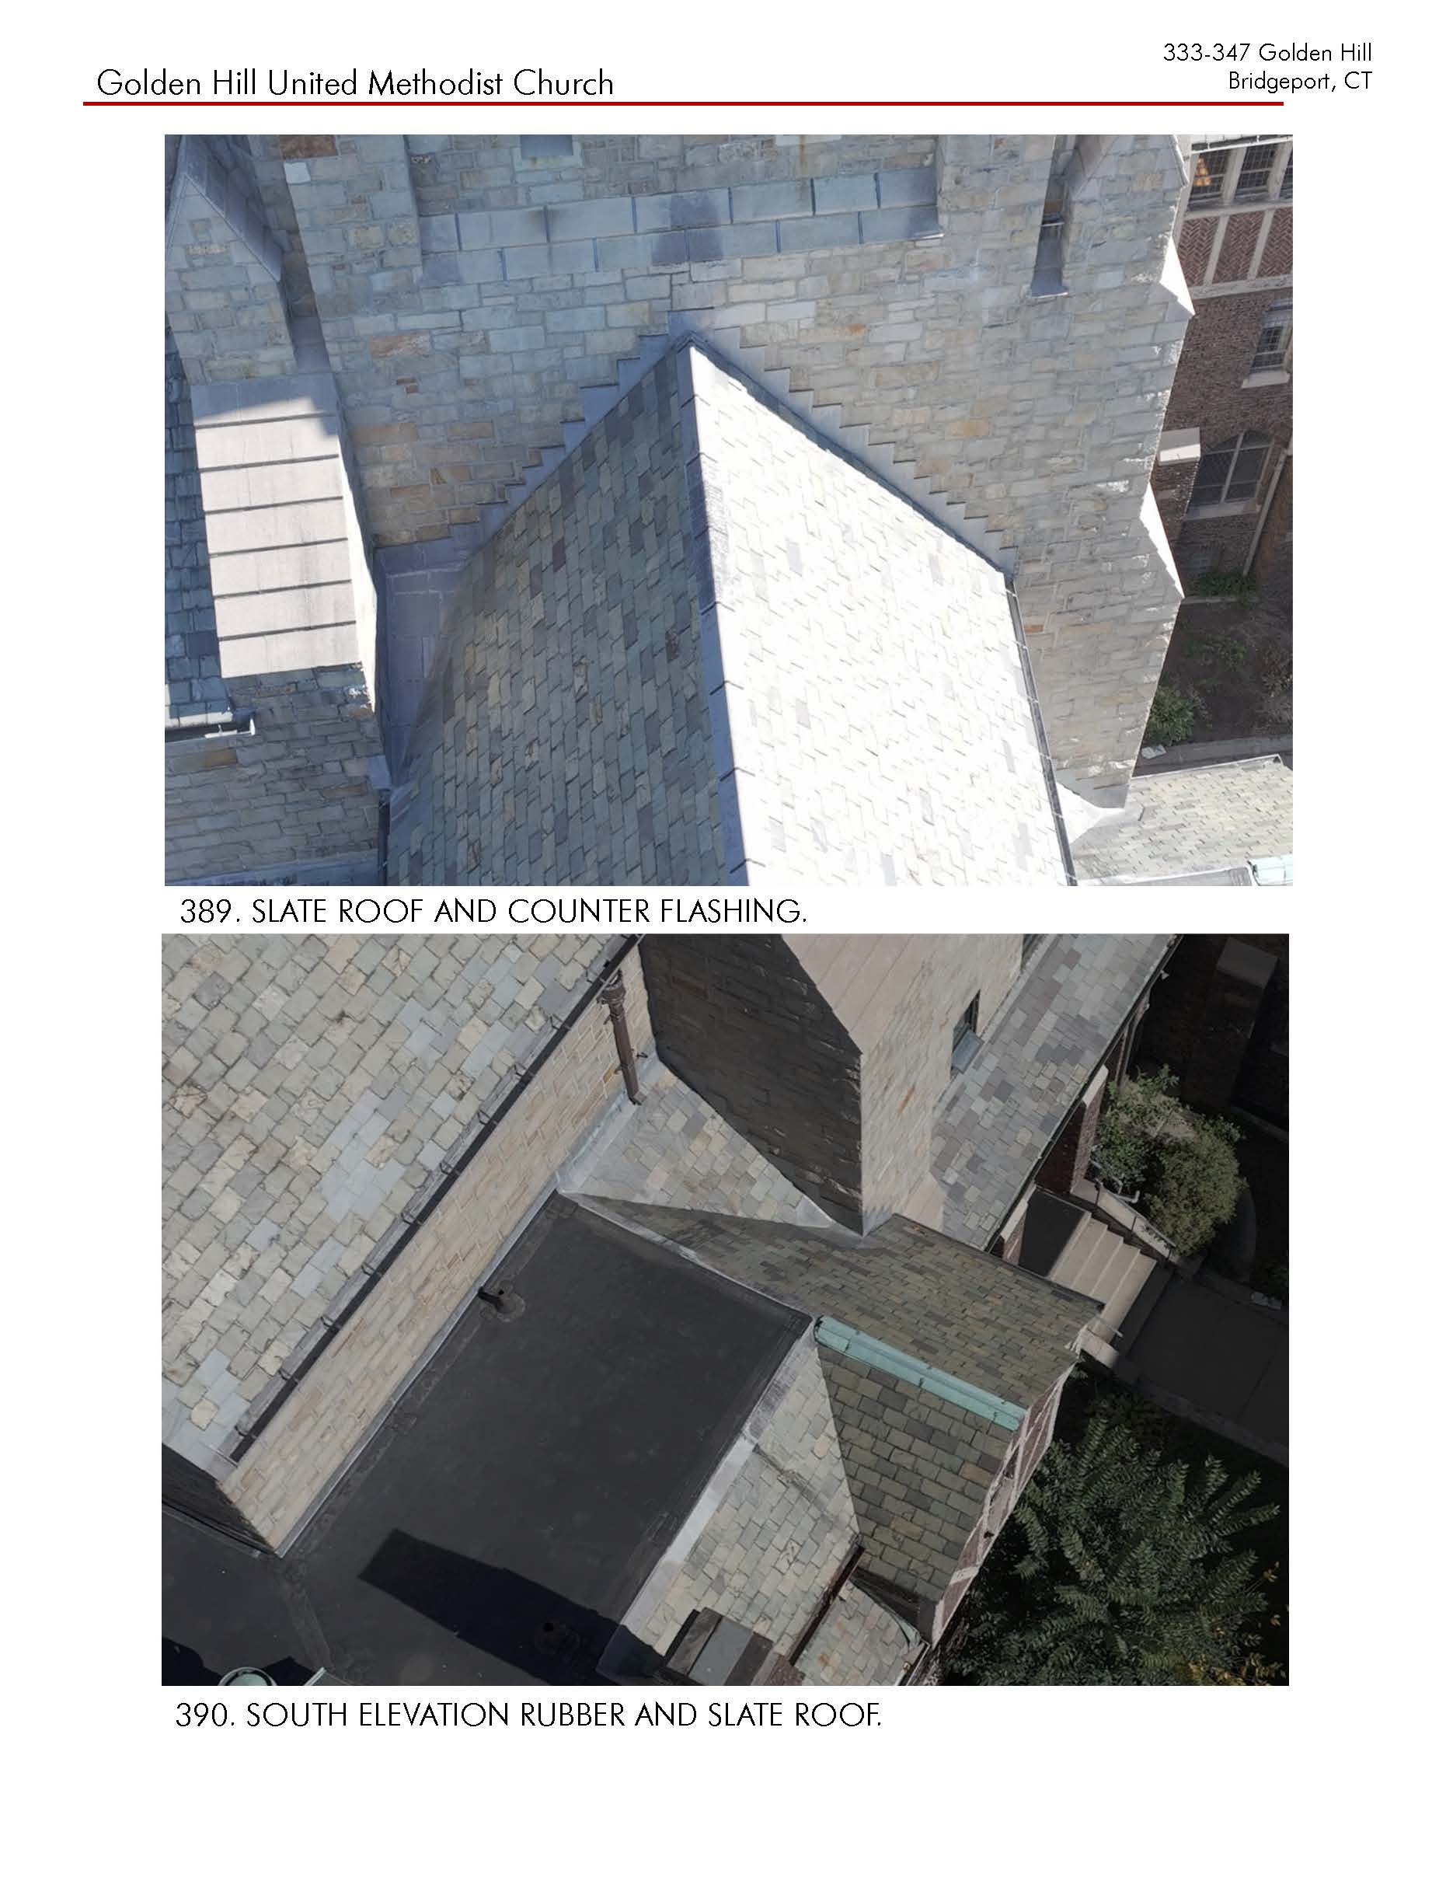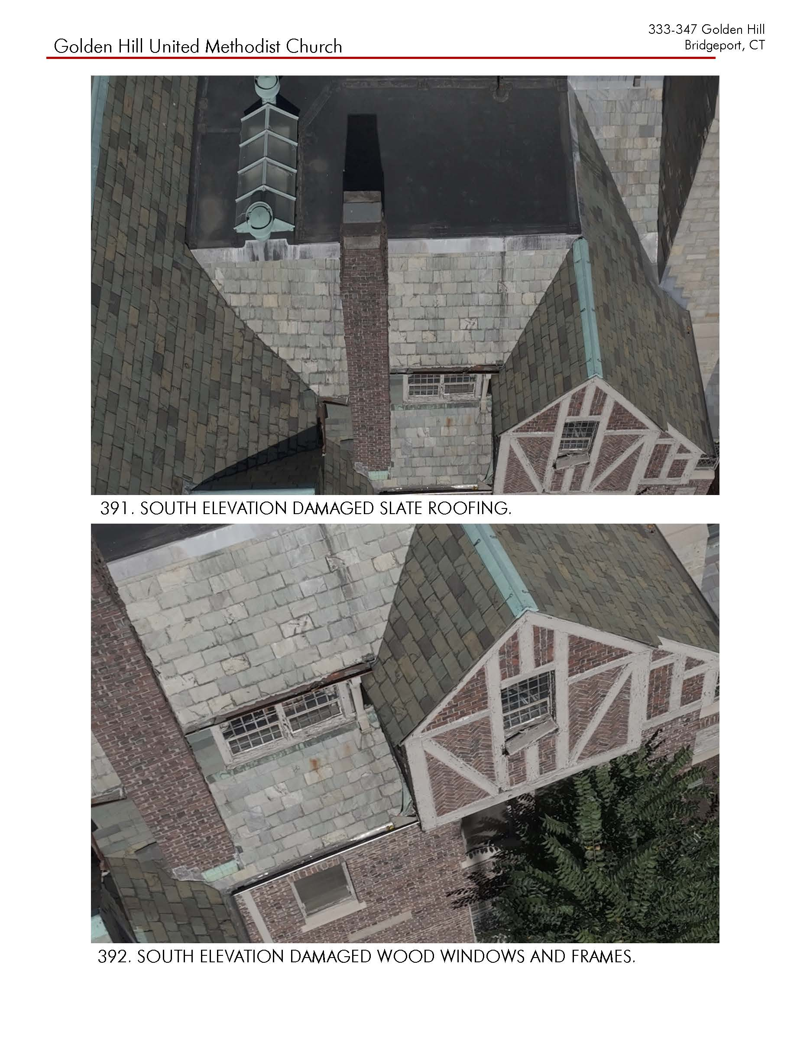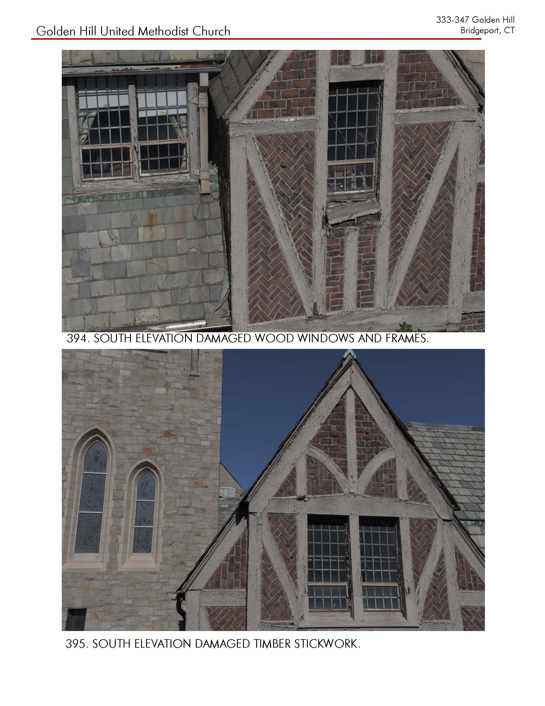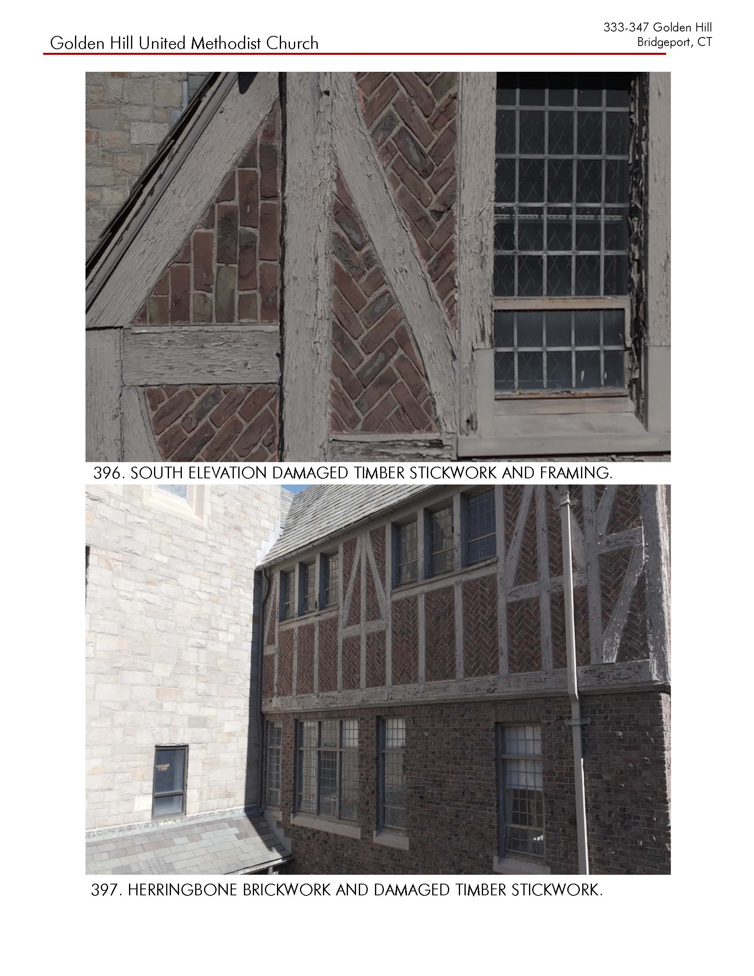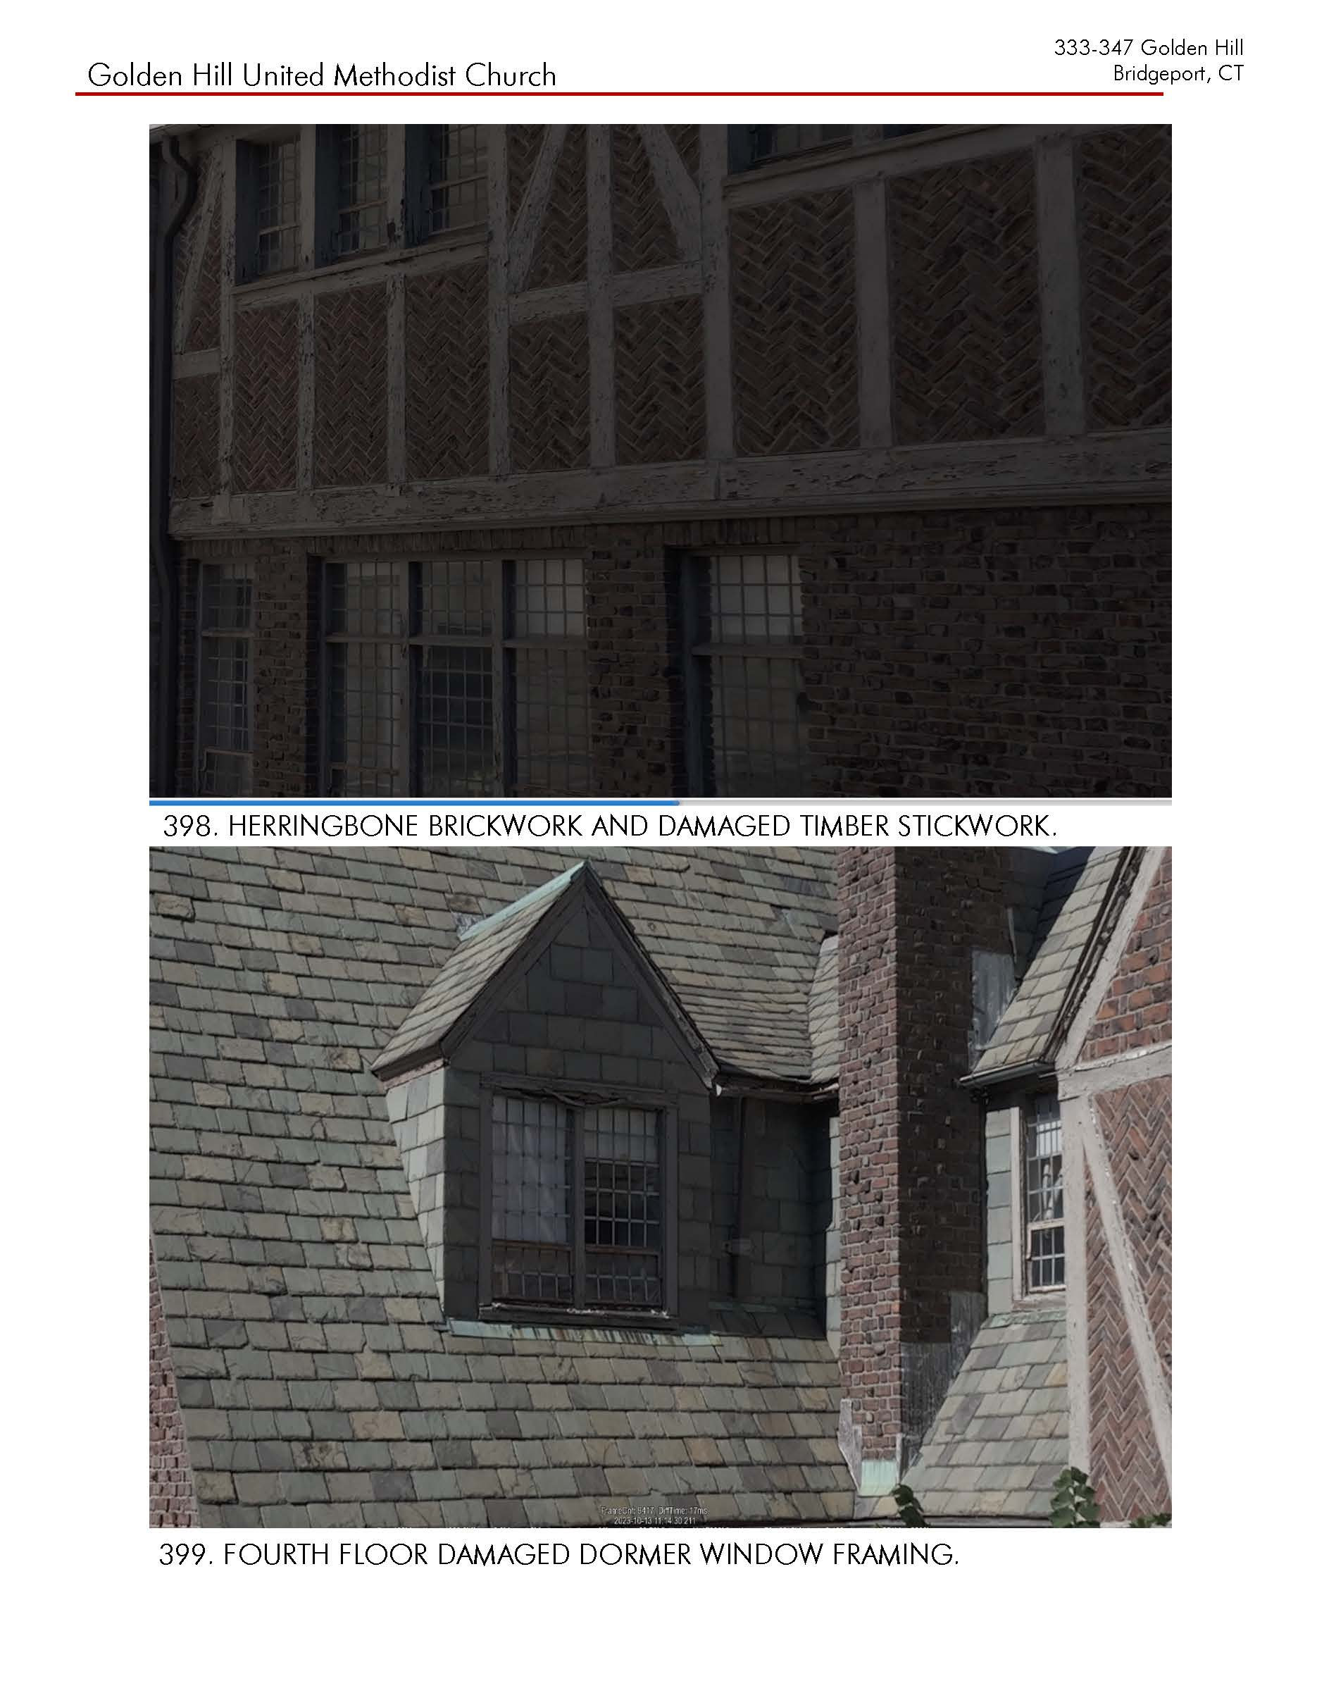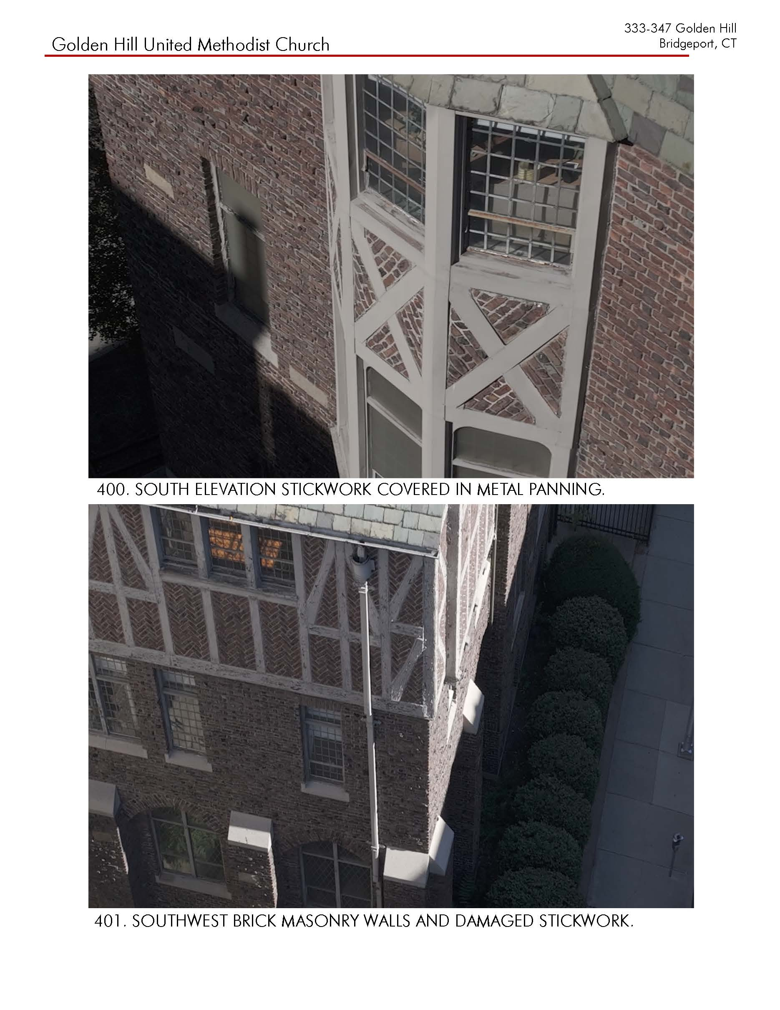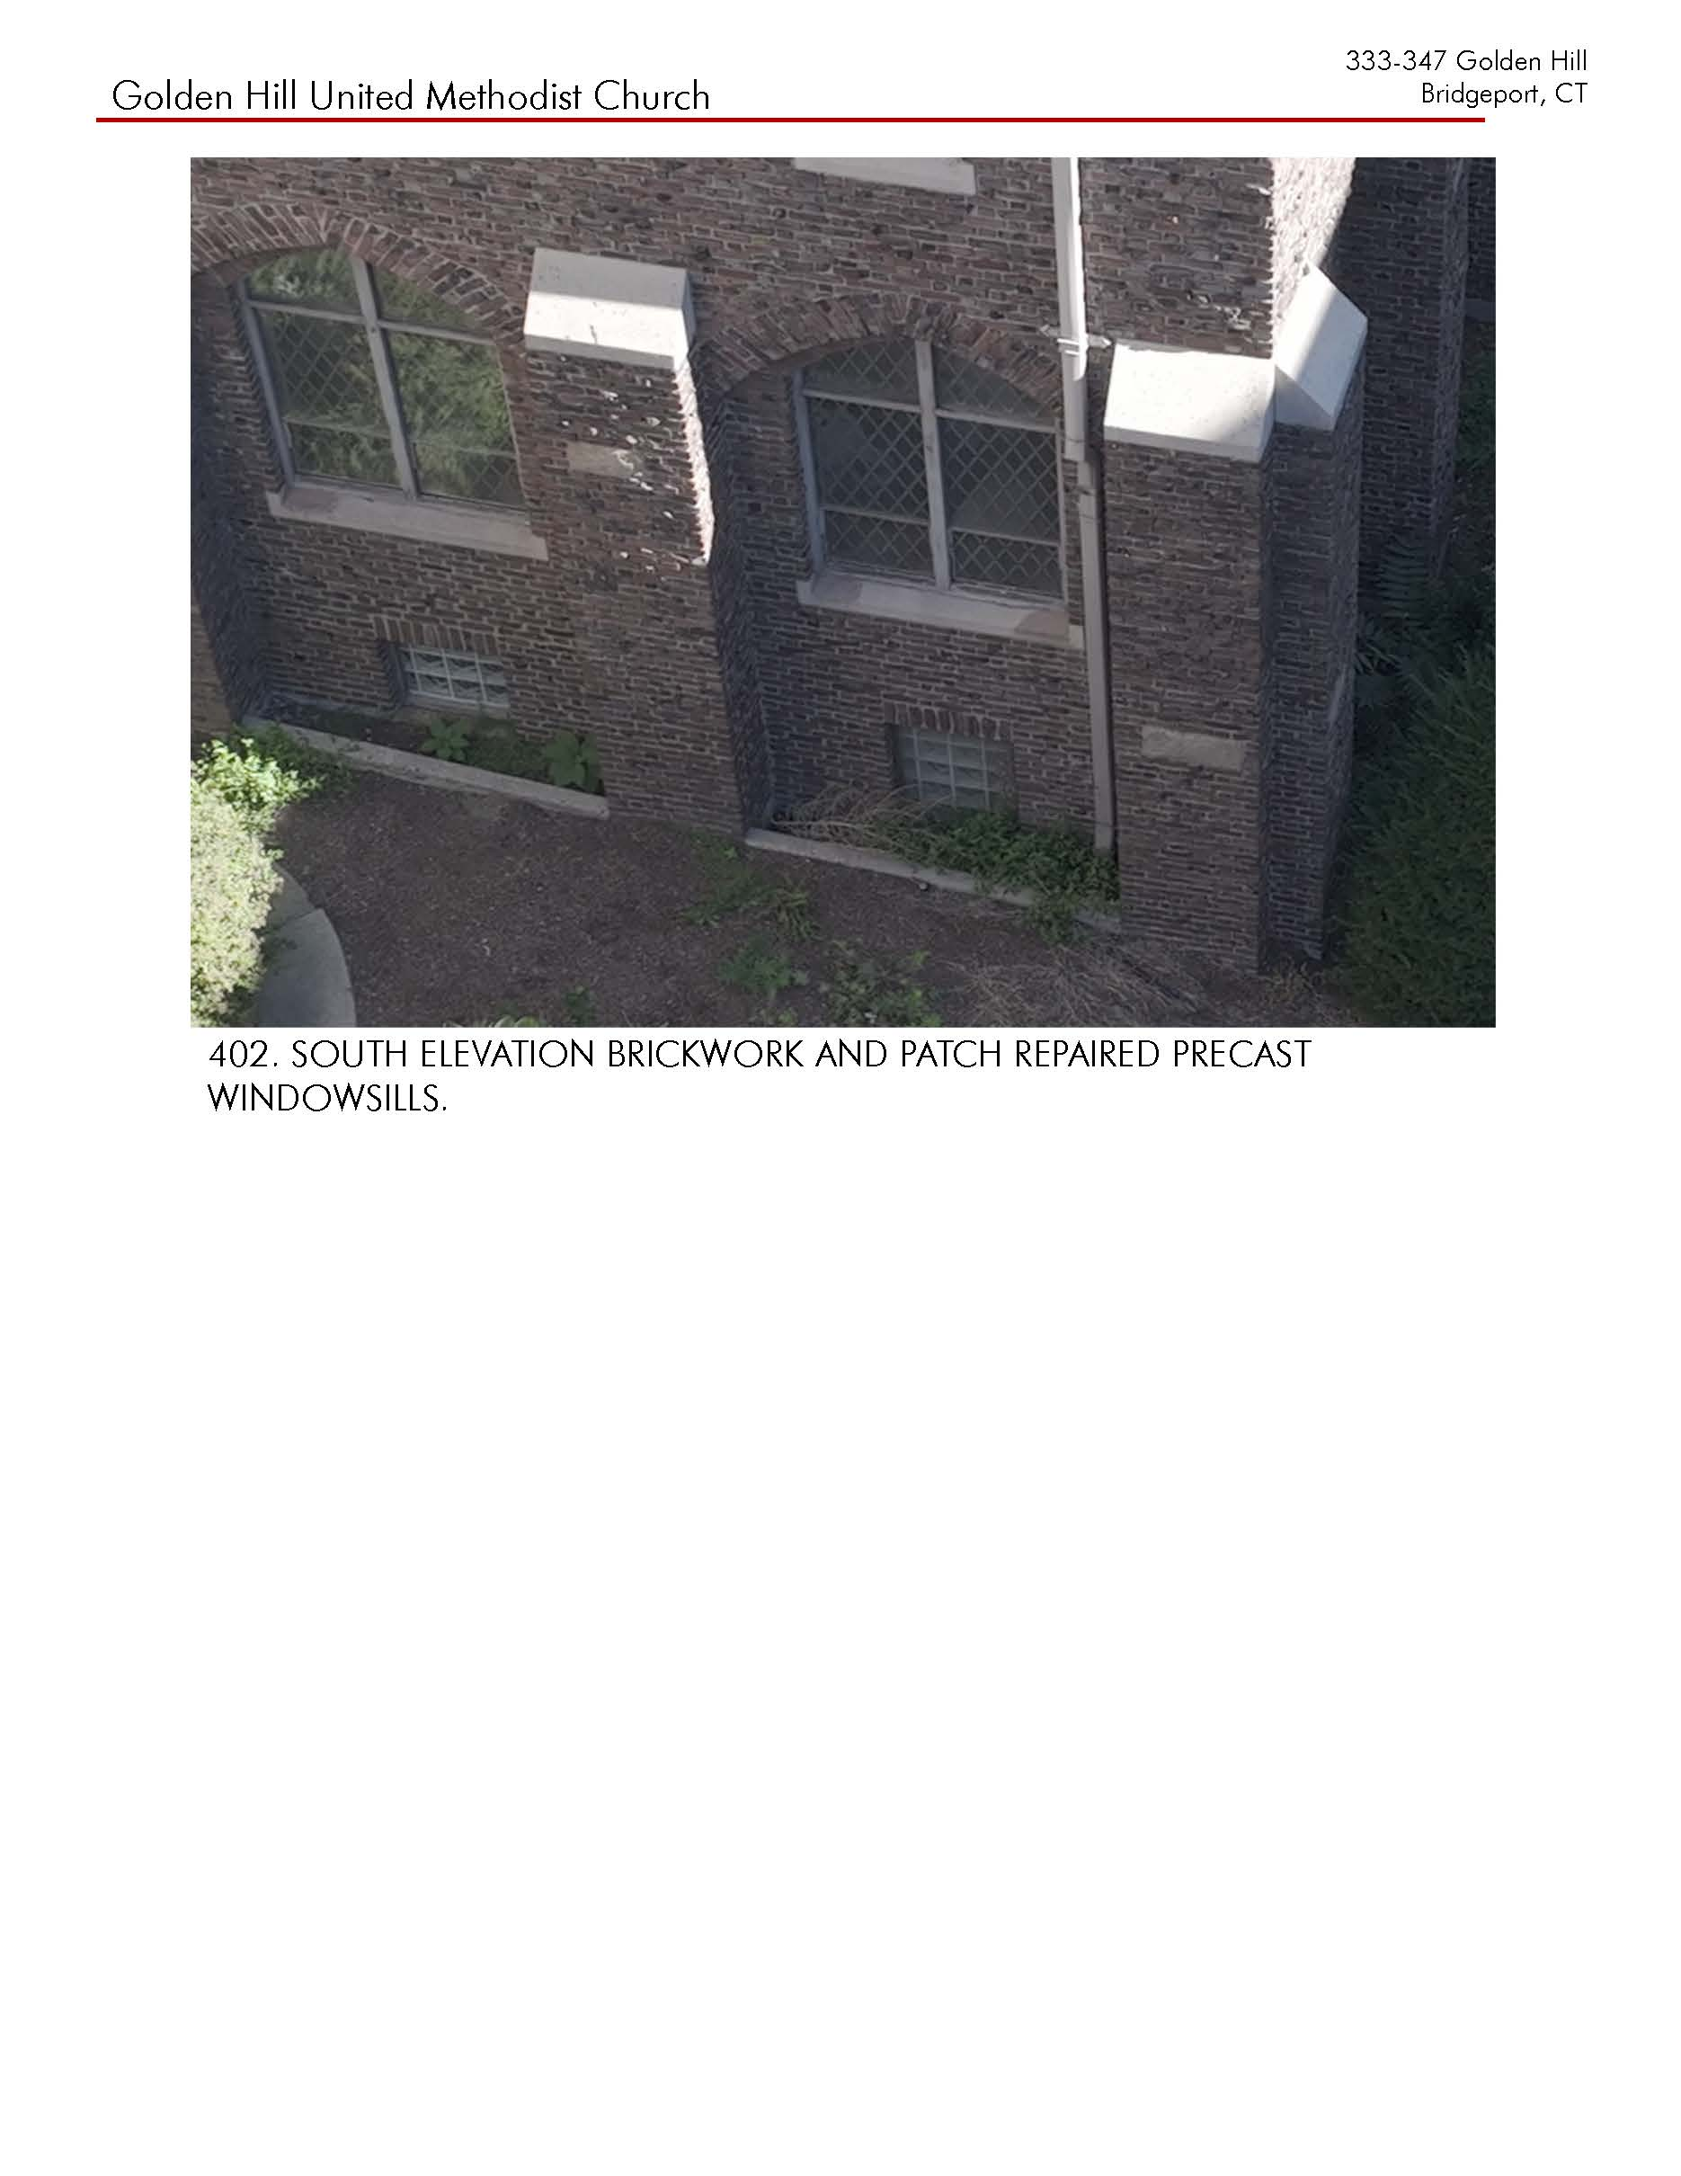

BID FORM

To: Golden Hill United Methodist Church
210 Elm St., Bridgeport, CT. 06604

Company Name:
Company Contact Person Name:
Company Contact Person Email Address:
Company Contact Person Phone Number:

- The undersigned, having examined the proposed bid documents for Golden Hill United Methodist Church for _______________ and having visited the site and examined the conditions affecting the work, hereby propose and agree to furnish all labor, materials and equipment, and to perform operations necessary to complete the work as required by said documents for the stipulated sum of:
TOTAL: $

Please itemize the cost of the following:

Scaffolding, safety equipment:

Masonry cleaning:
Repointing:
Brick repair:
Stone repair:
Chimneys:

Slate repair or replacement:
Flashing:
Wood fascia and trim:

Allowances:
Additional slate replacement discovered during work:
Additional masonry repointing beyond base scope:
Hidden wood rot at roof edges:

- The undersigned agrees to begin work as soon as possible after the award of the contract and to complete the work on or prior to a maximum of one hundred calendar dates from the start date.

- The undersigned agrees to comply with all applicable provisions of Title VI of the Civil Rights Act of 1964 and Section 504 of the Rehabilitation Act of 1973, the U.S. Department of the Interior which prohibits discrimination on the basis of race, color, sex, national origin, or handicap in its federally assisted programs.

- The undersigned agrees to perform all work in full accord with the Secretary of the Interior’s Standards for Rehabilitation and Guidelines for Rehabilitation Historic Buildings (Current Edition).

Further Instructions for Bidders
The successful bidder shall execute a contract on forms satisfactory to the church.

The bidder to whom the contract is awarded shall, within 15 calendar days of the notice of award, furnish the church with two original copies of the executed contract.

At or prior to delivery of the signed contract, the successful bidder shall deliver to the church the Certificate of Insurance required by these documents. The Certificates of Insurance shall be provided to the church prior to the start of work. Failure to provide the required Certificate of Insurance shall subject the successful bidder to loss of time from the construction period equal to the delay in furnishing required materials.

The contract shall not be subject to prevailing wage rates.

Any person contemplating submission of a bid for the work, who is in doubt as to the true meaning of any part of the proposed contract documents, or who finds discrepancies in or omissions from any part thereof, shall request an interpretation from the church not later than five working days prior to the due date for receipt of bids.

The agreement will contain a stipulation that work shall be completed within one hundred calendar days following issuance of the notice to proceed by the church. The work shall begin as soon as possible after award of the contract and shall be completed on or prior to completion date as calculated by the church.

Retainage amount of five percent of the contract sum shall be withheld by the church until such time as the church and its representative are satisfied that all work has been completed an all requirements of these documents have been met. All retainages shall be paid within thirty days of acceptance of completed work by the church. The church will require partial releases of liens from all subcontractors at all scheduled payments and complete release of liens from the contractor and all subcontractors prior to final payment.

Bidder name:

Bidder signature:

Company Address:
License Number:
License Type:
Bid date:
Bid time:

