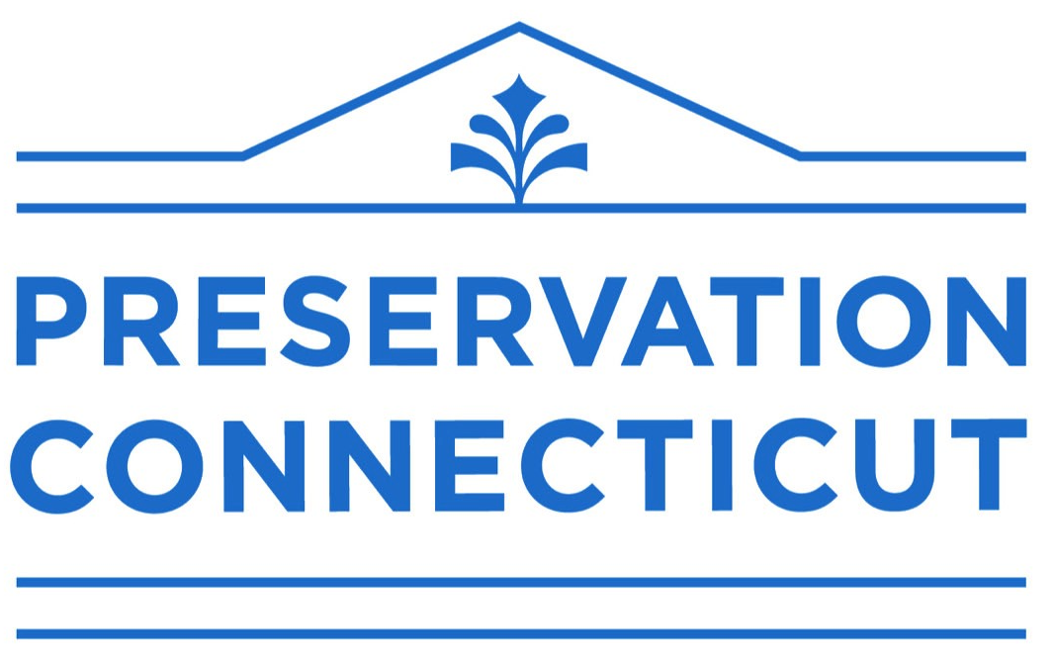

Preservation for people
CONNECTICUT PRESERVATION AWARDS ▪ 2025

The Connecticut Preservation Awards recognize outstanding achievements in revitalizing historic places to enhance the quality of life for the people of Connecticut.

Nominations are due by 4:00 p.m. on Friday, February 7, 2025. Awards will be presented on Thursday, May 8, 2025.

DESCRIPTION

Connecticut Preservation Awards honor outstanding efforts in the preservation and enhancement of historic places throughout Connecticut, with the goal of inspiring others to take similar action.

Connecticut Preservation Awards recognize projects that:
- bring new life to distressed historic places—buildings, districts, neighborhoods, landscapes or other
- revitalize sites associated with the history of minority or overlooked communities
- make significant contributions to sustainability—environmental, economic, or social
- develop innovative new perspectives or methods to historic preservation

Projects that primarily concern the architectural restoration, rehabilitation, or sympathetic additions to historic buildings are referred to the Elizabeth Mills Brown awards, jointly presented by Preservation Connecticut and AIA Connecticut. Watch for an announcement in the summer.

Connecticut Preservation Awards are presented to:
- individuals
- commercial firms or nonprofit organizations
- public and private property owners
- municipalities or other governmental bodies

The Mimi Findlay Award for Young Preservationists recognizes:
- individuals aged 35 or younger, or groups whose members are predominantly 35 or younger;
- who have demonstrated interest, involvement, and achievement or potential achievement in the restoration, maintenance, preservation or adaptive use of historic buildings, structures, complexes, neighborhoods, communities, and cultural landscapes or landscape features in Connecticut..

GENERAL INSTRUCTIONS

Any individual, organization or project involving historic preservation is eligible to receive an award. Renovation or rehabilitation projects must have been completed since January 1, 2019.

Nominations may be made without the knowledge of the nominee. Nominations must be made by members of Preservation Connecticut; for membership information, visit www.preservationCT.org.

Trustees and staff of Preservation Connecticut are not eligible for Connecticut Preservation Awards during their terms of service or employment or for activities carried out during those times.
REQUIREMENTS
Please submit all materials online at www.preservationCT.org or on a CD or thumb drive with copies of all documents in .pdf format and photographs in .jpg or .tiff format (more information below). Each nomination must include the following:
1. A completed nomination form and release authorization.
2. A very short summary, in 75 words or fewer, of the project, organization, or individual being nominated. What is the one most important thing for reviewers to know about this nomination?
3. A concise description, in 750 words or fewer, of the project, organization, or individual that is being nominated. The description should include the following information:
- Describe the project, including challenges, unique strategies and activities carried out, and the impact of these activities on the community. Digital copies of final reports or studies may be attached.
- Almost every preservation project is a team effort. Identify the people involved and their roles. All who made significant contributions to the success of the project should be listed. Project team lists do not count to the 750-word maximum.
- For preservation projects involving historic buildings, districts, cultural landscapes, or communities, explain the historic significance of the site and indicate if it is designated as a National Historic Landmark, in the National Register of Historic Places, the State Register of Historic Places, or a Local Historic District.
- Most important, describe what makes the nominated project, person, or organization outstanding, as an achievement in itself and as a model for others.
- For Young Preservationist nominations, describe the nominee’s interest, involvement, achievements, or potential achievements in preservation. Please include a copy of the nominee’s CV.

4. At least five and not more than eight photographs illustrating the project or program.
- Photographs should be digital files in .jpg or .tiff format, either submitted through the Preservation Connecticut website or on a CD or thumb drive.
  - Each photograph should be a separate file, with no collages and no superimposed text.
  - Photographs should measure at least 5 x 7 inches at a resolution of at least 300 dpi.
- Photographs should show:
  - before and after images, including a general exterior view
  - details or interiors from a variety of angles (if appropriate)
  - photos showing human activity are strongly encouraged
  - project site in the context of its surroundings
  - for nominations of individuals or groups, include a head shot, plus photos to illustrate the work for which they are to be recognized
- Include a written list of photographs with captions and credits for publication.
- Be sure to sign the Release Authorization on the nomination form.
5. Scanned copies of no more than three supporting brochures or news clippings (optional) and no more than three letters of support (optional).
6. Submit text materials in a Word document or PDF file, and photographs in .jpg or .tiff format.
7. Submit nominations online at www.preservationct.org/recognize or on a CD or flash drive delivered to Preservation Connecticut, 940 Whitney Avenue, Hamden, Connecticut 06517.
Nominations must be received by 4:00 p.m. on Friday, February 7, 2025.

For assistance, call Christopher Wigren at (203) 562-6312 or email cwigren@preservationCT.org.

CONNECTICUT PRESERVATION AWARDS ▪ 2025
NOMINATION

◻ Preservation for People Awards ◻ Mimi Findlay Award for Young Preservationists

Project or Person nominated
___________________________________________________________________________________

For projects, date of completion (no earlier than January 1, 2019): ______________________________

Address
___________________________________________________________________________________

City, State, Zip
___________________________________________________________________________________

◻ If there are co-nominees, please list them on a separate sheet and check this box.

Nomination submitted by
___________________________________________________________________________________

Organization
___________________________________________________________________________________

Address
___________________________________________________________________________________

City, State, Zip
___________________________________________________________________________________

Telephone ________________________________ Email ___________________________________

NOTE: The person making the nomination will be asked to notify the recipients of the award, and to communicate details of the presentation to them.
Please check one: ◻ I am a member of Preservation Connecticut ◻ My membership check is enclosed.

IN 75 WORDS OR FEWER (we mean it!), summarize why this person or project should be recognized—i.e., what is particularly noteworthy about it or about their achievements in terms of preservation. **This is a summary of the 750-word description that we ask for separately. Think of it as your elevator pitch.**

This person or project is particularly noteworthy because…

RELEASE AUTHORIZATION

To be signed by photographer or other owner of rights to photographs, drawings, videos, or other materials. If you are submitting materials from more than one source, please supply a separate copy of this form for each source.

The undersigned gives to Preservation Connecticut (formerly known as the Connecticut Trust for Historic Preservation) the absolute and unqualified right to use in whole or in part, in whatever manner Preservation Connecticut may desire, including (but not limited to) use for publicity, audio-visual presentation, and/or promotion—including press releases, printed materials, online and social media postings, public presentations and any other uses—all photographs, videos and other materials submitted to Preservation Connecticut’s Connecticut Preservation Awards program. This applies to submissions that receive awards as well as to submissions that do not receive awards.

Preservation Connecticut is hereby given permission to make any editorial changes and/or additions to the material referred to in the previous paragraph as it may deem necessary or desirable for production purposes.

The undersigned hereby guarantees to have on file all individual agreements and signatures from each model (adult, minor with parent or guardian written approval), creator, photographer and producer needed for this assignment to Preservation Connecticut.

Description of materials submitted:

Release authorized by:

_______________________________________________________________
(signature)

_______________________________________________________________
(print or type name and date)

AWARD NOMINATIONS SHOULD BE ADDRESSED TO:

Connecticut Preservation Awards
Preservation Connecticut
940 Whitney Avenue
Hamden, Connecticut 06517

For assistance, call Christopher Wigren at (203) 562-6312 or email cwigren@preservationCT.org.

Nominations must be received by 4:00 p.m. on Friday, February 7, 2025.

